Exciting news, as promised last month!
Fresh harvest, news, and pictures from the refugee camps in Chad.
We are grateful for our partnership with Globalgiving and its strong support. As well as the generous donation from the VMware Foundation. I am so proud of those who think and take brave action to feed those who have been hungry for long time.
Before war, they have their farms, their livestock, their homes. During harvest time they sell some of their crops, gave some away to the needy people, it is a must, it is called Zakat.
Our beneficiaries are Orphans, widows, disabled, elderly, and many vulnerable women. They depended on United Nations to eat - due to increase of refugees because of the conflicts in many counties, they receive less food, therefore, they are hungry.
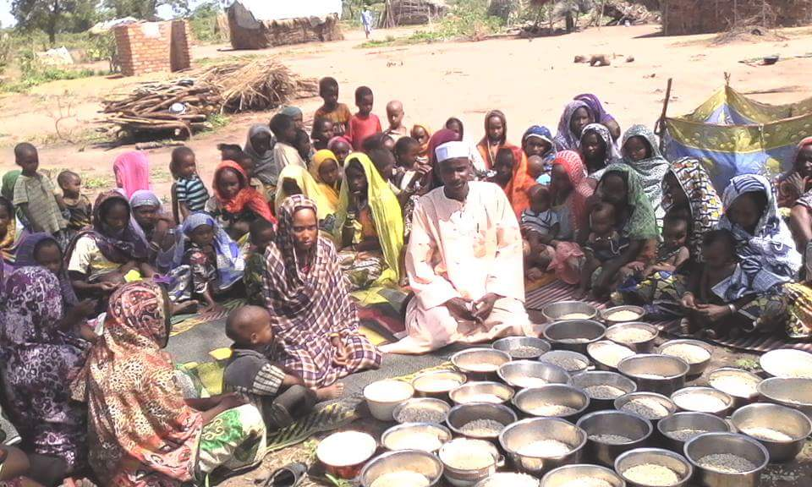

We provided agricultural inputs to experienced farmers (survivors of conflict) which had led to self-reliance. Empowering refugees is the greatest way to help them to end their hunger and to feel confident to do better in their futures.
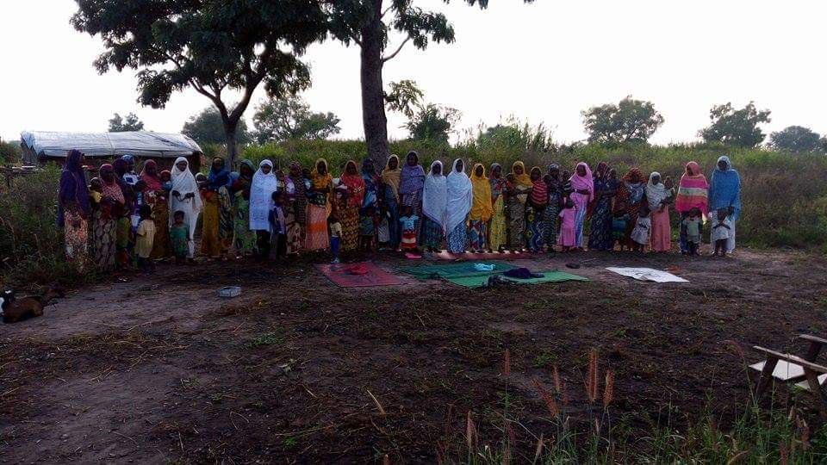
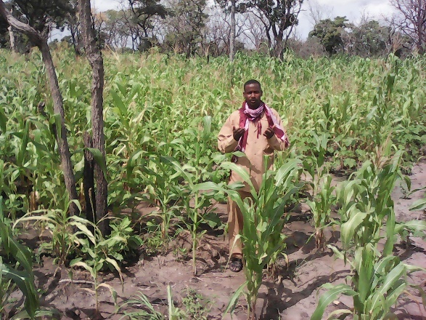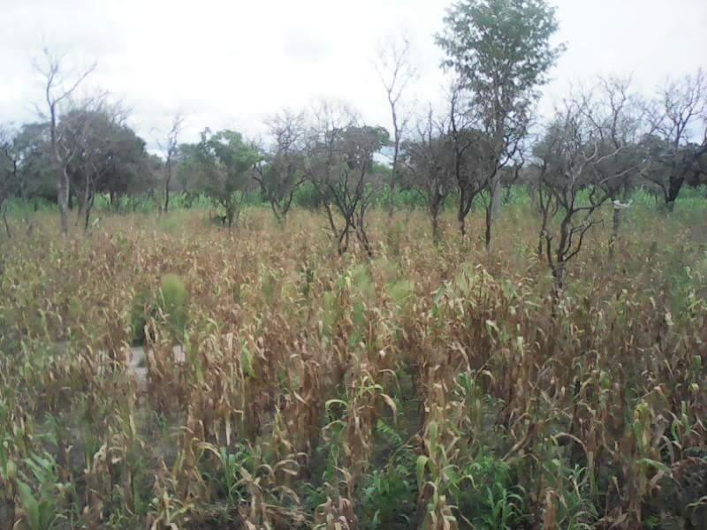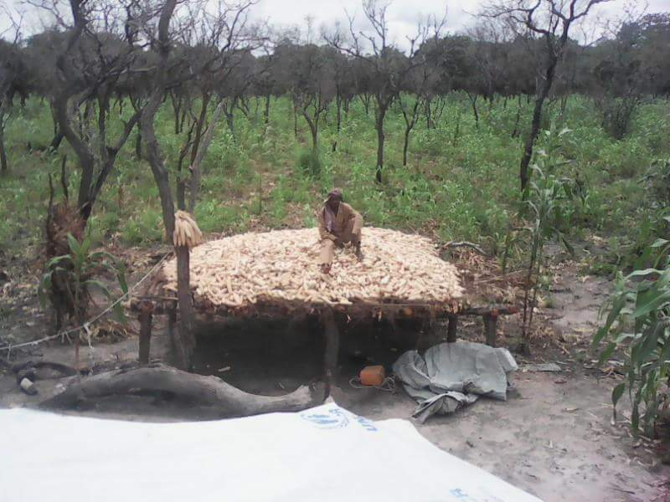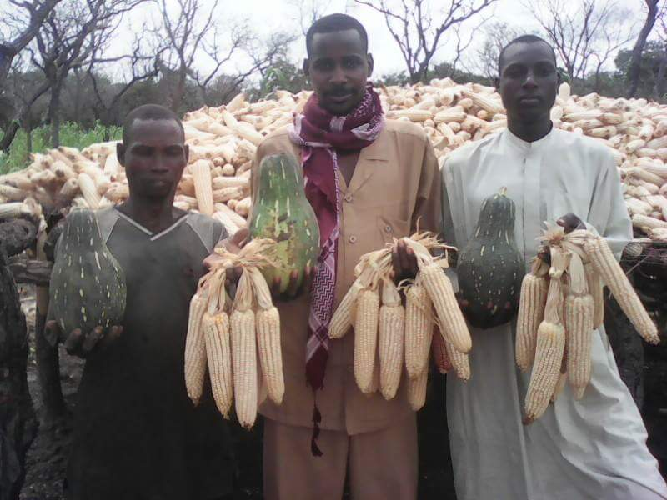
The survivors of the conflict suffered so much in different ways. They experienced rape and other hostile violence as well as huger.
The refugees are grateful for the strong support of Globalgiving and the generosity of The VMware Foundation and the individuals. We are excited to share our thrilling news from the field. One hundred and fifty families, each family consist of six members or more received participate in securing food for their families.
It is the great support that led them to self-satisfaction, however,150 families out of thousands is hard, but better than nothing. The question that I could not find an answer is that how can we keep the social impact of our Food Security project, and then, we could plan for maximize it?
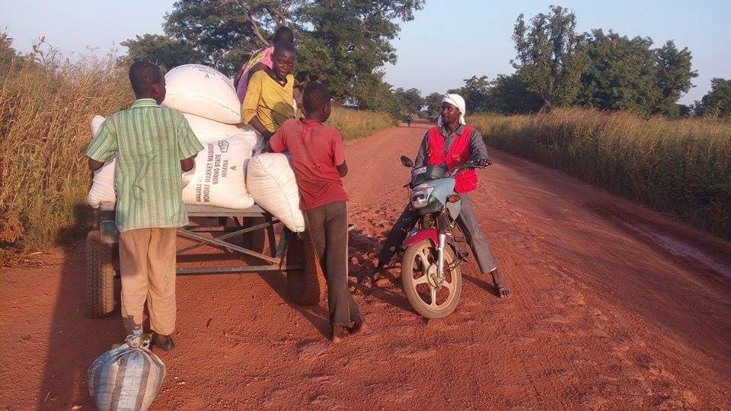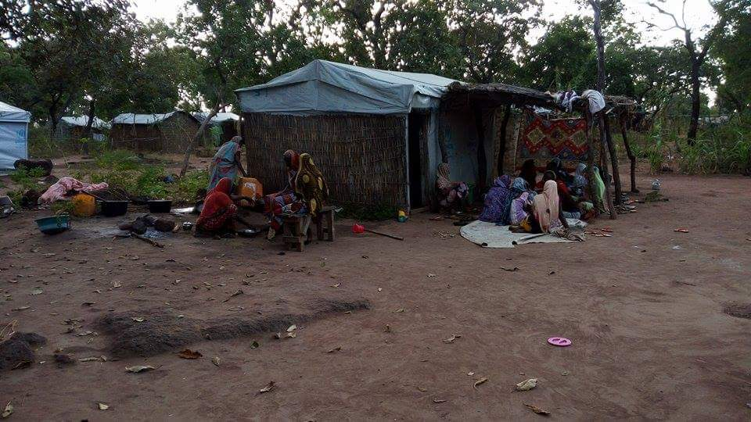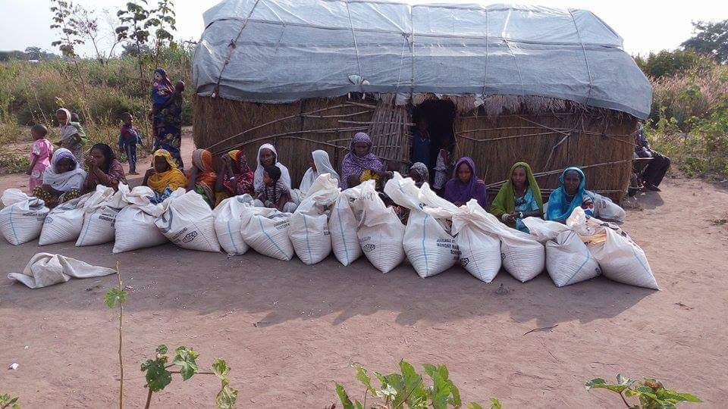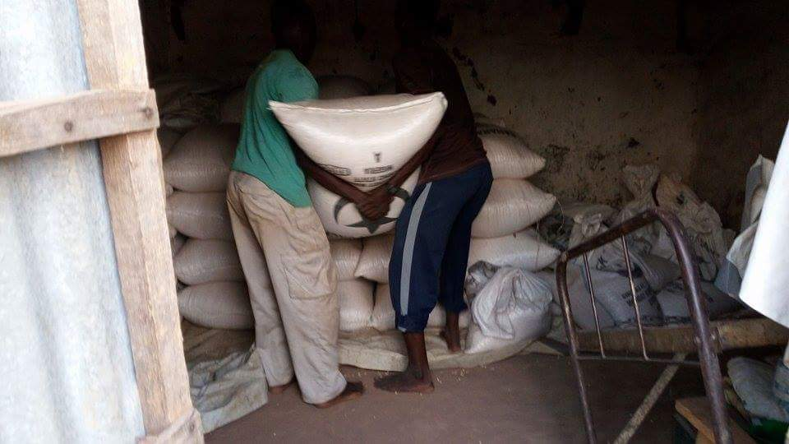
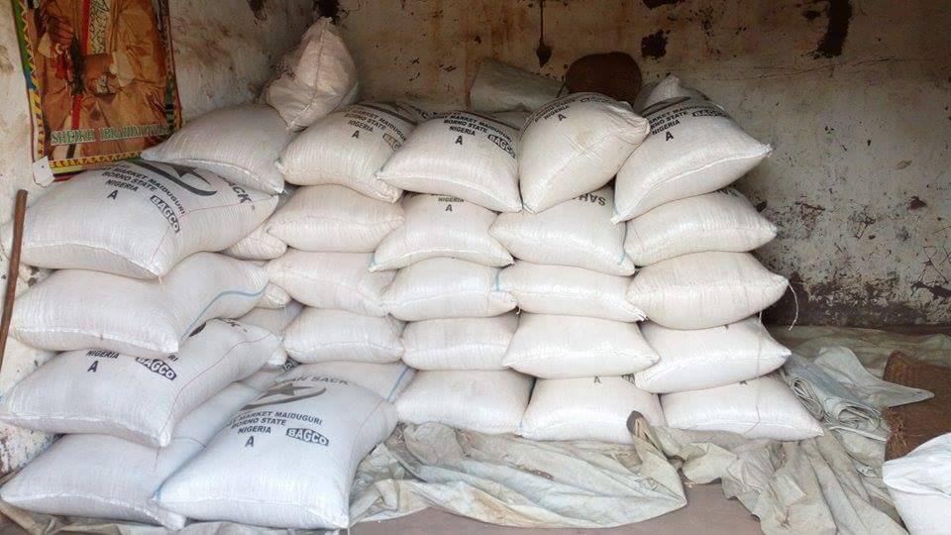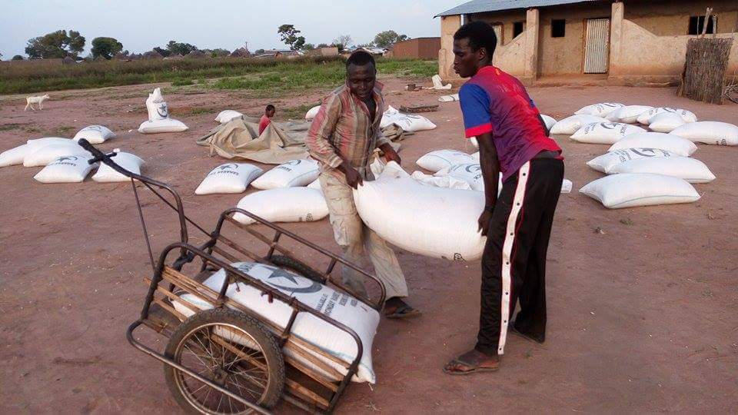
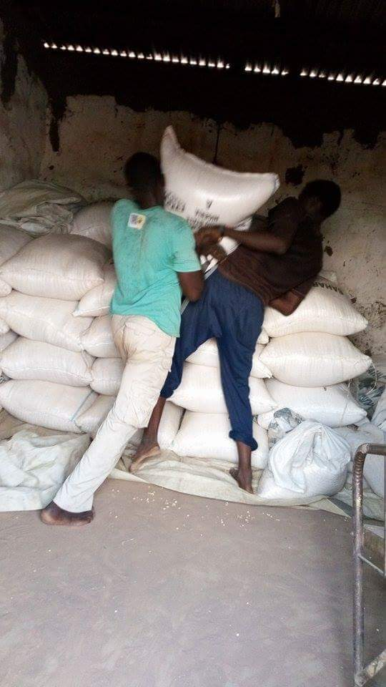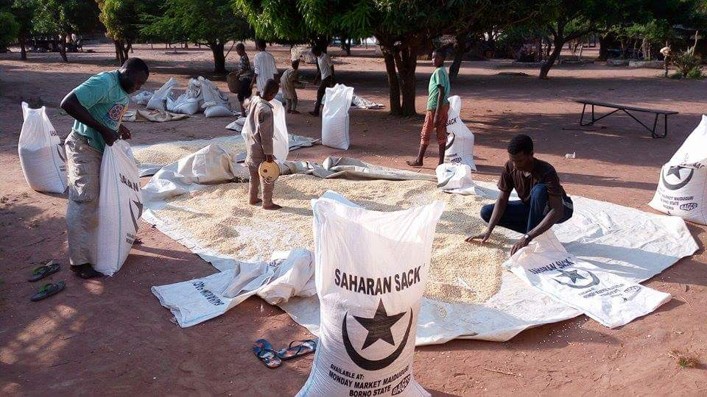

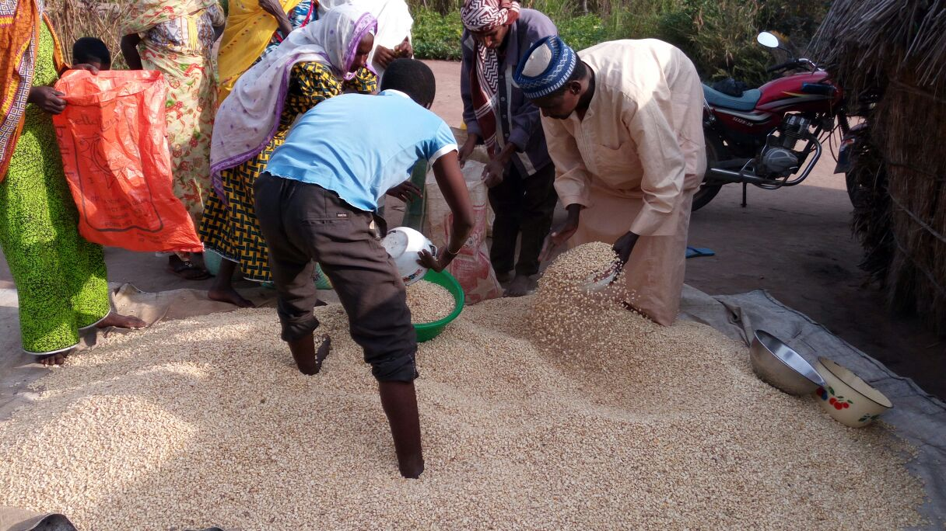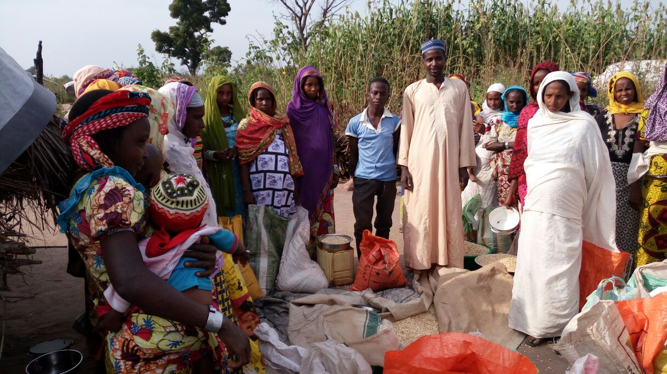
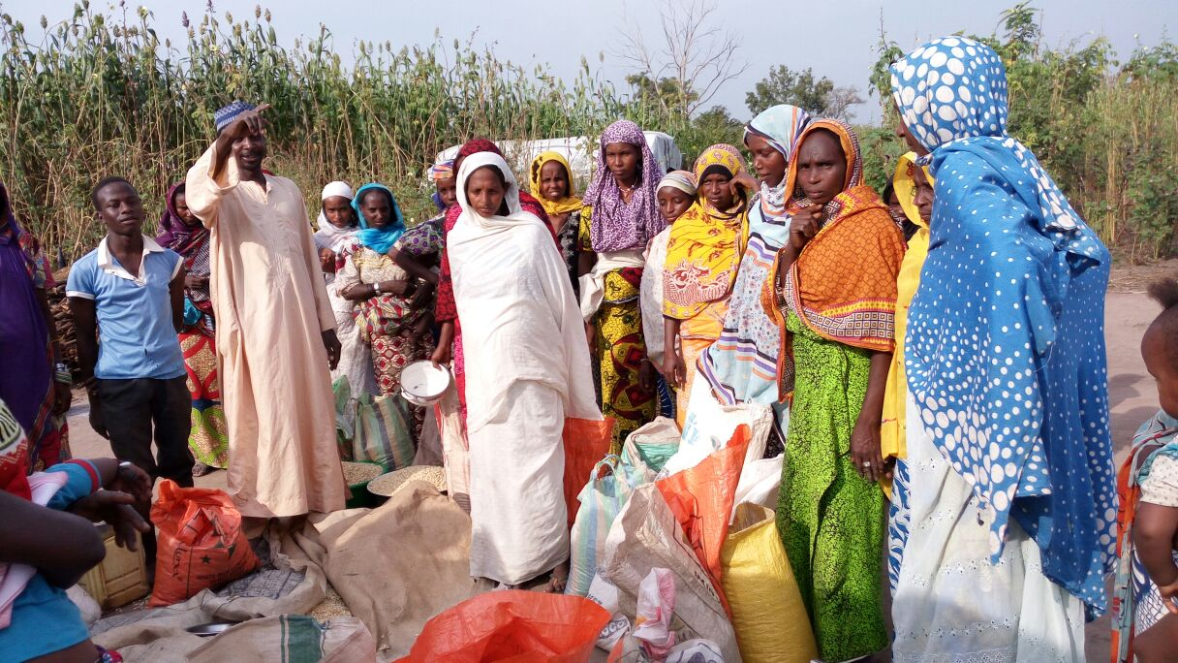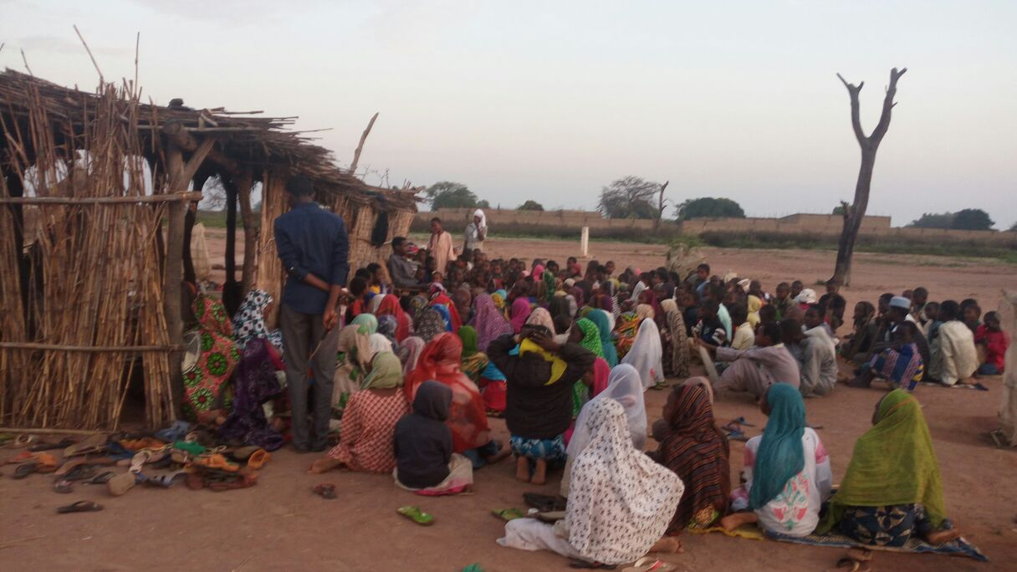

Please share the link with your network and your friends:
https://www.globalgiving.org/projects/food-security-and-agriculture/reports/#donationOptions

Your feedback is important for us to improve our work!

