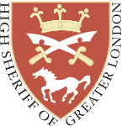

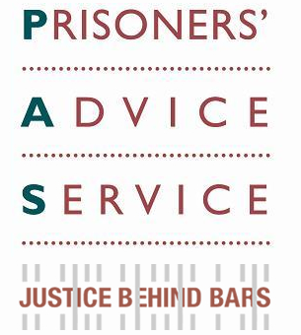

**The Prisoners’ Advice Service**

**and The High Sheriff of Greater London Kevin McGrath**

**invite you to the 2014 PAS Lecture:**

**“What Price Imprisonment?”**

**by** **The Lord Ramsbotham GCB CBE**

**When: Tuesday 25th November 2014, 7pm – 9pm.** Drinks will be served during the evening.

**Where:** 1st Floor Auditorium, Herbert Smith Freehills, Exchange House, Primrose St, London EC2A 2EG

**Who:**

* The **Prisoners’ Advice Service** (PAS) ([www.prisonersadvice.org.uk](http://www.prisonersadvice.org.uk)) is an independent registered charity providing free legal advice and information to prisoners in England & Wales
* **The High Sheriff of Greater London, Kevin McGrath,** is supporting a number of prison charities including PAS during his term of office (2014-15)
* **Lord Ramsbotham** is a Patron of PAS and involved with several other prison charities. He previously served as HM Chief Inspector of Prisons for England & Wales (1995-2001)
* **Herbert Smith Freehills** is a leading global commercial law firm with a strong commitment to corporate responsibility and pro bono support of charities including PAS

**RSVP:** Please e-mail [Helen.Brown@prisonersadvice.org.uk](mailto:Helen.Brown@prisonersadvice.org.uk) Tickets are free. Maximum two tickets per person. Please note that tickets are offered on a first come, first served basis. If you book and subsequently cannot attend, please notify us - so we can re-allocate your place.

**Our Thanks:** This event is kindly supported by the McGrath Charitable Trust (catering) and Herbert Smith Freehills (venue). PAS is most grateful for their generous support.

[](http://hsnet/)

