BRETHEREN CARE AND COMMUNITY EMPOWERMENT FOUNDATION
Located At Kawempe Lugoba Next To St Mark Clinic Bombo Rd
Field Office at Kamira Sub-County Head quarters, Luwero District
Tel: +256-788509993/+256-702749365E-mail:brethrencare@yahoo.com
Face book page: brethren care and community empowerment foundation
Blog page: http://projecthopekampala.blogspot.co.uk

Dear our honored friend!
We bring you greetings Brethren Care and Community Empowerment Foundation (BCCEF)
And we extend our sincere appreciation to you and your family for the Support you offered to us 2013
And we humbly request to continue with same spirit of love, sacrifice and caring for the big number of needy people we help in 2014
We are soon sending annual Report, annual work plan and certificate of appreciation to you and your family as well.
This is totally humble request and its an emergency which needs your fast reaction to support us in this project
The community offered us land worth 2 acres to start an orphanage school! With your help, we renovated a small building on, it contains 2 rooms to act as a school all has been and we have registered 100 children some will pay little and others won’t pay anything! But we have no enough rooms to accommodate all these children’s
I want you to feel this sense, we have only 20 days remaining to start, we want only 600$ to create these temporary structure! Even if 10$ can save the situation
May God reward you in this great work! Thank you in advance!

You can send anything to help on the account Number below
COUNTRY: UGANDA
BANK NAME: CENTENARY BANK
ACCOUNT NAME: KYATEREKERA DANIEL
ACCOUNT NUMBER: 3320502562
BRANCH NAME: KABALAGALA BRANCH
Below is the project plan
WORK PLAN FOR BRETHREN CARE PRIMARY SCHOOL
Name: Brethren care Primary School
Location: Kaazi Village, Kikyusa sub county Luwero District
Contact address: P O Box 25957 Kampala Uganda Tel:+256788509993/702749365
E mail Adress:brethrencare@yahoo.com
Description
Brethren care Nursery and Primary school is a school located at Kaazi Village Kikyusa sub county Luwero District. It comprises Nursery and primary without basing on Race, sex, religion and tribe.
This school was founded under the Organization of Brethren care and community empowerment foundation(BCCEF) in partnership with our Donors. The school uniform with have its uniform Colors ie :………………………………………….
Aims and Objectives
- To provide education to needy children
- To provide cheap and quality education to the community
- To empower young Generation skills to face future challenges
Mission
“Providing education which enables young generation to be self reliant citizens and caring for each other”
Vision
“Creating self reliant citizens who practice hospitality to each other”
School Motto
“Education with love is my success”
Management plan
This school comprises the: Board of Directors, school management committee, school Administration and prefect body
Board of Directors: This board will comprises nine members; Three (3)from BCCEF Organisation,Two (2)members from Donors, Three (3) members from the community and One (1)members from district technocrat in Education Department
This Board shall sit once a year i.e. at the the end of the year. Its main purpose is to pass the plan, budget, draft policies and receive reports from the School management Committee.
School management Committee (SMC)
This shall comprise of nine members i.e. The Head teacher, school bursar, two Directors from BCCEF organization, two community members and other three (3) members who will be appointed. SMC shall sit three (3) times a year i.e. at every end of term to draw budget, plan and receive reports from the school administrators
School Administrators
This will comprise of seven members i.e. the head teacher, Deputy Head teacher, Director of studies, School Bursar, senior matron, chaplain/counselor and head of welfare and sports. They shall sit whenever seen necessary, they shall carry out day to day running of the school
Prefect Body
This shall be headed by head prefect where pupils will elect their leaders democratically and shall report directly to the school administration. All positions, duties and responsibilities shall be determined by the school administration.
Financial Management
The school management shall draw a budget approved by Board of Directors. The school bursar shall be the only supposed to receive and bank money realizes at school, prepares books of account, pay salaries and expenses made while transacting school business in consultation with the Head teacher. The school shall have an account from any bank of Board of director’s choice. The signatories shall be determined by board of Directors. No asset for the school shall be moved without the consultation of school management.
Advertisement and promotion
Many activities shall be done to make sure this school is known all the country and worldwide and they will include the following: carry out community meetings, Radio and TV adverts, postors,bronchures,public address drives, maintain quality standards, Door to door advertisement, promoting sports and music activities and others.
Sustainability Plan
This school shall carry out many activities to ensure its sustainability. Among the activities will include; Farming to supply food to children, making Bricks at school premises to reduce the cost of construction, children who shall not be on sponsorship programme to pay reasonable school fees and all school requirements shall be bought at school, lobbying for more donors, fundraising shall be carried out to support needy children in this school, involving community members to support the school and others.
Projection
year | period | No. of Needy children | No. of half paying children | No. of full paying Children | No. of children whose guardian s offers services
2013 | Jan-Dec | establishment | establishment | establishment | establishment
2014 | Term 1 | 15 | 20 | 20 | 5
 | Term 11 | 20 | 40 | 30 | 5
 | Term 111 | 20 | 45 | 35 | 5
2015 | Term 1 | 25 | 60 | 50 | 5
 | Term 11 | 25 | 65 | 60 | 5
 | Term 111 | 25 | 70 | 65 | 5
2016 | Term 1 | 50 | 80 | 70 | 5
 | Term 11 | 50 | 90 | 80 | 5
 | Term 111 | 50 | 95 | 85 | 5

Practicing Hospitality for each other
School site Before Renovation
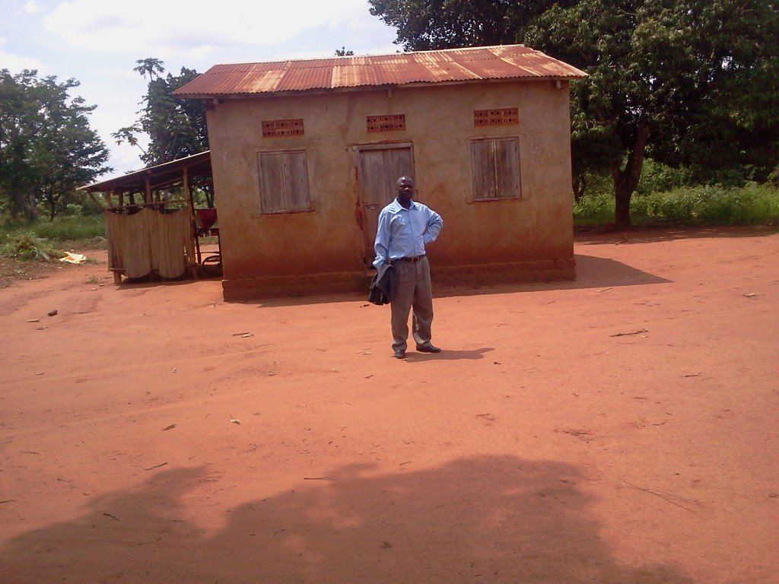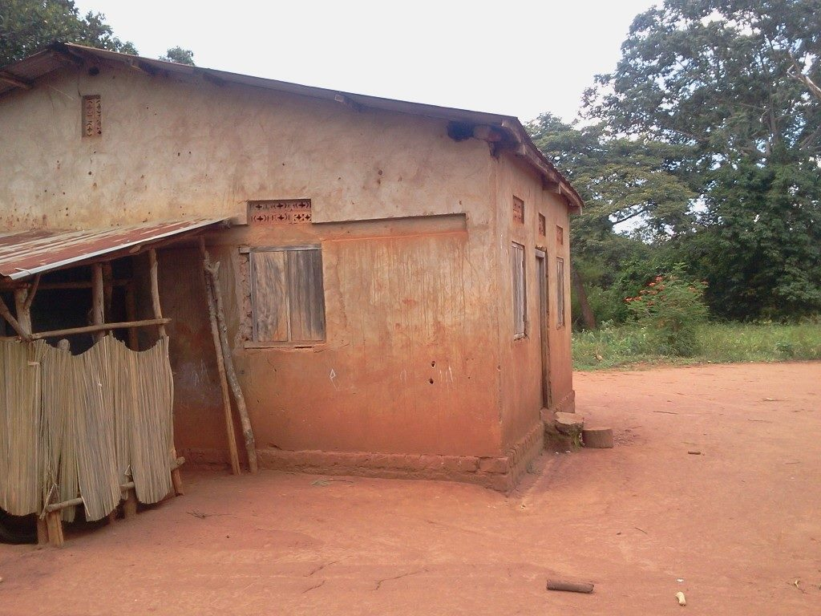
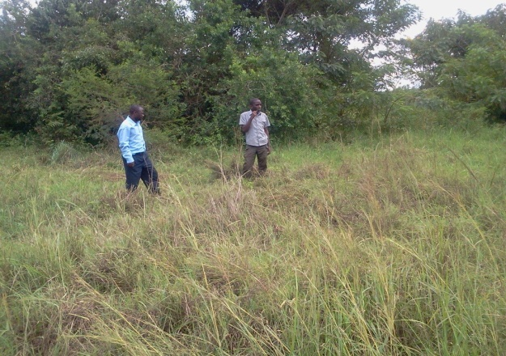
After renovation
