Project Proposal for Raksha (Protection) a home for 50 survivors of sex trafficking.
PART-I

Name of Organization: Goranbose Gram Bikash Kendra (GGBK).
Organization back ground: Goranbose Gram Bikash Kendra (GGBK) was established in 1985, registered in 1987, when a group of young men mobilized to challenge under development, poor governance and suffering of people in a disaster prone area called, Sundarban, world famous Mangrove delta, The Kendra extended to the Sundarban initially on relief and then women’s empowerment, children’s rights, GGBK also working for the physically challenged children, men and women in twelve (12) blocks of Sundarban, helped them by providing aids and appliance, survey on physically challenged people of 4 blocks in Canning Subdivision. GGBK organized a survey on disaster management and preparedness with ADHAR, Kolkata was organized in six (6) blocks of Sundarban. Due to increase in trafficking of girls and women, GGBK started assisting families to register cases, pressurize Police to rescue victims, providing shelter, food, clothes, medical treatment, life skill education, training for Capacity building and prosecute trafficker, network with the Ngo's to coordinate post rescue support and then rehabilitation.
Activity profile of GGBK:

To combat trafficking GGBK is having multi-pronged approaches.
- Child protection, movement against trafficking and violation of child rights.
- Help the survivors through a home where shelter, food, cloth, medical treatment, life skill education and training for capacity building are provided.
- Rehabilitate the survivors of Sex trafficking into their families.
Activities for the period of 2013-2014
Description | Number of Cases
Total no. of cases sourced | 137 (Below 18years + above 18years)
Cases from source area | 105
Cases sent from destination places | 32
Trafficking cases sourced | 112
Missing cases sourced | 14
Cases of unsafe migration sourced | 11
GDE lodged with the help of GGBK | 66
FIR lodged with the help of GGBK | 34
Charge sheets produced before court | 13
HIR received from destination organization | 29
HIR sent to destination organization | 19
HIR referred to other organization (SRDTC, BUP) for non-connectivity problem | 3
Networking being built with destination organization (Rescue Foundation, WCWF, Child Line, WB Task Force) towards | 24
Advocacy made towards state actors (Governor’s Office, Mahila Commission, DIG/CID, SP, SDPO etc.) | 17
Lobby being made with local PS (Canning, Basanti, Jeebantala, Gosaba, SB Costal, Bariupur, Sonarpur etc.) | 68
Trafficked girls rescued and reunified with their families | 42
Trafficked girls self-returned from the destination place | 13
Due to the intervention of GGBK and pressure mounted by police personnel the traffickers become compel to return the trafficked girls | 11
Trafficked girls rescued but not reunified with their families | 13 (staying at CWC and other shelter home in destination places)

PART- II
PROJECT PROPOSAL
Title of the project:- Raksha (Protection) a home for 50 survivors of sex trafficking.

LOCATION:- Country- India.
State- West Bengal.
District- South 24 Parganas, Sundarban.

Duration of the Project:- 36months.
Over all Objectives:- Thousands of girls, affected by poverty and lack of opportunities get trafficked from sundarban, of South 24 Parganas Dist, West Bengal, India to red-light areas in Mumbai, Pune, Delhi, Hariyana and other cities of north and West India. Overall objective of the project are to address the overall trafficking from Sundarban, South 24 Parganas a) poor investigation and rescue of missing and trafficked persons b) stigmatization of victim in their families and Communities c) regular intimidation made by the traffickers d) provide shelter, food, cloths, medical treatment, life skill education, training for Capacity building towards the victims of Sex trafficking.

Specific objectives:
The Specific objectives that govern the project are-
I) To build an efficient Co– ordination system among GGBK in source and destination points of trafficking on rescue and rehabilitation of trafficked victims.
II) To provide shelter towards the Sex-trafficked victims so that they can avoid stigmatization in their families and communities, intimidation made by the traffickers and provides food, cloths, medical treatment regularly.
III) Provide life skill education and training for Capacity building and legal support towards the survivors so that traffickers are prosecuted.
Target Groups: The primary target groups are trafficked children/ women or children/ women subjected to unsafe migration, rescued through intervention made by GGBK.
Methodology: The strategic approach for implementing the project is based on the following plans-
a) 50 numbers of Sex trafficked survivors will be provided shelter in a home organized by GGBK where those victims will be provided with cloths, food, medical treatment, life skill education and above all training for Capacity building enabling them to start micro businesses for their livelihood option.
Strategy: A multi-pronged approaches has been designed so that project objectives can be achieved. The approach aims to project the rights of trafficked survivors by preventing systematic abuse in custodian care and minimizing the gestation period in case management from rescue to reintegration of Survivors with her family, the approach also focus on joint prosecution of traffickers both at destination and source point, avoid stigmatization in their families and Communities avoid intimidation made by the traffickers, earn their own bread through life skill, education and training for their capacity building, preventing the survivors from making forced out of court settlements, resulting more conviction towards traffickers.

Monitoring: Internal monitoring of this project will be made according to the following procedure

Procedures for internal monitoring to be made by
Goranbose Gram Bikash Kendra (GGBK)
Governing Body

Secretary/Director
Responsible for monitoring

__________________________________________________

Coordinator Accountant Counsellor Superintendent

Counsellor Social Worker
Resident nurse/ Worden Cook Care taker

Security
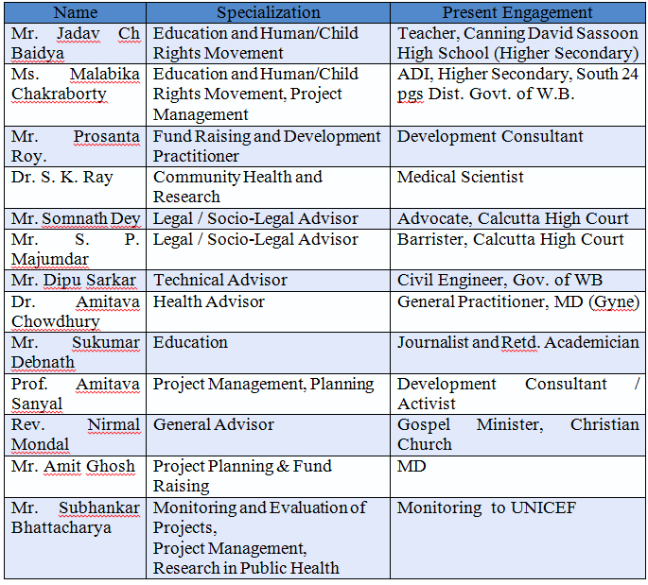

BUDGET FOR SHELTER HOME FOR 50SUURVIVORS OF SEX TRAFFICKING
Description of Activities | No. | Unit Cost | Amout Per  Month | Budget  for 1 Yr | Budget  for 2 Yr | Budget  for 3 Yr | Total Budget  (INR) | Usd Rate on 07/04/2014 | Total Budget  Forecast USD
(A) Shelter home for young women and girl
children rescued from Sex Trafficking
Welcome Kit | 10 | 1,250.00 | 1,250.00 | 15,000.00 | 15,750.0 | 16,537.50 | 47,287.50 | 60.11 | 786.68
Clothing and linen | 30 | 1,300.00 | 39,000.00 | 156,000.00 | 163,800.0 | 171,990.00 | 491,790.00 | 60.11 | 8181.50
Food & Nutrition | 50 | 1,800.00 | 90,000.00 | 1,080,000.00 | 1,134,000.0 | 1,190,700.00 | 3,404,700.00 | 60.11 | 56641.16
Health care and Diognostics | 10 | 1,200.00 | 12,000.00 | 144,000.00 | 151,200.0 | 158,760.00 | 453,960.00 | 60.11 | 7552.15
Mental health care | 5 | 1,200.00 | 6,000.00 | 72,000.00 | 75,600.0 | 79,380.00 | 226,980.00 | 60.11 | 3776.08
Hygiene of Sanitary Materials | 30 | 150.00 | 4,500.00 | 54,000.00 | 56,700.0 | 59,535.00 | 170,235.00 | 60.11 | 2832.06
Exposure visit for orientation | 55 | 2,000.00 | 110,000.00 | 220,000.00 | 231,000.0 | 242,550.00 | 693,550.00 | 60.11 | 11538.01
Lifeskill cum capacity building training to the survivors. | 50 | 800.00 | 40,000.00 | 480,000.00 | 504,000.0 | 529,200.00 | 1,513,200.00 | 60.11 | 25173.85
Home Investigation | 5 | 1,500.00 | 7,500.00 | 90,000.00 | 94,500.0 | 99,225.00 | 283,725.00 | 60.11 | 4720.10
Restoration Expenses | 4 | 2,500.00 | 10,000.00 | 120,000.00 | 126,000.0 | 132,300.00 | 378,300.00 | 60.11 | 6293.46
Sub Total A |  |  |  | 2,431,000.00 | 2,552,550.00 | 2,680,177.50 | 7,663,727.50 |  | 127495.05
(B) Training and Capacity Building for Staff, volunteers and Members | 12 | 5,000.00 | 60,000.00 | 120,000.00 | 126,000.00 | 132,300.00 | 378,300.00 | 60.11 | 6293.46
Sub Total B |  |  |  | 120,000.00 | 126,000.00 | 132,300.00 | 378,300.00 |  | 6293.46
(c ) Administrative and Management Expenses
i) Staff Cost
Project Director | 1 | 25,000.00 | 25,000.00 | 300,000.00 | 315,000.00 | 330,750.00 | 945,750.00 | 60.11 | 15733.65
Coordinator | 1 | 15,000.00 | 15,000.00 | 180,000.00 | 189,000.00 | 198,450.00 | 567,450.00 | 60.11 | 9440.19
Counselor (Part time) | 1 | 10,000.00 | 10,000.00 | 120,000.00 | 126,000.00 | 132,300.00 | 378,300.00 | 60.11 | 6293.46
Resident Nurse/ Worden | 2 | 10,000.00 | 10,000.00 | 240,000.00 | 252,000.00 | 264,600.00 | 756,600.00 | 60.11 | 12586.92
Field Worker | 2 | 8,000.00 | 16,000.00 | 192,000.00 | 201,600.00 | 211,680.00 | 605,280.00 | 60.11 | 10069.54
Care taker | 2 | 8,000.00 | 16,000.00 | 192,000.00 | 201,600.00 | 211,680.00 | 605,280.00 | 60.11 | 10069.54
Cook | 2 | 6,000.00 | 6,000.00 | 144,000.00 | 151,200.00 | 158,760.00 | 453,960.00 | 60.11 | 7552.15
Security | 2 | 5,000.00 | 5,000.00 | 120,000.00 | 126,000.00 | 132,300.00 | 378,300.00 | 60.11 | 6293.46
Life skill trainer | 2 | 8,000.00 | 16,000.00 | 192,000.00 | 201,600.00 | 211,680.00 | 605,280.00 | 60.11 | 10069.54
Medical Consultant | 1 | 10,000.00 | 10,000.00 | 120,000.00 | 126,000.00 | 132,300.00 | 378,300.00 | 60.11 | 6293.46
Legal Counsel need based | 1 | 10,000.00 | 10,000.00 | 120,000.00 | 126,000.00 | 132,300.00 | 378,300.00 | 60.11 | 6293.46
Accountant | 1 | 12,000.00 | 12,000.00 | 144,000.00 | 151,200.00 | 158,760.00 | 453,960.00 | 60.11 | 7552.15
ii) Administrative exp
Premises | 1 | 2,500,000.00 | 2,500,000.00 | 2,500,000.00 | 0.00 | 0.00 | 0.00 | 60.11 | 0.00
Land | 1 | 2,000,000.00 |  | 2,000,000.00
Audit Fees | 1 | 30,000.00 |  | 30,000.00 | 31,500.00 | 33,075.00 | 94,575.00 | 60.11 | 1573.37
Documentation Expenses | 1 | 2,000.00 | 2,000.00 | 24,000.00 | 25,200.00 | 26,460.00 | 75,660.00 | 60.11 | 1258.69
Administrative Expenses | 1 | 10,000.00 | 10,000.00 | 120,000.00 | 126,000.00 | 132,300.00 | 378,300.00 | 60.11 | 6293.46
Sub Total C |  |  |  | 6,738,000.00 | 2,349,900.00 | 2,467,395.00 | 7,055,295.00 | 60.11 | 117373.07
TOTAL-(A+B+C) in INR र |  |  |  | 9,289,000.00 | 5,028,450.00 | 5,279,872.50 | 15,097,322.50
TOTAL- in USD $ |  |  |  | $154,533 | $83,654 | $87,837 |  |  | $326,024.33

