GIRLS GLORY PROGRAM STATUS OCTOBER-DECEMBER 2019
Toilet facilities in every school are very essential for the improvement of health and educational development of the children .Realizing this, construction of new toilet units by providing water facilities with special provision in separate toilet blocks for girls has been going on smoothly.

Toilets in schools are necessary for the healthy growth of the children. Some norms were followed both in the selection of toilet designs, location, selection of quality contractors in construction of the toilets units.
To make a school sanitation program sustainable, which is one of the important strategies, maintenance is covered by institutional bodies at school level with assistance from Reaching Hand.

SENSITIZATION WORKSHOP

The sensitization workshop focused on assessing the awareness on WASH (Water, Sanitation and Hygiene) for girls and boys and MHM (Menstrual Hygiene Management) practices for girls by engaging visual aids and participatory activities were conducted.

The workshops therefore began with the starting point of helping the beneficiaries in recognizing their current knowledge and practices pertaining to hygiene. Behavior Change is a critical component of improving access to and practices around water, sanitation and hygiene. The provision of services alone is not enough to achieve the outcomes associated with improved WASH. Facilities must also be utilized habitually and properly at key times. The workshops are seen as a vital exchange platform for necessary knowledge sharing.
Through workshops, participants gained a clear understanding of the best practices in changing their behavior of WASH and MHM practices.
Special Day Celebration

Global Handwashing Day 15th October 2019,- a global advocacy day dedicated in increasing awareness on the importance of hand washing with soap as an effective and affordable way to prevent diseases and save lives. Education on hygiene in schools helps promote those practices that would prevent water and sanitation related diseases as well as encourage healthy behaviour in future generations.

To increase awareness about the benefits of handwashing with soap, 14 Master of Social Work students from CMR University conducted and awareness program on 23rd October 2019 in GHPS, Khajisonnenahalli. They also performed a mime on how germs easily gets transmitted that can make people sick if hands are not washed with soap and clean running water.

Through mime, children understood that germs can make people sick owing to unhygienic practices and importance of handwashing especially during key times such as after using washrooms, when preparing food, before eating, after coughing, sneezing, after recreation activity etc.

Practical demonstration on handwashing steps was depicted to children and few children actively took part and learnt how to wash their hands properly with soap by following simple steps.

The theme of World Toilet Day 2019 - "Toilets for All," which means leaving no one behind as the world strives to achieve universal access to sanitation. Sustainable Development Goal 6 has a target to eliminate open defecation and ensure everyone has access to sustainable sanitation services by 2030, “paying special attention to the needs of women and girls and those in vulnerable situations”.

World Toilet Day was celebrated in 2 schools through mime to raise awareness among students how to safely manage sanitation and not to practice open defecation. Students also understood that by practicing open defecation, untreated human waste gets out into the environment and spreads diseases. Audio visual aids were displayed for easy understanding by all age groups of students.

MENSTRUAL HYGIENE MANAGEMENT SESSION
1 | No. of Schools | 5
2 | No. of Girls | 404
3 | No. of Girls benefitted through workshop | 229
4 | No. of MHM kits distributed | 261

HEALTH & HYGIENE SESSION
1 | No. of Schools | 6
2 | No. of Girls/Boys | 807
3 | No. of Girls/Boys benefitted through workshop | 616
4 | No. of HH kits distributed | 807

WASHROOM CONSTRUCTION
1 | No. of Schools | 11
2 | No. of units constructed for girls | 11
3 | No. of units under construction for girls | 19
4 | No. of units renovated for girls | 4
5 | No. of units under renovation for girls | 8

CASE STUDY
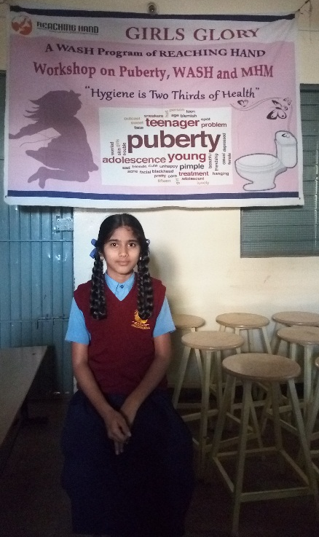

I was trying to understand things myself and then Reaching Hand explained everything to us in detail. I feel like now I know everything; The workshop was very informative, and I was very active and keen in learning new things about menstruation and puberty.
Through sensitization workshop I learnt the importance of personal hygiene especially during menstrual days. I gained knowledge on practicing Menstrual Hygiene Management.
I thank the sponsors for constructing new toilet units in our premises for girls and we are so grateful to them.
Ms.Ramya, 6th Std, GMPS: Doddanekkundi

There is a lack of knowledge and information about menstruation. Majority of the girls did not know what happened when they experienced menstruation for the first time and therefore were scared and most of my friends come unprepared to school during menstruation days and often stain their school uniform.
Through sensitization workshop I learnt the importance of personal hygiene especially during menstrual days. I gained knowledge on usage of pad and how to manage stomach cramps during menstrual days.
I thank the sponsors for constructing new toilet units and installing pad burning machine in our premises for girls and we are so grateful to them.
Ms.Meghashri, 6th Std, GHPS: Ganadakatte, Channagiri, Davangere

There is a lack of knowledge and information about menstruation. Majority of the girls did not know what happened when they experienced menstruation for the first time and therefore were scared and most of my friends come unprepared to school during menstruation days and often stain their school uniform.
Through sensitization workshop I learnt the importance of personal hygiene especially during menstrual days. I gained knowledge on usage of pad and how to manage stomach cramps during menstrual days.
I thank the sponsors for constructing new toilet units and installing pad burning machine in our premises for girls and we are so grateful to them.
Ms.Meghashri, 6th Std, GHPS: Ganadakatte, Channagiri, Davangere

SENSITIZATION PROGRAMS

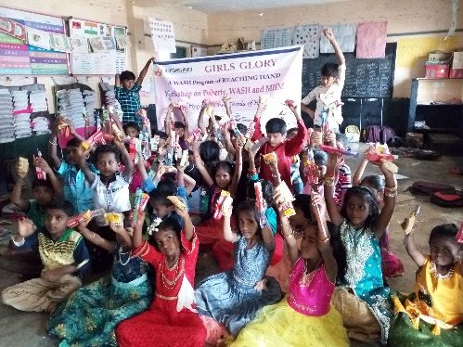
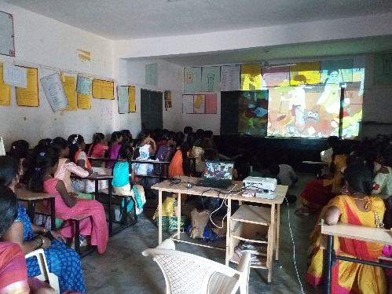
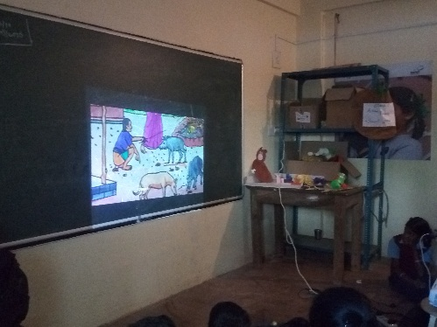
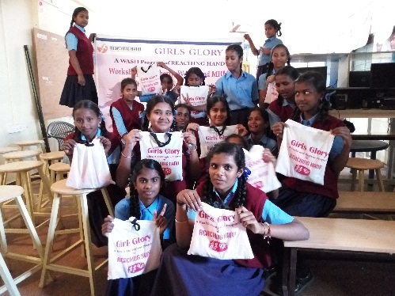
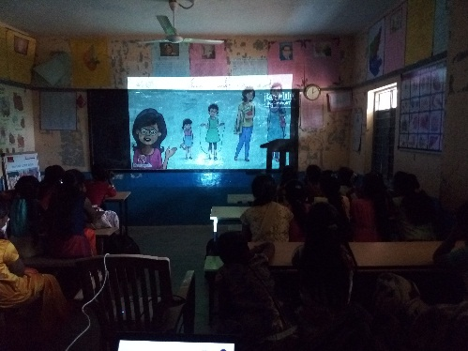
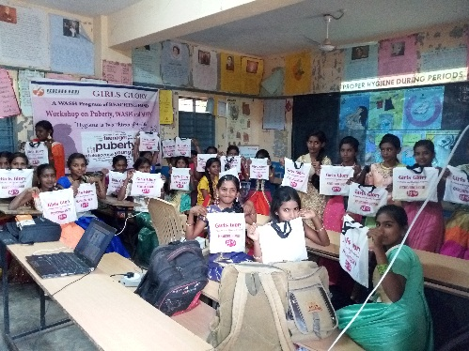

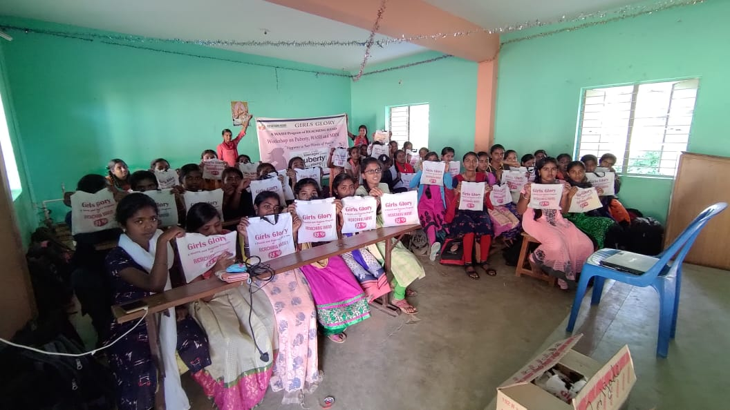
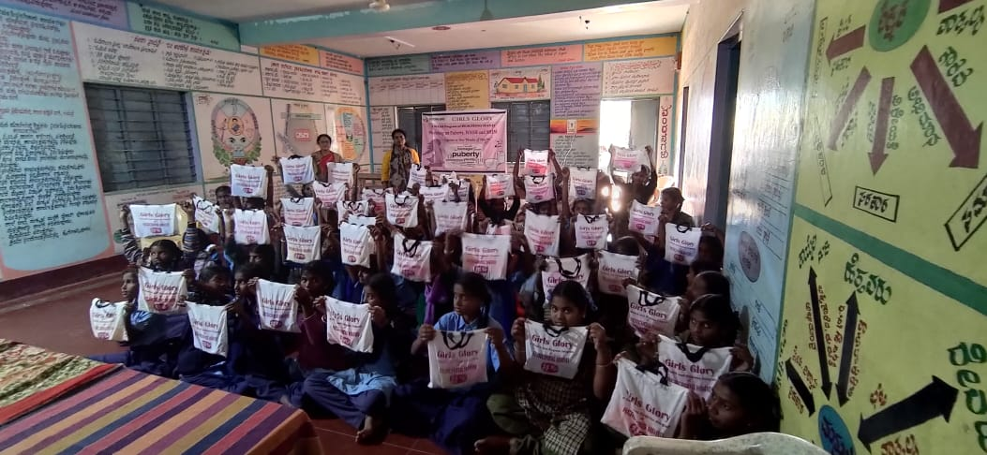

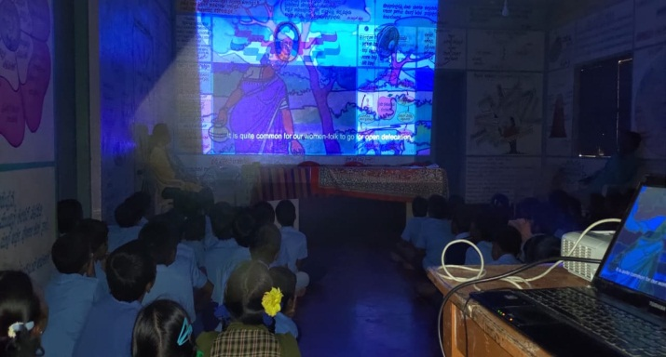
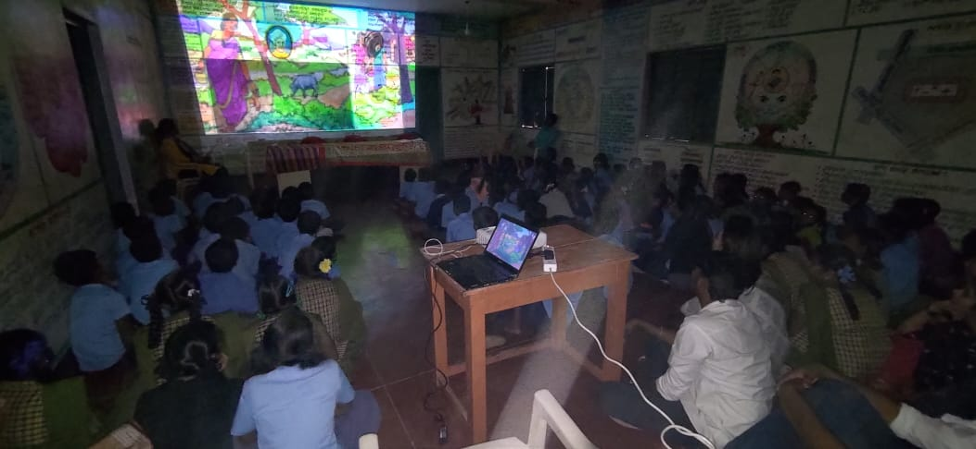
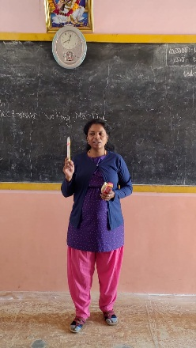

SPECIAL DAY CELEBRATION-GLOBAL HANDWASHING DAY
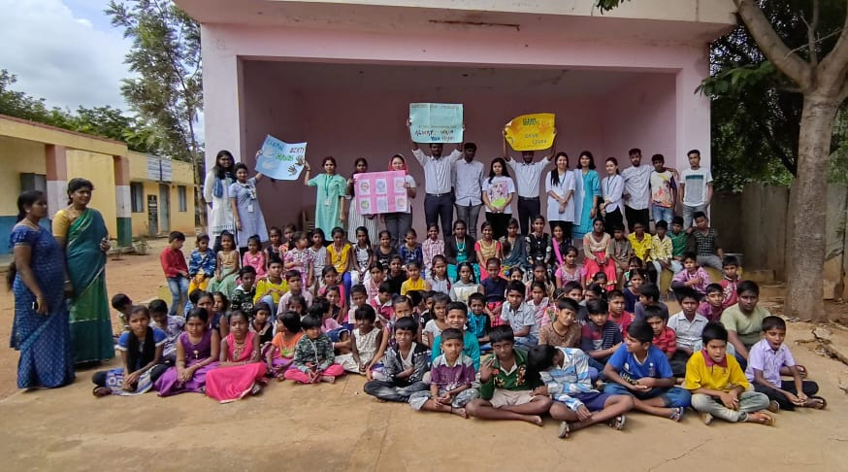
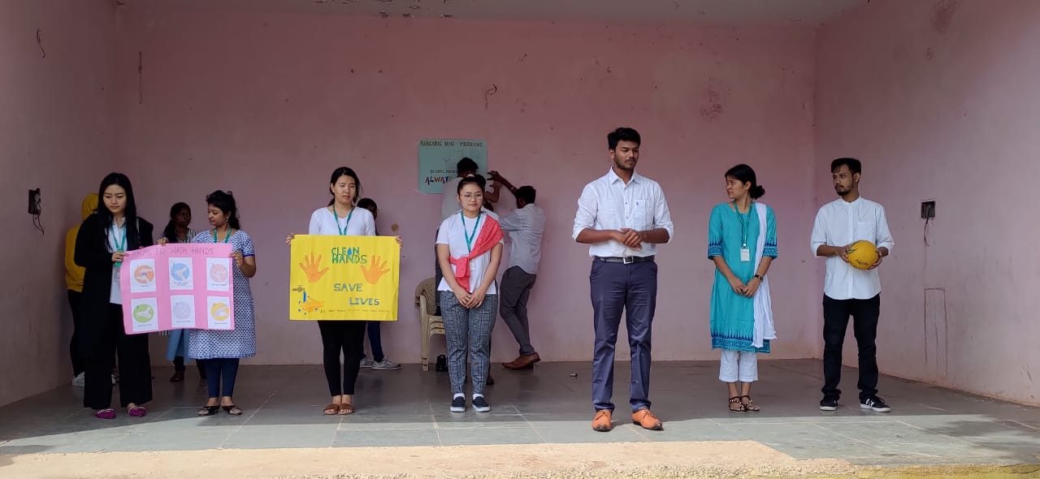
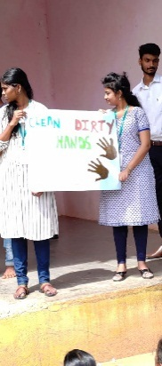
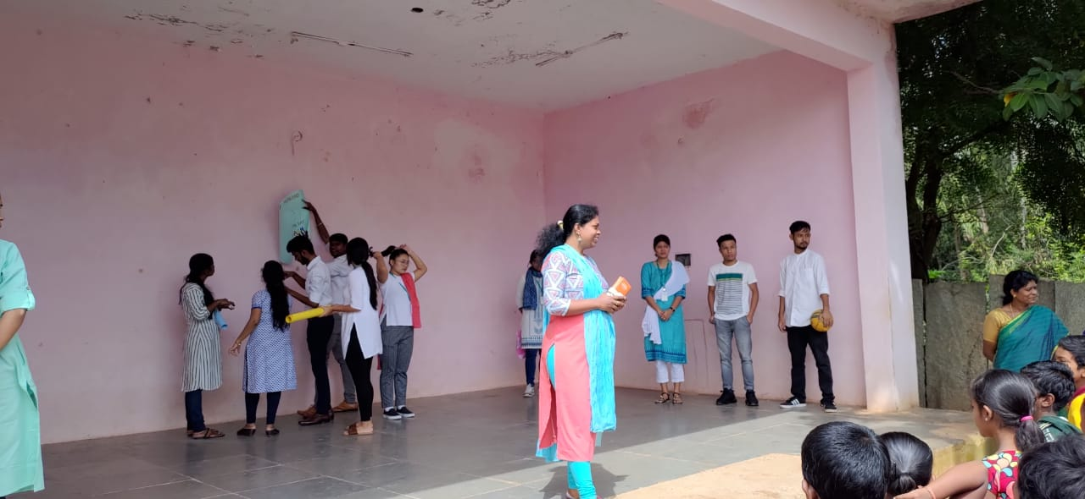

WORLD TOILET DAY
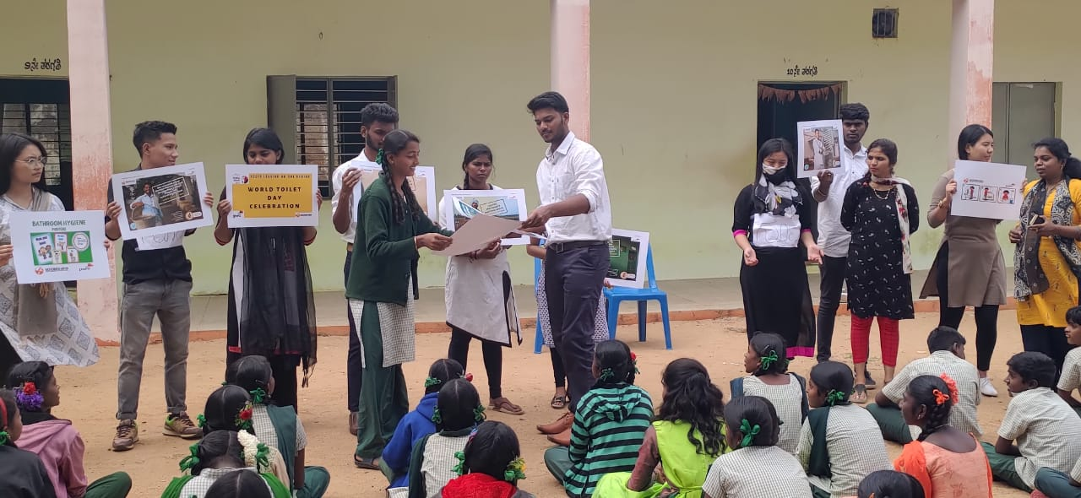
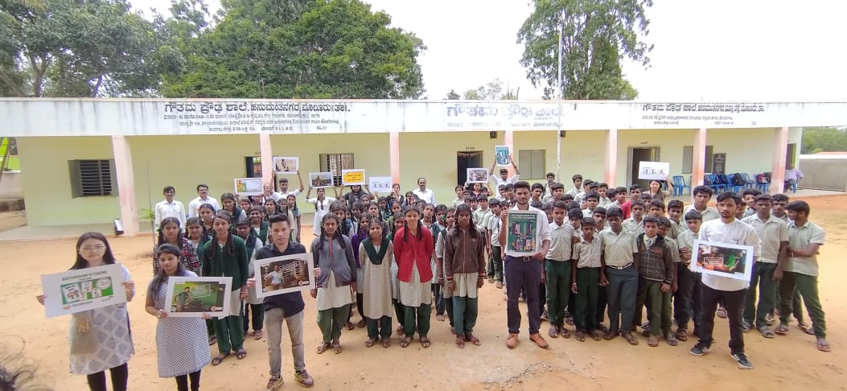

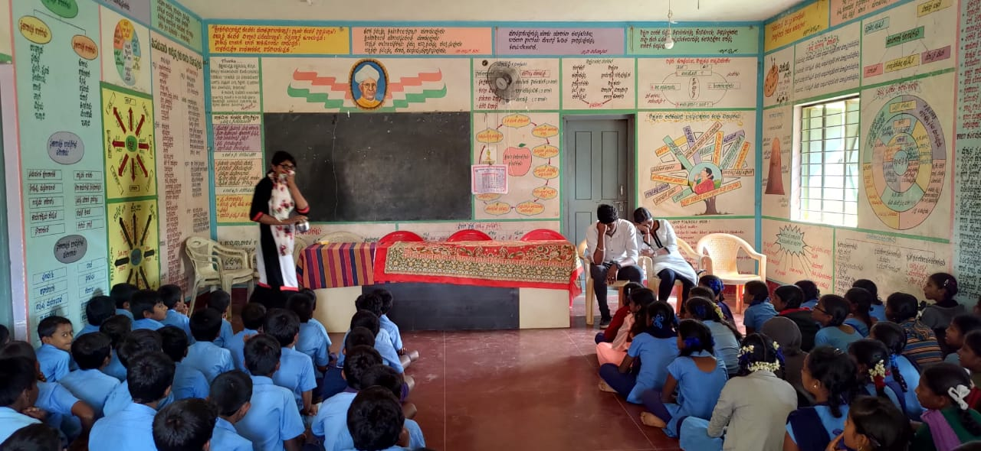
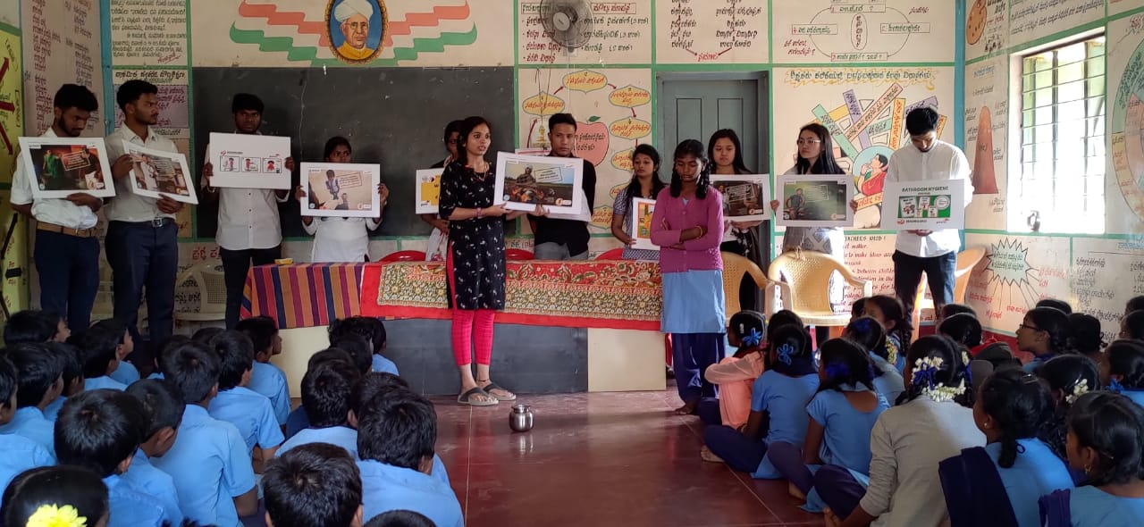

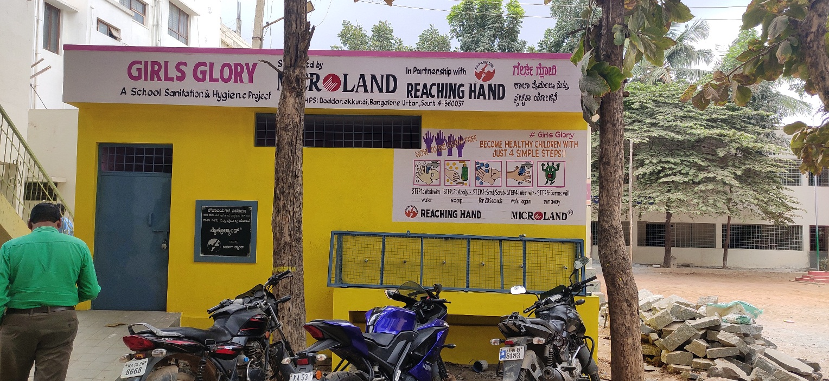
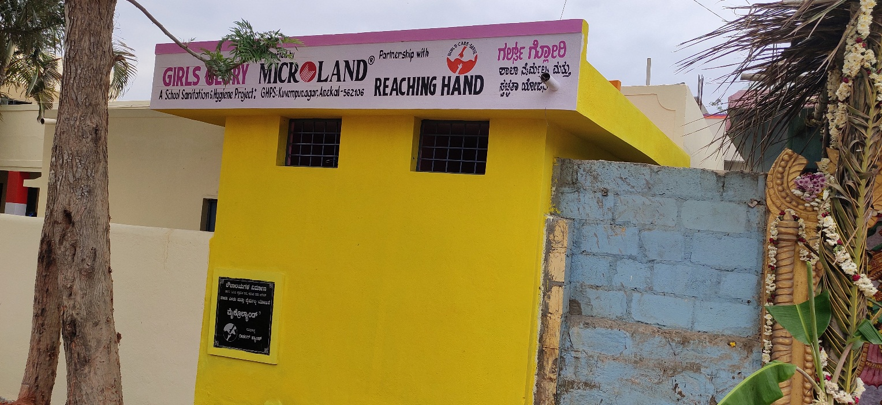
TOILET UNITS CONSTRUCTED
