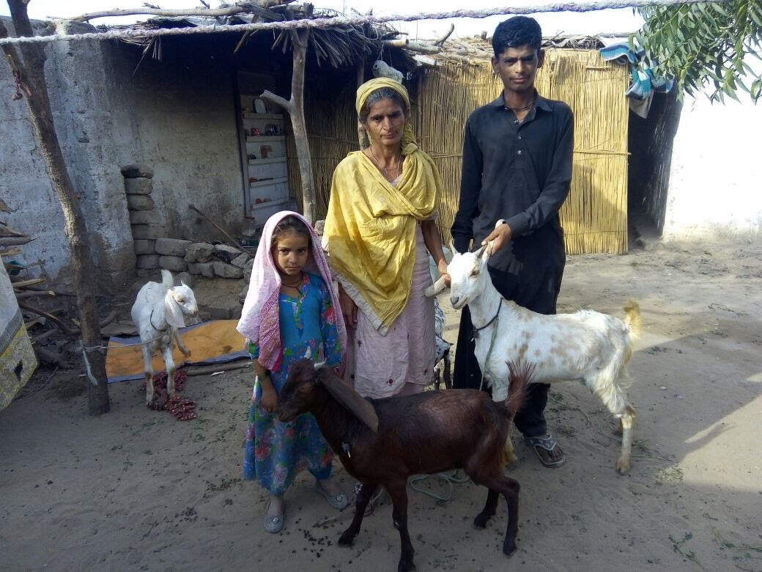From Poverty to Prosperity

Photo: Latifha with her productive assets, goats

Latifah Sattar Dino, a 48 years old women, with a family of two sons and two daughters, lives in a village - Bilal Nagar Dhabeji, near Babay ki Market. Her husband, Sattar Dino stays on daily wages, and unemployed when work is not available. The family’s basic needs are not being met. This is a common problem in Pakistan, as household income in these parts is generally dependent upon the male members of the household, while the women are required to stay at home and take care of the children and elderly.

Consequently, Latifah joined IET’s Livelihoods and Training Program to help her family escape poverty and help them attain basic human needs. The program offers micro-loans and grants to villagers who display entrepreneurial skills and have viable business propositions as well as training for new skills and skill enhancement. Upon finishing her enterprise development training, she displayed the urge to start her own business of dairy production, to which Indus Earth Trust supplied her with a grant of four goats at the cost of 30,000 Pakistani rupees (USD 230).

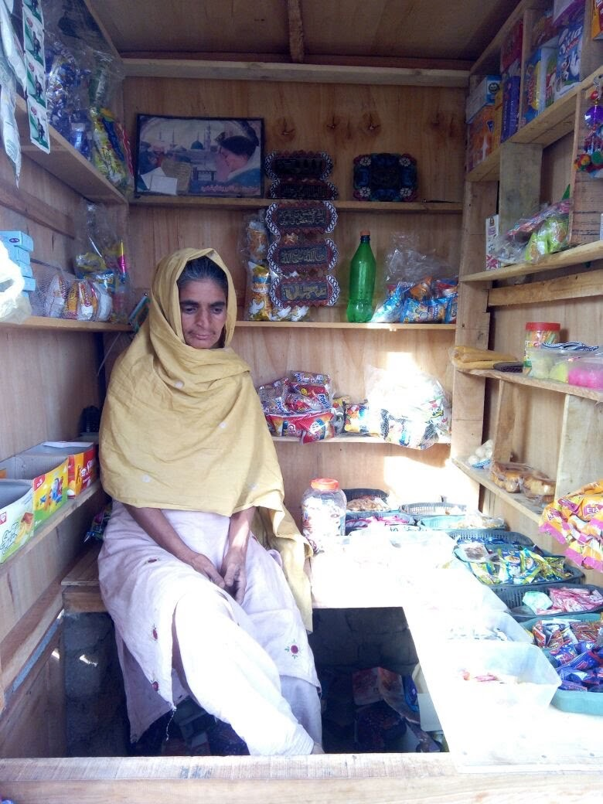In just a couple of years those goats turned into 14! She sold some of them for profit and kept the rest for dairy production. She produced the milk for subsistence at first, giving her children an added support of nutrition, but then started selling the excess for profit.

Almost a year later, she was able to borrow 50,000 rupees and open up her own shop. This shop not only now sells her extra produce but also a range of other products, that were not available to the village previously.

Now she runs the shop with the help of her younger son where she is able to make a profit of at least 300-400 rupees a day which helps keep her family from falling back into poverty.

She has become the main supporter of her family and her husband, and is a well-settled woman in Bilal Nagar Dhabeji.

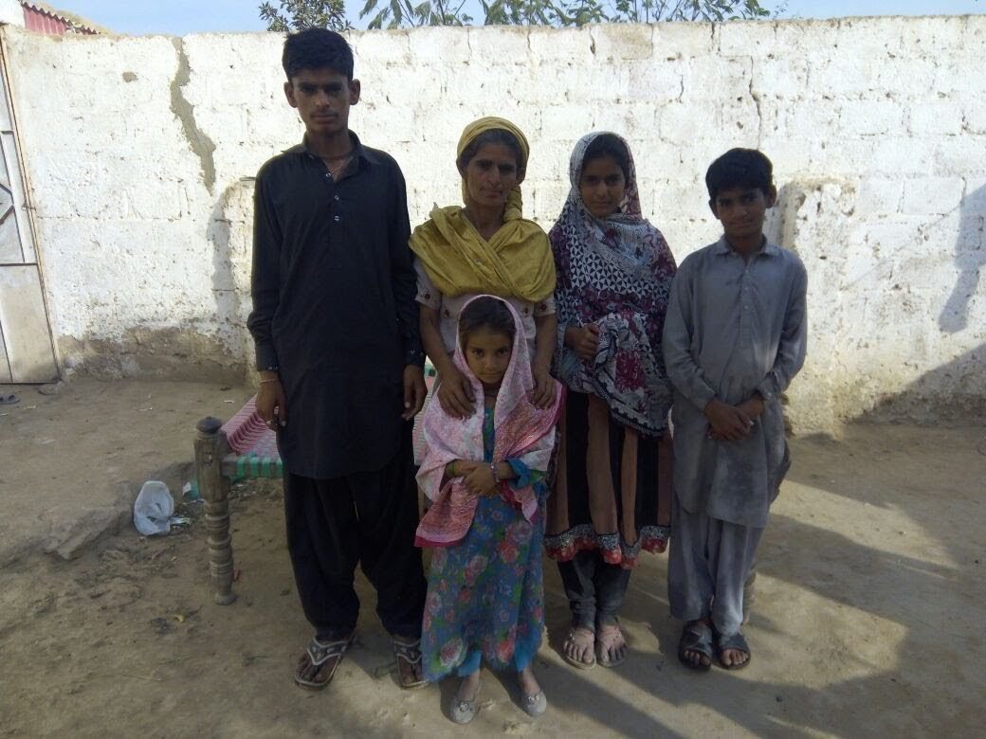By diversifying her skill sets, Latifah’s family and husband are better prepared for future events and have a larger income coming in to depend on. IET believes that from a long-term standpoint, such trainings are necessary for sustaining the future prosperity of these communities, since many of the skills will be passed onto future generations.

Photo: Latifa at her newly acquired general shop

Photo: Latifah and her children