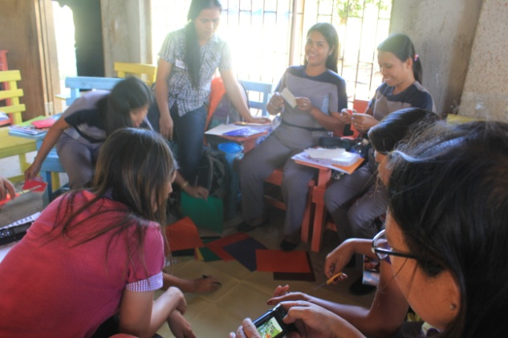 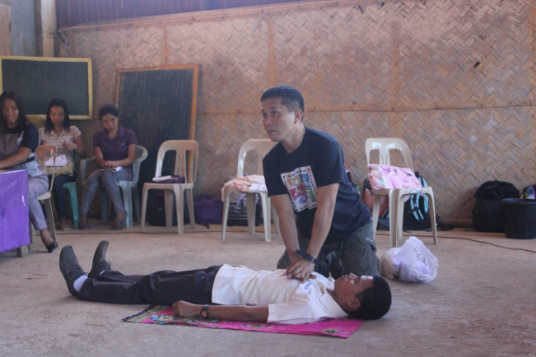

The teachers’ role in the classroom is more proactive. She/he assumes the role of a facilitator of knowledge; allowing the students to create their own learning.

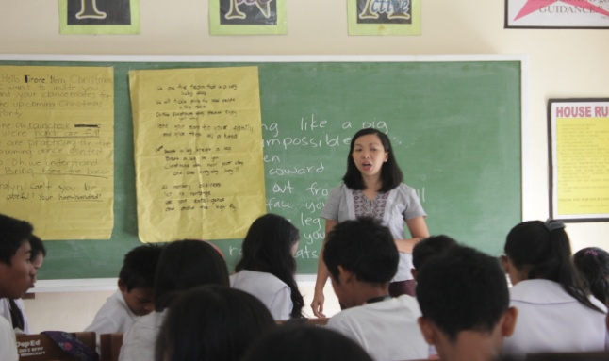 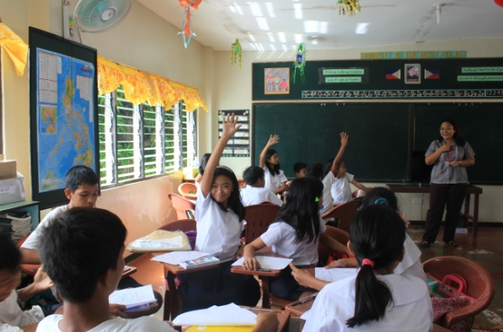

The 3 day training enriched the teachers’ knowledge on enhanced teaching strategies that are useful in the K to 12 curriculum. All modules are activity-based and put emphasis on collaborative learning. The training is anchored on the theme of disaster risk reduction and management.

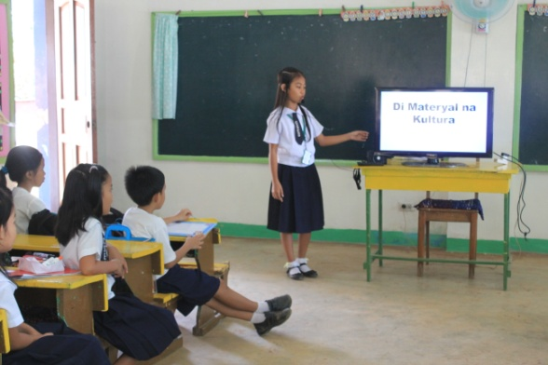

 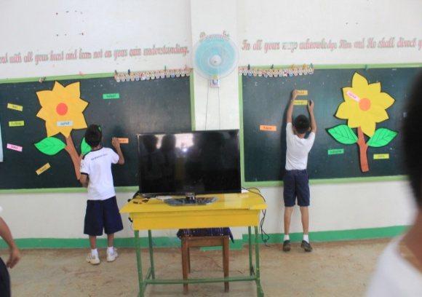

The materials given to the schools may be used to introduce a lesson, enrich students’ learning and for evaluation and assessment.