MOUNTAINS OF HOPE CHILDRENS MINISTRIES

Date: 23rd May 2014

From: James Malinga

To: District probation officer

Cc: DHO

Subject: Training report on reduction of teenage pregnancies in Mpigi

Overall goal: This project is aimed at empowering young girls in their choices and create a safe community that promotes parents and guardians to support young girls through healthy discussion of these topics.
Progress towards goal: Mountains of Hope organized a two days training workshop on 8th and 9th May 2014.The training was carried out by the Mpigi District Health Officer Dr. Ruth Nassanga who covered topics on sexual reproductive health, sex, sexuality, sexual rights,Adolescence,pregnancy prevention, unsafe abortion, breast cancer, STI/HIV/AIDS prevention and self-esteem development, together with the District Health trainer Sister Loy Kazinda who covered topics on reproductive health, psychological changes, hygiene, signs of pregnancy, life skills and harmful traditional practices to abortion.
The first phase of the project targeted one village called Kafumu which according to our research has high rates of teenage pregnancies, as a result we trained 02 primary school teachers, 04 school girls (02from Primary school, 02 from Secondary school), 02 female guardians, 01 male guardian and 01 Local council leader.
The training topics included Sexual Reproductive Health, Sexual Rights, and Pregnancy Prevention.
The participants expectations as noted at the beginning of the training were all met, for example Teddy a primary school pupil who attended the training had expected to know how to avoid pregnancy at a teen age, this topic was covered where by the y were able to learn the following:
Abstain from sex, visit a youth center to get information on reproductive health, avoid situations that may lead you to getting pregnancy, have values and goals in life and have life skills
Group discussions encouraged a high level participation during the training
At the end of the training the participants developed a work plan to follow while training others on the same, beginning June 2014 all participants will move around the community and schools disseminating information on dangers of teenage pregnancies.
The training has improved the parent/guardian's role in their capacity to provide a supportive environment, and has provided teachers with skills to guide and protect young girls from avoiding teenage pregnancy.
The second part of the programme is focusing on carrying out community sensitizations in Kafumu village beginning June 2014, the trained guardians and community leaders, teachers and pupils will train others on the dangers of teenage pregnancies, we will monitor the progress by the end of December 2014, facilitate school going pupils with sanitary pads, distribution of reusable sanitary pads will radically create a world where girls can step boldly into the promise of their future. In this case, vulnerable school girls in our community will be assisted to acquire at least one sanitary pad per month (3 packets per term)
James, the project leader noted “one of the complicating factors is that adult men are frequently the fathers of children born to teenage girls” he noted that the project is now involving youth in needs assessment, programme design, implementation and evaluation. The project is also coordinating messages to target both young women and men like in sexual communication, assertiveness and refusal skills
The workshop was closed by the Mpigi District Child Protection and Family Unit officer Monica Nawegulo who in her remarks thanked Mountains of Hope for organizing this kind of workshop in the community, she also noted “in April 2014, 11 cases of teenage pregnancies were reported to my office of children aged 16, 17, 18 and all responsible men denied the pregnancies” she pledged to work with Mountains of Hope to sensitize communities on the same.
Pictorial
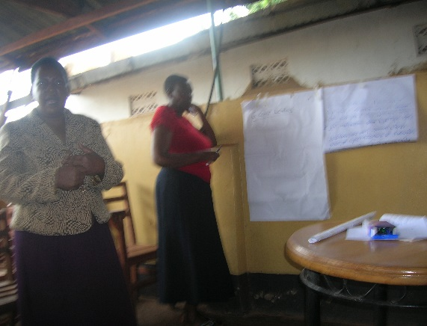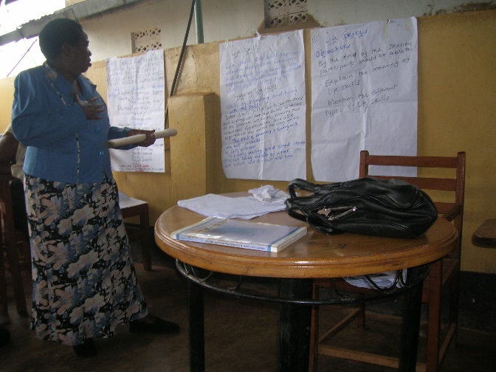
Sister Loy facilitating
Dr. Ruth Nassanga facilitating

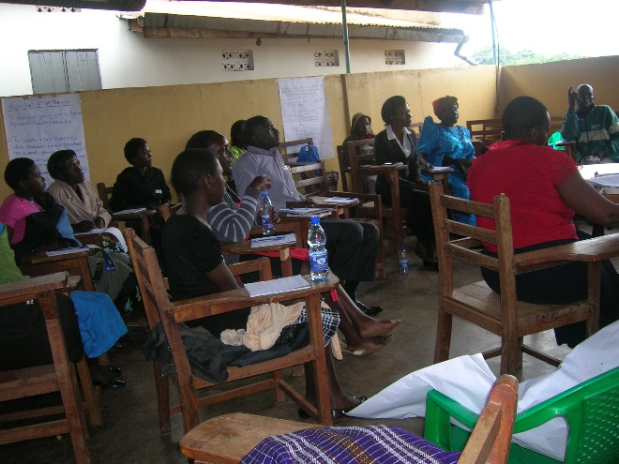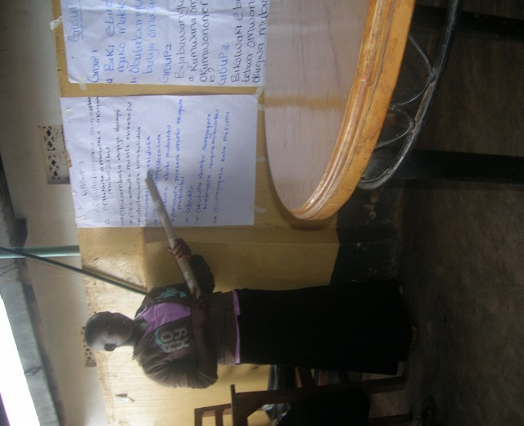
A pupil presenting during group discussions
Across section of some of the trainees

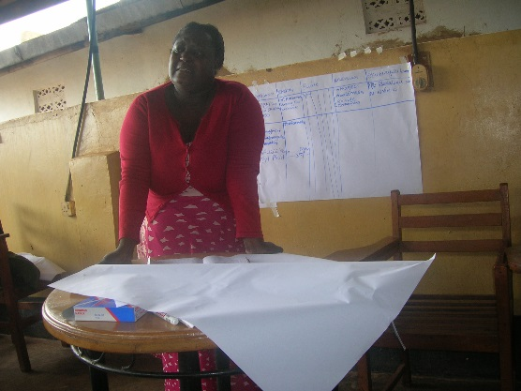
Mpigi police Child protection officer, Monica Nawegulo

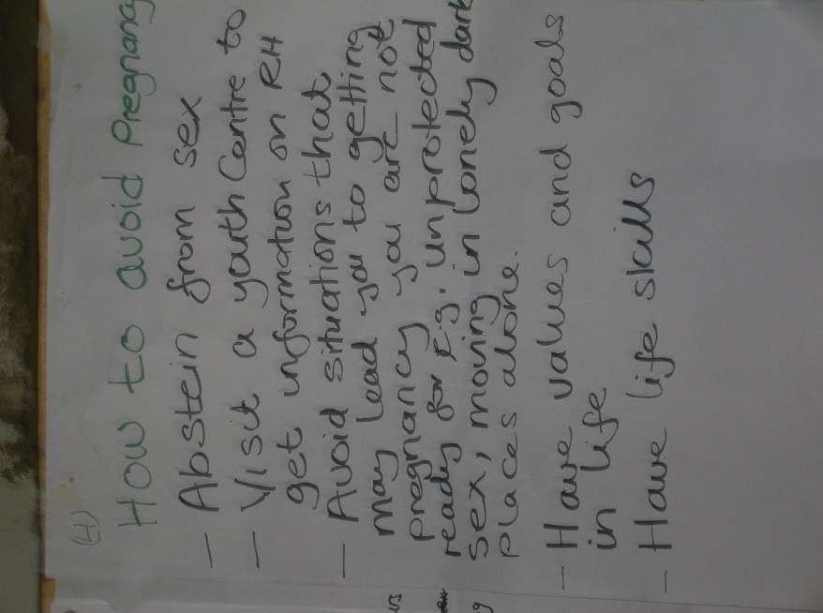
Part of the notes

