Shehnaz Baji: A New Breath of Life

“Why should I take the health insurance when I and my husband have been healthy all these years? I think the idea of paying this money for something that is not going to be used is totally absurd”
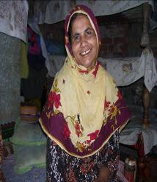

OR so thought Shehnaz Baji. A resident of Green Town, Shehnaz and her husband were signed up for the mandatory health insurance policy that was initiated by Kashf Foundation in November 2007. She vehemently opposed the decision and stated that she did not have enough money to meet household needs let alone pay for the health insurance premium. Since the insurance was a requirement for taking on the loan, she and her center members took it but were not convinced.

Few days later, Shehnaz Baji’s husband Mr. Riaz developed breathing problems. She took her husband to a local clinic but his condition did not improve. Since he was the only earning source in the household, their economic situation began to suffer as their entire savings were used up for his treatment. While on one hand, Shehnaz Baji was concerned about her husband’s health, she was also alarmed by the state of household affairs where it was increasing becoming difficult for them to carry on. Upon informing the loan officer about her plight, the loan officer told her that she could use her health insurance to get her husband treated at the prescribed hospitals. Shehnaz frantically called on the 24/7 Medical Hotline set up in collaboration with First Micro Insurance Agency (FMiA) where Dr. Nousheen instructed her to take Riaz to Ittefaq Hospital.

At the hospital her husband was diagnosed with Bilateral Nasal Polyps; an overgrowth of tissue in the nose glands which required nasal surgery. He was operated and the operation went very well and for some time after the operation, the doctor stayed with Shehnaz Baji to give her moral support.
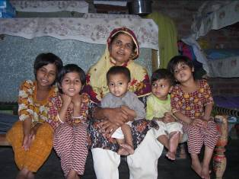
“I would have never bought the insurance policy of my own accord had Kashf not forced it upon me. I now truly realize the value and proposition of the health insurance and I am thankful to Kashf to have thought about us”, declared Shehnaz.

Less than 20% of the people in Pakistan are covered through some form of insurance mechanisms and the population at large remains unprotected against medical contingencies. Health care is increasingly becoming more and more difficult for a family like Shehnaz to afford. As a result they tend to delay their medical expenditures or resort to medical quacks for temporary relief often leading to chronic illnesses and even mortality. The health insurance product has been specifically designed by Kashf Foundation to give these very people a fighting chance in stabilizing their lives and help protect themselves for a better tomorrow

