VIDYACHETANA (A project of Hindu Seva Prathisthana)
July 2015
Vidyachetana – Computer labs Program Overview

Table of Content
Computer Labs Program overview: 3
Activity Details: 4
Opened two Computer labs at Tribal areas of Karnataka 4
Opening of two computer labs at economically backward areas of Tumkur district 7
Tharuru computer Lab: 7
Kallembella Computer Lab: 7
Testimonials: 8
Shivanna – Computer Lab teacher 8
Priya P – Student 9
Purnima C – Student 9
Video Testimonial: http://youtu.be/oDaZ0jcSEMw 9
Major Challenges: 13

Computer Labs Program overview:
On August 22, 2014, two computer labs in Kallambella and Tharuru villages near Tumkur were inaugurated. The computer centers were inaugurated by Sri, Dharmendra, Director, IT at CISCO. CISCO Sambhrama team also graced the occasion. Vidyachetana is determined to enable children with the knowledge of basic computers. At the centers, the enthusiastic group of children was eager to try their hands on the computers. Around 80 students in 12 batches have been benefited from these centers till date. They are trained on the basic use of computers and some tools such as MSWord, MSExcel, Notepad, Wordpad, and MS Office. In the future, these centers will be equipped to provide training on Desktop publishing (DTP) that includes Photoshop, Pagemaker, and Corel Draw.
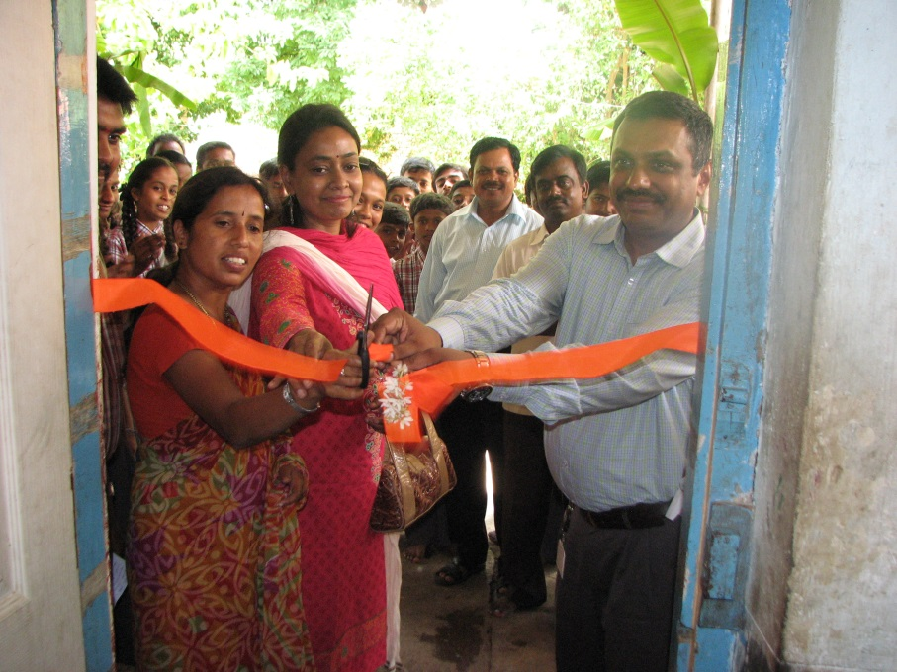

Activity Details:

Opened two Computer labs at Tribal areas of Karnataka

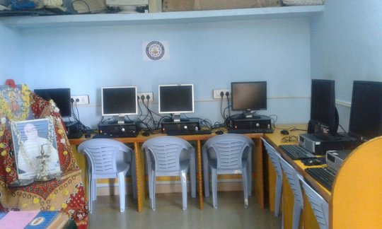

Back Ground:
Uttarakannda district is home to many indigenous tribal communities among others, including the Sidhis, Goulis, Kunabis Gondas and Hallakki.
The Halakki people are scattered across several Taluks of Uttara Kannada district namely Karwar, Ankola, Kumta, Gokarna and Honnavar. Their villages are mostly located on either side of the National Highway 17 that cuts through the above mentioned places and also on strips of land adjacent to the waters of the Arabian Sea.
Earlier the Halakkis resided at the foothills of the Western Ghats and were known to practice a system of agriculture similar to that of the Thodas of the Nilgiris. They also depended on forest produce and were know to hunt.
More info: http://www.kamat.com/kalranga/people/halakki.htm
Map: http://goo.gl/BrWm0d

Kumta:
No of Computers: 5
No of Students:12
Location: Ratnakara Vanavasi Vidyarthi Nilaya, Kumta
Course Content: Basics of Computers(Windows, MS Office, Internet)
Further Requirements: Internet Connection and Printer and few more work stations
The computer lab in Kumta is set up in Ratnakara Vanavasi Vidyarthi Nilaya, Kumta to provide basic knowledge of computers to the students staying in the hostel. The students are studying in 7th, 8th and 9th standards. Total of 12 students are availing the computer lab facility.
The courses offered are Basics of Computers, introduction to using Windows operating system, introduction to MS Office tools and use of Internet. There are five computers available at the centre. This is first ever computer lab offering computer education students from tribes.
Dandeli:
No of Computer: 5
No of Students: 39
Location: Rukmani Balika Nilaya, Dandeli
Course Content: Basics of Computers(Windows, MS Office, Internet)
The computer lab in Dandeli serves nearly 40 students at Rukmani Balaka Nilaya. The students are studying in Higher primary and High schools. The courses offered are Introduction to Windows OS, introduction to MS Office, and use of internet.

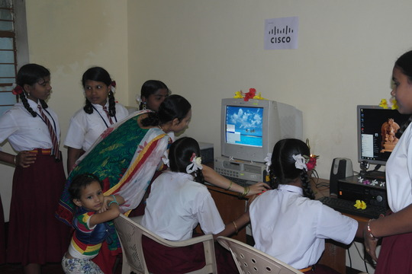
Lab pictures at Kumta
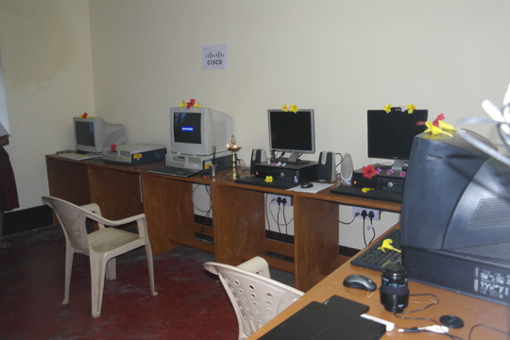
Lab pictures at Dandeli

Opening of two computer labs at economically backward areas of Tumkur district

Tharuru computer Lab:
41 children are attending sessions at the computer lab regularly. Every day 4 batches are held, first batch between 7.30 and 10 m, and second batch between 4.30 and 6.30 pm.
The batches include the children studying in 8th, 9th and 10th grade.
8th Grade : 13 9th Grade :11 10th Grade : 17
Topics Covered
Fundamentals of computers , Introduction to tools, MS word, MS Paint, Note pad,
Parts of computer & its uses, basics of Computer hardware and Baraha.
Courses to begin:
MS Excel, MS Power point, Nudi software, Email, Google apps, and Basics of internet.
All these 4 batches will be completing their first course in Computer Fundamental by end of October and 22 children from 5th grade to 7th grade have already registered for next batches.

Upcoming Courses:
Other course that will be offered include Tally 7.2 course by November 2nd week. Planning is in progress.
Key Observations:
This computer lab is functioning regularly with good attendance with community involvement. Lot of youngsters & local villagers are gaining knowledge of computers by spending few hours daily. The attendees who are benefitted from this lab are spreading good message about computer lab across the village which has resulted in more and more children enrolling for new batches. Overall, lab seems to be getting popular across the community & training on new course for teacher is needed.

Kallembella Computer Lab:
44 Children are regular to this Computer lab. The children from 5th grade to 3rd B.com are regularly attending the sessions in 8 batches every day. Each batch contains 5 children as per the computer availability and the duration of each batch is 1 hour. The batches starts at 8.30 am and runs till 6.30 pm
5th Grade:4 6th Grade :8 7th Grade:2 8th Grade:4 PUC:14 ITI :2 Bcom :5 OTHERS :3
Topics Covered
Fundamentals of computers , introduction to tools, MS word, MS Paint, Notepad,parts of computer & its uses, Basics of computer hardware, and Baraha.
Courses to begin:
MS Excel, MS Power point, Nudi software , Email, Google apps, Basics of internet.
Out of 8 batches, students in 4 batches will complete the courses by October and remaining 4 will complete by November 1st week.
Upcoming Courses:
Computer lab teacher are asking us to give training on DTP and Tally. We are planning to organize training to teachers.
Key Observations:
This Computer lab is functioning regularly, however there is an issue with regular power supply. Due to this reason, many times children come to lab and get disappointed. This centre is located very close to NH4 highway and has many Government Colleges and schools. More than 30 children and youths are enrolled into new batches. As our centre offers courses at free of cost, majority of the youngster on daily basis are coming to our centre and many are enrolling for new batches. People working at the Tahashildar’s office next to our computer lab are encouraging the local villagers to make use of the opportunity provided by us at the computer lab. By this word of mouth, Kallembella centre has received good publicity and has resulted in more enrolment for next batches.
Key Challenges:
Power fluctuations
Internet facility
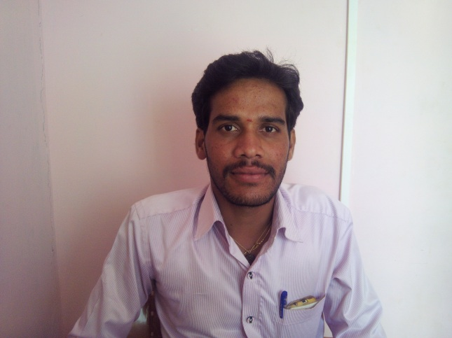
Reporting

Testimonials:

Shivanna – Computer Lab teacher
Kallambella
Vidyachetana in collaboration with CISCO in Kallambella is like bringing light into darkness. In the technological world, knowledge of computers is as important as food for people. Because of this lab, children in the rural area who from economically weaker section are benefitted with free computer education which otherwise would be impossible for people from these regions. Thanks to Vidyachetana and CISCO for setting up the lab here. We request for continued service from Vidyachetana and CISCO in brightening the life of these children.

Priya P – Student
Bhoopasandra
I PUC
Sponsored by Vidyachetana, students in the rural area we are given an opportunity to learn computers. Students here like me are unable to take up computer courses paying hefty fee. I had no knowledge about computers before joining this course. With the course offered here, I learnt how to use computers. I hope in the future, with this knowledge of computers I will be able to study subjects related to computers better. The teacher, Mr. Shivanna teaches computers very interestingly and makes it easy to understand.

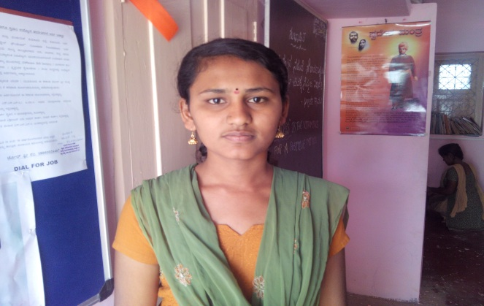

Purnima C – Student
II BCom
I stay in Kallambella. Before joining the computer course offered by CISCO through Vidyachetana, I had no knowledge of computers. I am grateful to the organization for setting up the computer lab here and now I am able to learn how to use computers. By offering free courses, the organization is not only providing education to people like us, it is in turn helping in the overall development of rural areas. We thank the organization for setting up computer lab for us. I request you to continue providing such opportunities in rural areas.

Video Testimonial: http://youtu.be/oDaZ0jcSEMw
Pictures:
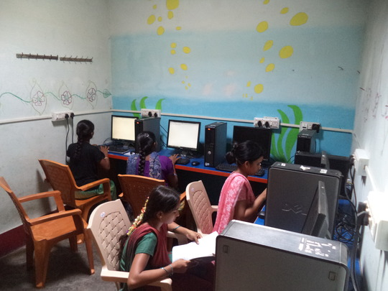
Kallambella Lab

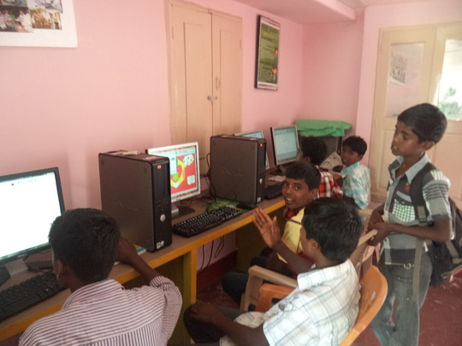
Taruru Lab

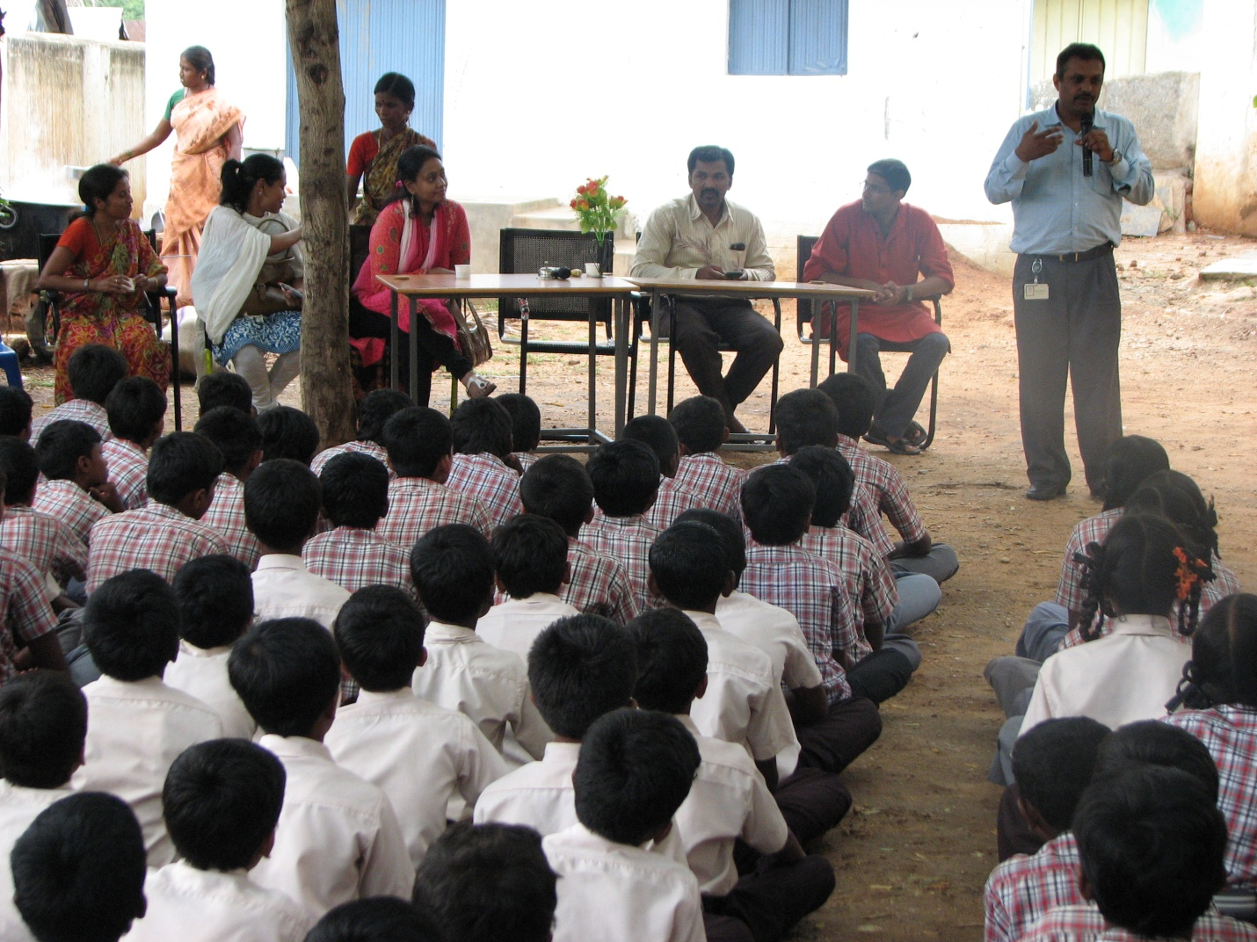

Inaugural Address by Dharmendra during Inauguration.

Annual Summary for Karur and Kallambella :

Batch | Tarur | Kallambella
Batch 1 | 20 | 43
Batch 2 | 19 | 22
Batch 3 | 13 | 25
Total | 52 | 90
Grand Total | 142

Out of 142, 29 Youth are trained and 3 have found jobs.

Major Challenges:
1. Due to non availability of Electricity 2 month’s course is taking 4 months to complete.
2. Large number of students seek admission for basic computer course that costs Rs.3000 outside but due to power shortage not able to use full capacity of lab.
3. Youth want certificate course and placement help. For that we need to hire full time teachers and placement consultant.

