promote & provide school sanitation, water & better health to the rural poor

PROGRAM PROPOSAL

PROVISION OF CLEAN WATER, HYGIENIC SANITATION FACILITIES AND SERVICES TO NEEDY AND POOR RURAL PRIMARY SCHOOLS IN NYAMIRA DISTRICT, WESTERN KENYA

CONTACT PERSONS:

EVANS MISATI WILLIAM MARWANGA
EXECUTIVE DIRECTOR PROGRAMS MANAGER

Utumishi Cooperative House-4th Floor, Mamlaka Road, off Nyerere Road
P.O Box 16923 GPO 00100 NAIROBI, KENYA. Tel: +254-20-2734261, +254-722-753173 Fax +254-20-2734257
E-Mail: info@healthandwater.org Website: www.healthandwater.org

1. EXECUTIVE SUMMARY

Health and Water Foundation aims at contributing to improving the sanitation situation in primary schools in Kenya particularly schools in Nyamira District of Nyanza Province. The overall objective of this initiative is to enhance the learning environment for the pupils especially the girl child who are hard hit due to lack of an enabling school environment. The poor quality of education in this district is partly attributed to poor sanitation within the schools that contribute to absenteeism either as a result of water and sanitation related diseases and lack of privacy on the part of girls. Statistics from the some the schools show that the drop out rate has gone as high as 23.5% per year. The unprecedented influx of children into primary schools arising from the bold move by the Kenyan government to implement the free primary education compounded the sanitation situation in schools. The available sanitation facilities could not adequately serve the children. The government is still unable to provide enough funds for the construction of proper sanitation and hygiene facilities. The school administrations have been met with the difficulty of overstretching the sanitation and hygiene facilities to high enrolment rate.

This program will cover fifty (50) schools at the end of 3 years, but implementation is through four (4) school lot projects hence 13 projects to cover the program. Each project (4 schools) supports the construction of 4 toilets apiece for girls and 4 for boys in each school. The criterion of selection of these schools was based on the level of need. In addition the project will carry out hygiene promotion activities geared at engendering behaviour change on water and sanitation hygiene in the interest of maximising on benefits from water and sanitation facilities. This software component essentially targets achieving a higher level of sustainability of the objectives of the project. Menstruation management by will girls will be given due attention to equip them with skills and knowledge on proper and hygienic ways of conducting themselves during these periods. The current practice amongst the girls renders them to ridicule and embarrassment and as a coping mechanism most of them opt to stay away from schools until the menstruation is over.

HWF aims at solving the young girls’ sanitation problems by providing toilets, wash rooms, safe water, sanitary towels and capacity building on safety and hygiene for the affected girls, especially in Nyamira district. Each project aims at solving the most immediate needs, and also testing the viability of the project before we embark on a wider Nyamira District as a whole until 50 schools are covered at end of the 3 year program. Each school takes an average of 3 months and is estimated to cost US$ 21,705. HWF and the local community pledges to contribute a total of US$1,829 per school. We request donations to fund the difference of US $ 19,877 per school for most needy schools. A donor can decide to support one or more schools.
2. BACKGROUND AND GENERAL ENVIRONMENT

2.1 Nyamira District
Nyamira is one of the 12 districts that make up Nyanza Province. It covers an area of 896.4 km² and is sub-divided into seven administrative divisions, Nyamira, Nyamaiya, Nyamusi, Borabu, Ekerenyo, Manga and Rigoma. The district has four local authorities, namely Nyamira Town Council, Nyamira County Council, Keroka Town Council, and Nyansiongo Town Council.
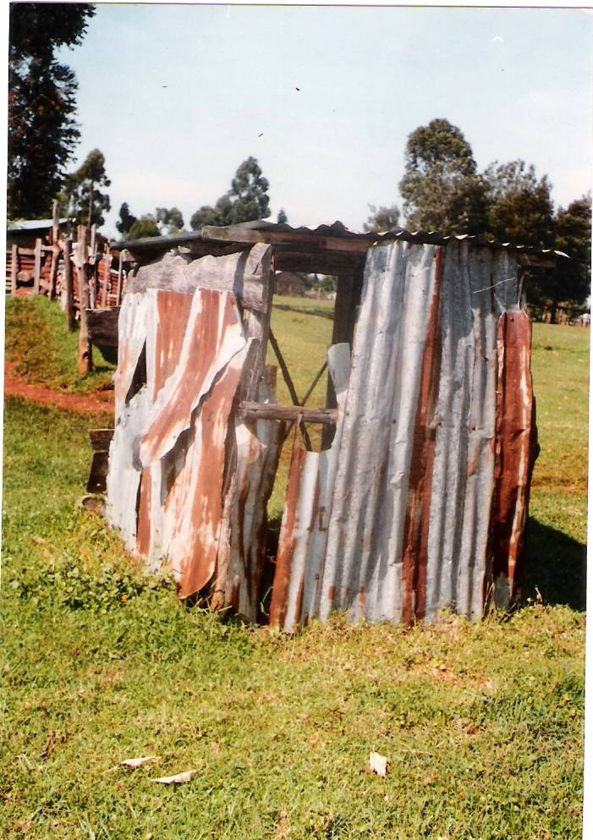
Pupil’s toilet in Nyaisa Day
Primary school-Nyamira

The topography of the district is mostly hilly with a series of ridges. The hilly nature of the district makes the construction and maintenance of roads costly. The district has a bi-modal pattern of rainfall that is well distributed, reliable and adequate for a variety of crops. Annual rainfall ranges between 1200 mm – 2100 mm per annum. The long rains season is from December to June and the short rains season from July to November, with no distinct dry spell separating them. Although the vegetation in the district is evergreen, there are no gazetted forests.

The district had a population density of 556 persons per km² in 1999 and this is projected to increase to 690 persons per km² in 2008. This high population density has led to the subdivision of land into small uneconomical plots, mainly used for subsistence farming and the construction of residential houses.

2.2 Problems Facing the District

2.2.1 Poverty
From the economic survey report by the Ministry of planning, absolute poverty in the district, estimated to be 62.3%, is defined as inability by the poor to access basic needs such as food, clothing, shelter and other socio-economic activities such as education and health facilities. From Economic survey report by the Ministry of Planning and National development, the following are regarded as the main reasons for poverty in the district.

- Impassable roads.
- Small land parcels.
- Inadequate health services.
- Inaccessibility to credit facilities.
- Inadequate energy supply.
- Insecurity.

- Agriculture decline, leading to low agricultural and livestock production, resulting from low rates of adoption of new technologies and poor marketing systems.

2.2.2 HIV/AIDS
In Nyamira, although people acknowledge the existence of the disease, it is difficult to establish the exact figure of those infected by HIV/AIDS, as they do not declare their status. This is exacerbated by lack of testing equipment in the district. However the prevalence rate is estimated to be 17%, which is considerably above the national rate of 13.5%. As a result, a huge increase in health expenditure, a rising dependency ratio and dropping productivity levels have contributed to increasing poverty. Many AIDS orphans lack the bare necessities for survival and contribute to high absenteeism levels in schools.

2.2.3 Gender Inequality
A Participatory Poverty Assessment study conducted in the district in 2001 revealed that the majority of women, who comprise 52% of the population, engage in productive work, while men spent most of their time in unproductive activities. Women work on the farms but it is the men who enjoy the fruits. Although women are responsible for the bulk of agricultural activities, they have least access to the means of production, receive the lowest wages, and know least about how to improve the productivity of land with modern inputs and technology. Migration of men to urban centers has increased the number of women who have to carry the full burden of earning income and managing households. The worst forms of poverty persist because of lack of high social status, education and opportunities for women, which lead to early marriages and pregnancies. Lack of basic health care facilities in turn leads to high and maternal mortality rates. Domestic violence commonly involves wife battering, sexual abuse of girl children, rape, sexual harassment and intimidation at work and in educational institutions, forced prostitution, among others. Women comprise a very small proportion of all persons holding elective office at the location, division and district level. Increased awareness of gender issues is vital to any efforts to alleviate poverty and achieve sustainable development. The first step towards women empowerment is to boost their confidence amongst fellow male counterpart. Convenient sanitation facilities for girls shall enable them participate in all activities without the worry of being caught unaware by their menstruation.

2.2.4 Disaster Management
Tragedies caused by lightening, especially in education institutions, have been a problem in recent years. The absence of lightening arresters causes worry to school children during rain seasons. HWF got this information from the ground due to plea by the school administrations’ call for the installation of lightening arresters. A development plan from the Ministry of Planning rates Nyamira district the most affected by the lightening.

2.2.5 Environmental Conservation
The vegetation cover in the entire district is dominated by the Eucalyptus tree species. This species is known for its high water consumption capacity. This has had adverse affects on stream volumes, especially during dry spells. Nevertheless, due to its fast growth rate it is preferred to other species of trees due to the general dependence on wood fuel for cooking.

2.2.6 Poor Sanitation in schools:
This problem is almost throughout the whole of Nyanza province. Lack of proper waste disposal facilities e.g. toilets, lack of clean water and the technical know how on sanitation issues has lead to many problems:

Chronic diseases:
Cholera outbreak is so common in this part of the country. Waste disposal systems are so poor that it makes the communities very much vulnerable to sanitation related diseases. In deep rural communities, toilets are unheard of. The bushes around schools serve as places for long calls encouraging the spread of sanitation diseases such as cholera and typhoid.

Lack of privacy for young girls
Young girls and women often fall pray to rapists, who take advantage of the lack of toilets to peep at the girls/women when they go to relieve themselves in the bushes. The schools may have toilets, but are partially covered such that they expose the girls to the passers-by. This induces rapists to develop interests in the young girls when they see them in the toilets.

Absenteeism for young girls from school
The poor toilet or the absence of it in schools forces the ladies to absent themselves from school during their menstruation.

3. SITUATION OF WATER AND SANITATION IN SCHOOLS IN NYAMIRA DISTRICT

- An average of 70 to 400 school children per one functional toilet compared to the recommended 1:25 for girls and 1:30 for boys with urinals.
- A significant number of toilets are in disrepair and not in use.
- There are long queues at toilet facilities during the class breaks
- In some schools, existing latrines were full.
- Most schools has badly built toilets, with risks of subsiding
- Cases of pupils having fallen in pit latrines were reported in some schools
- No school has got the hand washing facility.
- Lack of privacy for girls at all pit latrines and they were exposed to passers-by on feeder roads
- The toilet facilities are dirty and unhygienic and thus very risky environment.

3.1 The Problem to be addressed by the Proposed Project
In most rural areas of Kenya enrolment of girls in primary school is lower than that of boys and efforts to achieve universal primary education are often targeted at ensuring that parents send their girls to school. Women’s groups and NGOs such as FAWE focus on sensitization of rural parents on the importance of educating girls and building awareness of the benefits that accrue to the whole community from educating girls. However, performance in examinations such as the Kenya Certificate of Primary Education is relatively worse for girls than that for boys. While mean grades in most subjects are similar, there are fewer girls in A and B grades and more girls in D and E grades. A contributory factor in this poor performance is the high absentee rate for girls, especially after they have reached puberty. Studies have shown that the girls need more privacy, more attention and more counseling at puberty. HWF aims at improving the privacy and sanitation situation for girls at puberty to reduce the absentee/drop-out rate in girls.

4. PROJECT RATIONALE (Literature review)

4.1 Impact of Poor Sanitation Facilities on Girls’ Education
The Female Education in Mathematics and Science in Africa (FEMSA) project carried out detailed school studies during 1996/97 in four countries, Cameroon, Ghana, Tanzania and Uganda, on the status of girls’ participation and performance in Science, Mathematics and Technology (SMT) subjects and produced comprehensive country profiles for these four countries. Subsequently, during 1998, in eight new countries (Burkina Faso, Kenya, Malawi, Mali, Mozambique, Senegal, Swaziland and Zambia) smaller studies corroborated the findings of these large-scale studies. The following are some of the relevant findings.
- Poor toilet and sanitation facilities for girls, especially adolescent girls, were a major contributory factor in encouraging absenteeism among girls. Lack of privacy in the few available toilets and subsequent harassment of girls by boys led to girls abandoning school for one week every month during their menstruation periods.
- This regular absenteeism among girls was especially damaging to the learning of SMT disciplines, which are essentially hierarchical in nature.
- Syllabuses and textbooks which adopt a one-off approach, where topics are covered and teachers move on to the next topic, rather than a cyclical approach maximizes the impact of the regular absenteeism of girls.
- In Uganda, the FEMSA project encouraged schools to construct adequate toilets for girls and this led to a dramatic reduction in girls’ absenteeism and, together with other interventions, a consequent improvement in girls’ performance in SMT subjects.
- The sensitization and awareness building activities associated with building local community support for the toilet building programme, led to closer relationships between school administrations, teachers and parents and a stronger willingness among parents to play an increased role in encouraging their girls’ education.
- The activities which were focused on improving SMT participation and performance among girls also led to more interest among boys and also enhanced the school environment to such an extent that performance in all subjects improved.

More recent studies funded by the Rockefeller Foundation in Kenya, Uganda and Zimbabwe, on the sexual maturation of girls and the management of female adolescence in schools, enlarge on these FEMSA findings and make a strong appeal for the provision of adequate sanitation facilities for girls and much more sensitive and effective building of awareness of the difficulties and problems associated with adolescent girls among teachers and the girls themselves. Life Skills, Sexual Maturation and Sanitation, What’s (not) Happening in Our Schools, is the report of the Kenya study on a research based exploration on the acquisition of basic learning competencies/life skills and issues of girls’ sexual maturation and menstrual practices, which was undertaken in Kenya, Uganda and Zimbabwe in 2000 and supported by the Rockefeller Foundation. Three reports in this overall report have important findings on the impact on adolescent learning of the process of sexual maturation, its poor management and the constraints introduced by poor sanitation in schools:

- Sexual Maturation Process and Practices by Professor Olive Muenda points out that one possible contributing factor that may lead to low access and completion rates, but which has not been seriously addressed in Kenya, is the process of sexual maturation which often takes place at primary school level for girls.
- Girls’ Participation in Primary Schools: the Impact of Institutional Management of Menstruation by Mr. Warue Kariuki, highlights the importance of effective management of menstruation and the provision of adequate support for the girls.
- Water and Sanitation Policies and Legislation: Implications for Managing Menstruation by Prof. J K Mati, points out that the state of environmental sanitation in schools has deteriorated over the years as a result of myriad factors, among them is the increased demand for education leading to congested classes without a parallel expansion of the support infrastructure, especially toilets.

4.2 Increased efficacy of the government policy on free primary education
The government policies have resulted in the increased enrolment in schools severely straining the existing sanitation facilities in schools and compounding the sanitation problems of the schools without such facilities.

However, the limited scale of many projects and lack of funds has made it impossible to address this problem adequately. HWF wants to be part of the stakeholders taking steps to accelerate and coordinate progress on water, sanitation and hygiene in schools especially in Nyamira where hygiene and sanitation standards are low and WES related diseases pose a big burden.

The girls are the most affected by the lack of sanitation facility due to their need for sanitation arrangements that offer privacy. To ensure that the girls benefit from the free primary education, there is need for NGOs and private sector to intervene in the provision of sanitation facilities.

Facilities Learning Outcomes and Protection from HIV Infections

Experts from the ministry of health, Teachers and counsellors or pastors shall give information on sexual maturation as its one of the process that affects the behavioural changes in boys and girls, thus affecting concentration in class. In older children, life skills in avoidance of risky behaviour can reduce drop out due to early pregnancies or drug abuse as well as protection from HIV infections shall be provided. In fact, keeping the girls in schools is one of the key strategies in reducing the rate of HIV infections amongst girls.

4.4 Education Vs Long-Term WES Objectives
There is evidence that the children of educated mothers are less likely to die at infancy and childhood. Educated mothers are better informed and more likely to accept new practices.
Considering the WES related diseases are major cause of infant mortality, it is of interest to the program that girls transit through primary school with good grades, especially in science and mathematics. For if the children transit out of primary school with strong understanding of and history of practical participation in hygiene and sanitation, the costs of WES capacity building interventions for disease prevention will diminish. The WES programme in its present forms will not be necessary. The parents of the future will already have the capacity to protect the children.
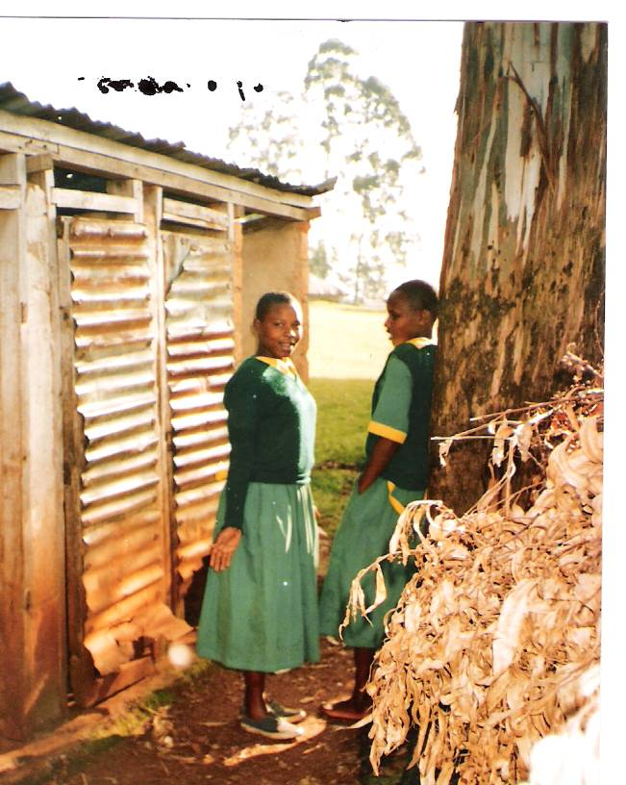

Girls wait in a queue at a Primary school

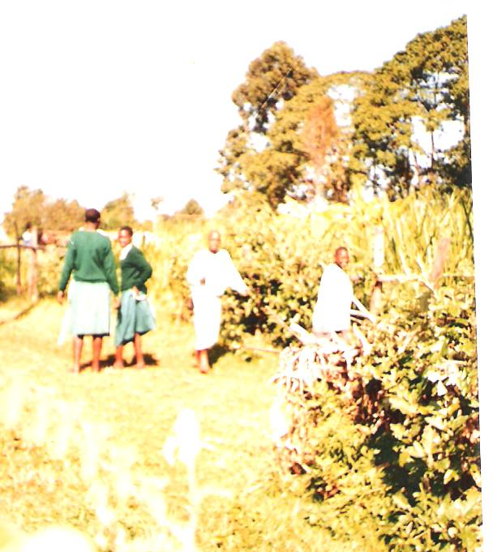
Girls at a day Primary School opt for the nearby bush other than the unhygienic toilets at school

5. PROJECT OBJECTIVES
The main objective of this project is to provide proper sanitation facilities and services to sexually maturing girls in primary schools, so as to give them “peace of mind” to enhance their performances on SMT subjects. This main objective is broken down as follows:

- Provide the required toilet and sanitation facilities, exclusively for the use of girls, in proportion to the number of girls in the schools. It is hoped that the local community in conjunction with the local education authorities will be thus encouraged to provide similar improved facilities for boys.
- Motivate local community support for this activity in order to build a partnership of all relevant stakeholders.
- Provide sensitization and awareness building activities designed to highlight the importance of providing adequate toilet and sanitation facilities for girls and on the sensitive and effective management of adolescent female sexual maturation. This shall also aim at introducing the girls to proper use of sanitary pads during their menstruation periods

- Undertake the required capacity building and training of local personnel to ensure the smooth implementation and sustainability of the intervention. Female teachers will be identified and trained to train the girls on menstruation cycles and care for menstruation periods.
- Undertake initial planning on the future expansion of sanitation facilities to water-closet type facilities when piped water might be available and provide guidelines which might be used to implement such an expansion.
- The provision of safe water and sanitation facilities in schools is a first step towards a healthy physical learning environment benefiting both learning and health.

However, the mere provision of facilities does not necessarily make them sustainable or produce the desired impact. It is the use of latrines and the related appropriate hygiene behaviour of people that provides health benefits. In schools, hygiene education aims to promote practices that will help to prevent water and sanitation-related diseases as well as encouraging healthy behaviour in future generation of adults. At Health and Water Foundation we intend to play both an advocacy and partnership role to achieve these goals.

5.1 Expected results:
By the end of the project (6 months), 4 public schools shall serve as role models in Nyamira district in providing clean and safer water, girls’ sanitation facilities and capacity building for young but sexually maturing girls. The 50 public schools program will take 36 months.

Enhanced performance in SMT subjects is highly expected in the 4 schools. This is because the schools will be more conducive places for sexually maturing girls, hence their confidence to mix with their male counterparts.

.Absenteeism, drop-outs for girls are expected to reduce considerably. Rape cases on school girls shall be minimised.

The community and educational administration in the area is expected to appreciate and adopt the similar approaches in other schools so as to spread the services and facilities to benefit wider society.

- Appropriate number of boys and girls using latrines
- Better performance for girls in SMT subjects
- Healthy classrooms and school compounds
- Existence of health and hygiene sanitation lessons
- Availability of storage tanks and hand wash taps
- Sufficient and functioning toilets with doors for privacy
- Soap/ash by the hand washes facility
- Confident girls in school/classrooms

6. PROJECT IMPLEMENTATION STRATEGY
- Selection of schools for the each project (4 schools) and program (50 schools) will be an important issue. Priority should be given to schools in greatest need of having their sanitation facilities upgraded relative to the increase in enrolment resulting from FPE. Accessibility will be an important factor in relation to logistics and the need for effective monitoring and evaluation of project activities.
- Toilets design phase will be carried out by technical officers from UNICEF. This applies because the UNICEF team command experience in similar projects.
- Local community input becomes essential in terms of generating a feeling of ownership of intervention activities leading to strong support and willingness to ensure sustainability of activities.
- Capacity building and training should be an important element in ensuring the success of interventions through adequate sensitisation and awareness building activities and the ongoing maintenance of the facilities provided.

- Innovation and reliance on local creativity and use of locally available materials should be encouraged with a view to having ideas generated at school level replicated in local homes and trading centres.
- While the sanitation facilities provided by HWF will be exclusively for the use of girls, efforts should be made to ensure that the provision of these facilities will spur efforts by school administrations to utilize funds made available by Ministry of Education, Science and Technology (MOEST) and other interventions to provide similar facilities for boys.
- The building of strong local partnerships with education, civic and religious leaders, and with other NGOs and groups engaged in similar activities, will be an important element in the success of the project.
- To have a long-term, sustainable, positive impact on the health and hygiene conditions of the schools and the community, we will focus on development of life-skills through case presentation and demonstration. This is because we know that knowledge that is not applied to hygiene behaviour has no impact on health.
- Program communication and social marketing: there will be a public launch of the program with the various stakeholders, sponsors and especially the school P.T.A. This will be highlighted at the laying of the stone by the Health Ministry official.

6.1 Monitoring and Evaluation
- To ensure effective monitoring and evaluation of the project accurate baseline data in relation to absentee rates and performance in all subjects, especially SMT subjects, will be vital.
- Effective records of absentee rates and subject performance on a term basis will be taken and maintained.
- Strict supervision of construction activities and the supply of materials will be undertaken by a Civil Engineer appointed by HWF.
- Transparent accountability for the expenditure of project funds will be exercised. Additional staff may be added at the cost of the organisation if there be need.
- Monitoring and evaluation at local level will be in the hands of project implementation committees made up of members of the school administration and the Parent Teachers Association/School Committee chaired by the school Head Teacher and the HWF appointed Appraisal officer/Field Coordinator.
- The training on health and hygiene and proper use of sanitary pads shall be conducted by the professionals from the company that supplies the sanitary pads (Procter & Gamble EA Limited) and the Ministry of Health, Kenya.
- Overall monitoring and evaluation will be the prerogative of HWF officers form the Head office.

7.0 WORKPLAN

ACTIVITY | PURPOSE | DURATION
Compilation of data on the level of need | -Establishing the data to get the most needy school for the project | 1 Week
Compile data on girls’ absentee rate in schools | -Information to be used in performance analysis at the end of the project | 1 Week
1st Field Visit | -Strategy meeting with the local stake holders to plan for the project.  -Getting the community ready to contribute their share of the costs | 2 Weeks
Acquisition of materials & equipments, and Labour | -Establishing suppliers and logistics for the materials to and equipments to be used in the construction  -Determine the most cost effective logistics | 1 MONTHS
Installation of water tanks and hand wash facilities and digging of toilets | -Actual construction of the toilets, Erecting water tanks | 2 MONTHS
2nd Field Visit | -Monitoring the construction activities with a Civil Engineer  -commissioning the use of the facilities  -Planning for the training and Capacity building (Phase 2) | 2 Weeks
Training of school children on proper use of the facilities provided | -Enabling the pupils to use the facilities effectively and economically | 1 Week
Training of girls on sanitation and hygiene, use of pads and FGM | -Equipping the girls with the knowledge of their expected changes during sexual maturity.  -Teaching the girls to expect and handle their menses/Use of sanitary towels etc. | 2 Weeks
3rd Field Visit | -Evaluation of the performance on the training of school children.  -Collecting Data on the level of satisfaction from pupils, teachers and parents | 3 Days
Training female teachers on management of sexual maturation and FGM | - To ensure the continuity of the training program to be carried out by the female teachers to train new pupils every year | 3 Days
Evaluation and review | - Collecting final data and evaluation | 1 Weeks
Final Field Visit | - handing over the project to the community.  - Closing ceremony | 2 Days

8.0 PROJECT BUDGET (4 Primary Schools)

6 Months
 | Item description | Unit | Qty | Rate  US$/ School | Total cost US$  (4 Schools)
1 | Provision of Toilets, Water and Hand-wash:  Dig & construct 8 latrine units,  6 Hand wash units for boys and girls and install  20000 litre tank for rain water  (Note1) | schools | 4 | 11,468 | 45,873
4 | Promotion of WASH♣ and Training  Participatory appraisal in health and hygiene  Training and capacity building by Procter & Gamble (EA), Rentokil and Ministry of Health  Supply of Always sanitary pads at 500 pcs per school (for demonstration & emergency)  Supply of 240 bars of soap per school for hand washing (40 for demonstration)  Training on FMG  Training on PHAST | schools | 4 | 3,467 | 13,868
 | Project Coordination  Project Engineer, Coordinator, Technician and Driver | Schools | 4 | 879 | 3,514
7 | Communication and Utilities  Vehicle running costs  Phone and fax  Internet and postage | Schools | 4 | 836 | 3,343
8 | Monitoring & Evaluation  Field Visits  End of Project Audits | Schools | 4 | 2,143 | 8,571
 | SUB - TOTAL |  |  | 18,792 | 75,170
 | 15% Provision for project administration cost | Schools | 4 | 1,879 | 7,517
 | 5% Provision for contingencies | Schools | 4 | 1034 | 4134
 | GRAND TOTAL (US$) |  |  | 21,705 | 86,821
 | Less Community Contribution |  |  | 1,829 | 7,314
 | Total Amount Requested from Donors for 4 Schools |  |  | US$21,105  (per school) | US$79,507  (4 schools)

9.0 INSTITUTIONAL CAPACITY
HWF has wide experience in project management acquired from the several projects that have so far been implemented by us. For the last one year, HWF has been on the ground implementing projects on capacity building for community based organizations (CBOs). The management structure of the organization is relatively flat, thus enhancing easy management communication and feedback relays. The organization structure recognizes the importance of involving the community in the implementation of the projects in the specific areas. Thus, the inclusion of the CBOs in the management structure of HWF was to enhance community involvement. The CBOs are given the grassroots’ roles so as to create an easy communication channel between the community and HWF.

In addition, all the management staff has experience and “drive’ to run community based projects that are aimed at alleviating health and poverty problems. The Executive Director, Programs Manager and Education and Gender Expert all have project management skills acquired at the University level plus a minimum four years in Project Management. The Project Manager will be in-charge overall in the field assisted by Field Coordinators. Field coordinators are appointed for each project in one or a group schools. The appointments take into consideration the specific requirements of the particular school and surrounding community. The Field coordinators MUST be conversant with the school, area/location and the community in which the project is taking place. Thorough scrutiny of the applicants is done taking into consideration that the Field Coordinators are the eyes of HWF in the field. In addition, a Project Accountant will be recruited, stationed on site and will report to Finance and Administration Manager. He/She will be in charge of project accounting and report preparations including posting of the receipts and documents, keep record of the project accounts and carry out bank reconciliation to ensure proper usage of the funds.

9.1 Current HWF Management Structure

The Staff at HWF Head Office is as below:

- Evans Misati James - Executive Director
- William Marwanga - Programme Manager
- Martha Tureti - Education Gender expert
- Alice Omesa - Finance & Administration Manager
- Eng. Joseph Nyachieo - Technical Manager/Water & Sanitation Engineer
- Susan Makhanu - ICT- Officer
- Ben Okindo - Monitoring & Evaluation officer
- Henry Mareri Moseti - Water Technician/Supervisor
- Pheris Motanya - Field Coordinator
- George Mokoa - Driver/Messenger

9.2 Project Management

The Executive Director will be the overall in charge of the project for quality assurance, reporting and accounting to the board and donors on the project. He has over 3 years of experience in management of NGOs and over 10 years in companies and private businesses.

Mr. William Marwanga, Programmes Manager, is charge of implementation of the project and the whole program. He is a holder of BSc (Agric Econ), MS in Community Development, MBA, Diploma in Marketing, and Post Graduate Certificates in FSR, Management of Micro-Credit and Finance and Micro-Enterprise Development. He has over 22 years experience in strategic planning and management, project management, rural extension, research, business information technology and training in NGOs, UN agencies, Public and Private Business Sectors in Kenya, Zimbabwe and USA.

Ms Martha Tureti, the Education and Gender Expert reports to the Programme Manager and is in charge of child, youth and gender issues in the project which includes sexual maturation education, FGMs, sanitary towels and hygiene trainings. She holds a B.A and M.A in Gender/Peace Studies with over 12 years working experience in both National and International NGOs in emergency, relief and development programs and is well versed in gender and education issues facing children, orphans, refugees and other vulnerable groups, project management, organizing and conducting trainings and research, and human rights advocacy.

The “Project Engineer and Coordinator” both report to the Programme Manager on projects’ progress. Coordinator is in charge of the project on-site running day to day activities of the project. She has over 5 years experience in field implementation including the on-going health, water and sanitary initiatives in Nyamira and Kisii districts. The Engineer with over 12 years in water and sanitation engineering supervises the works.

Ms Alice Omesa, HWF’s Finance & Administration Manager, is qualified in both Accounts (B.Com Degree - Accounting Option, CPA II) with 12 years diverse experience gained from reputable NGOs. She is in charge of accounting and reporting of the projects funds to ensure transparency and accountability. In addition she administers the projects and the program in terms of materials procurement.

The “Consultants” advise HWF on technical, financial and other resources mobilization. Both have over 20 years of experience in development work all over the world. Other experts for the project will be hired on a need basis.

9.3 Financial, Accounting and Administration

All the accounting operations of HWF are in accordance with International Accounting Standards (IAS). Each project is accounted for separately, and a copy of the external audit report will be submitted to the donor at the end of the year. All payments/withdrawal vouchers are counter-checked, and then approved by the Executive Director/Programmes Manager to ensure internal controls and check and balances.

HWF operates a the main bank account with Commercial Bank of Africa - Kenya, Nairobi but for these community based projects, a new account is opened and operated by at least one National official and the Project Manager or Field co-coordinator in that area.

BIBLIOGRAPHY

- Ministry of Finance & Planning
Nyamira District development plan 2002 – 2008
- Life Skills, Sexual Maturation and Sanitation
What’s (not) happening in our schools?
An exploratory study from Kenya
By: Rockefeller Foundation
- East African Standard Newspaper, November 22 2004

List of abbreviations:
HWF Health and Water Foundation
SMT Science Mathematics and Technology
WASH Water and Sanitation Hygiene
CBO Community Based Organization
FGM Female Genital Mutilation
MOEST Ministry of Education, Science and Technology
WES Water and Environmental Sanitation
HIV Human Immunodeficiency Virus
AIDS Acquired Immune Deficiency Syndrome
NGO Non Governmental Organization
PTA Parent Teachers Association
UNICEF United Nations International Children Education Fund
FPE Free Primary Education

▪ Water and Sanitation Hygiene

