We operated the protection of the reserves without encountering significant problems or challenges in this period, which tends to be the most problematic due to low water levels and forest fires. We were present in all the reserves, where the reality is conservation, so it is clear to us that the activities we carry out, interacting with neighbors and local authorities has consolidated an effective scheme for their protection. Now it is a matter of keeping it that way and adding protection to the surrounding forests, which is happening with the properties in the Carbon Balanced Program of the World Land Trust and those that joined the new project with the Government of the State of Querétaro and the Querétaro Low Carbon Emissions Seal. Now our neighbors have a real and substantial income for protecting their forests, which mitigate CO2 emissions from their natural regeneration, without interventions and allowing nature to heal itself.

The month of April brought some fires in the Sierra Gorda, but none of them affected the reserves and the month of May was anomalous; it brought significant and unseasonal rains which eliminated the threat of fires, and then June arrived with a prolonged heat wave and extreme temperatures with the worst heat wave ever recorded in Mexico, so we decided to extend for an additional month, with GESG's own resources to the brigade funded by the WLT. Fortunately, and despite the brutal temperatures, no fires occurred, although for the first time we recorded magnolias damaged by the high temperatures and drought, being naturally a species with a particularly delicate and narrow ecological niche, growing in the shady and humid environments of the cloud forests. Although they did not die, they could not withstand extreme parameters of dryness and heat, causing concern about their condition and survival in the future.

Fortunately, during last week's tour and with the little rainfall during the first half of August, the damaged magnolias have tender buds, and this allows us to see that they are recovering despite the damage suffered, which makes us very happy and means that they survived such an ordeal.

And once again we had the generous contribution of primary school students from the International School of Queretaro, as their teacher, Ms. Yeetlih Gomez, contacted us again and offered a new donation from her students, to whom we suggested to buy snake gaiters, an important element of protection. During the maintenance activities and opening of gaps they found several poisonous snakes (rattlesnakes, nauyacas, metapilas) so the brigadistas commented on the possibility of having them.

The students ordered the model I suggested online and sent it directly to our offices. They were delivered to the brigadistas, who were obviously very happy and grateful.

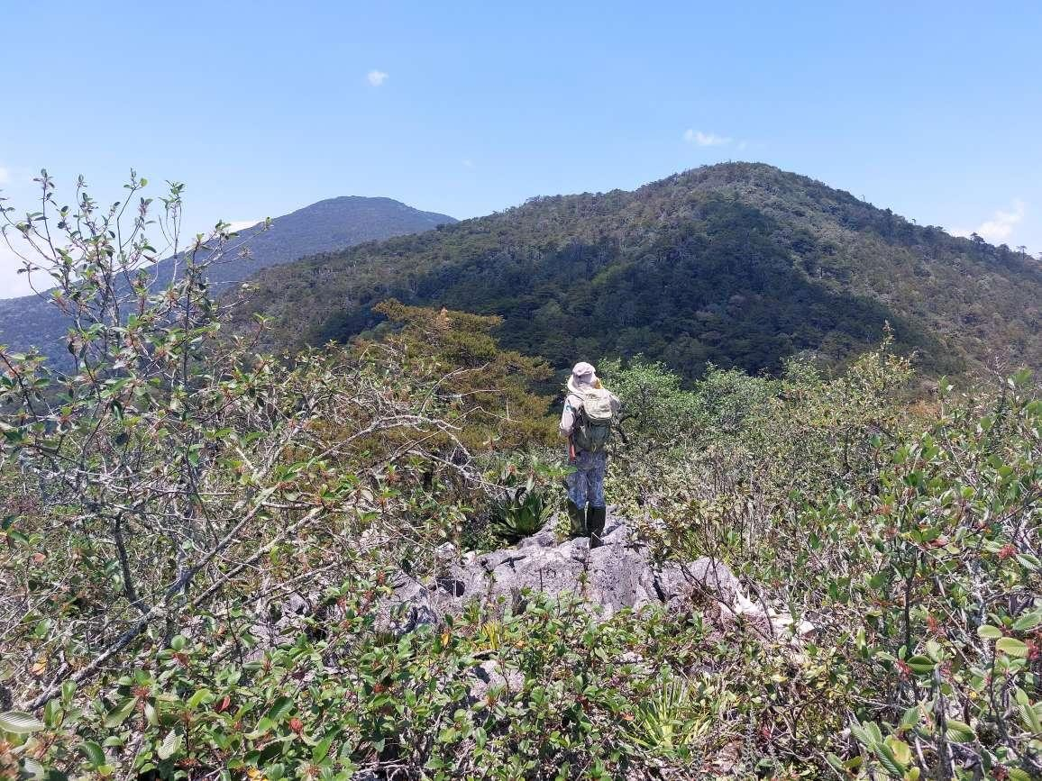

Surveillance tour of the upper brow of Cerro Prieto, Cerro Prieto reserve.

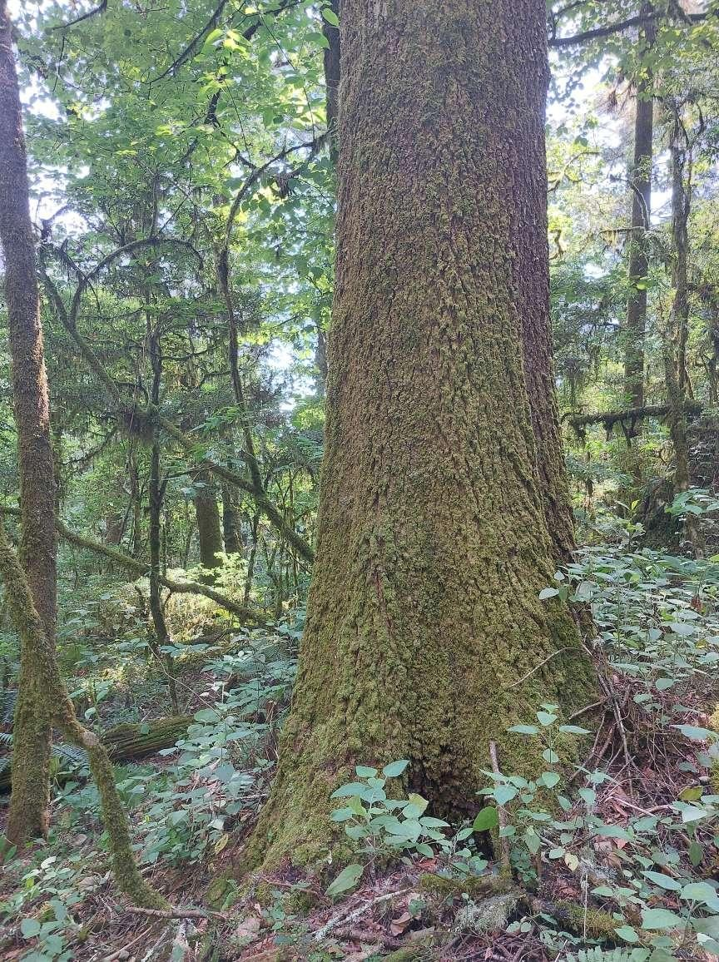

Spruce (Abies guatemalensis), an old and particularly robust specimen. It is a species with protection status. Cerro Prieto Reserve.

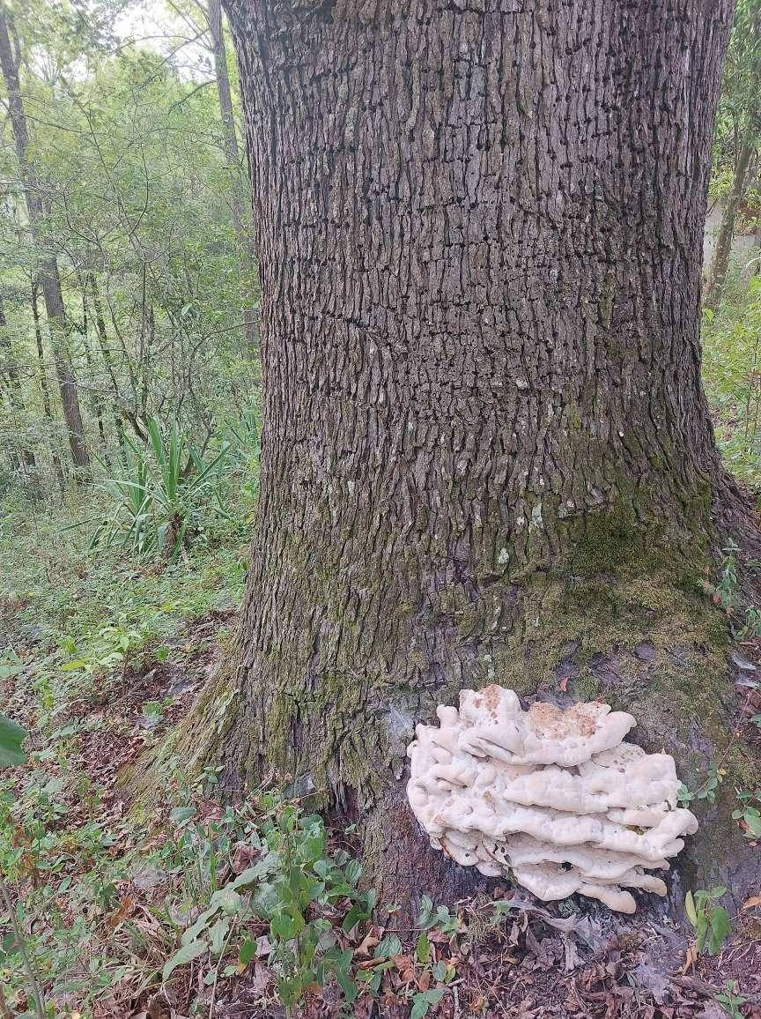

Liquidambar (Liquidambar styraciflua) with wood destroying fungus. La Hierbabuena Reserve.

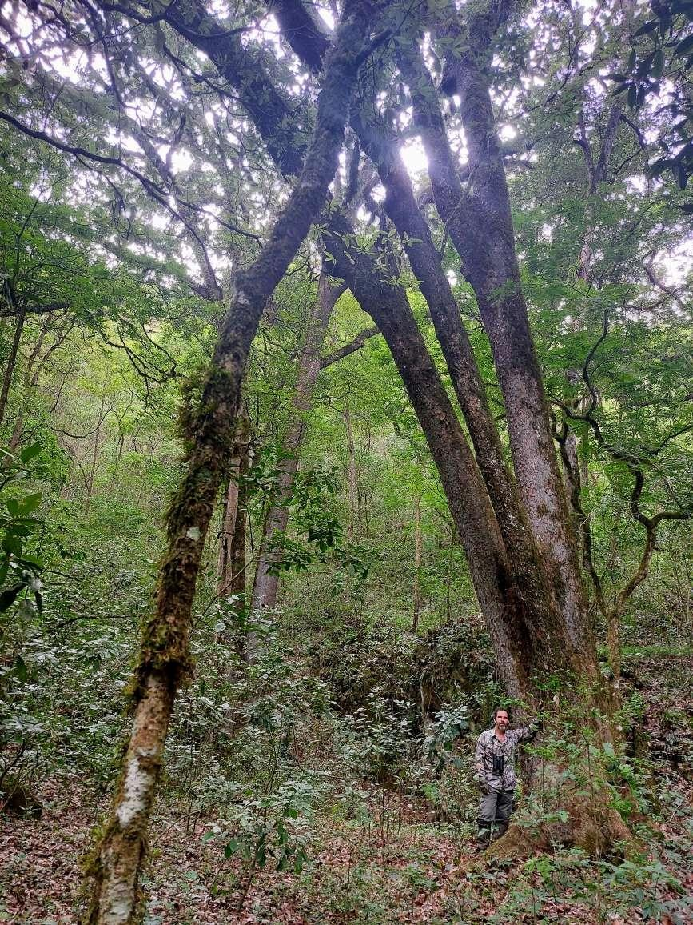

Acorn oaks (Quercus germana), particularly old and corpulent, a representative species of cloud forests.

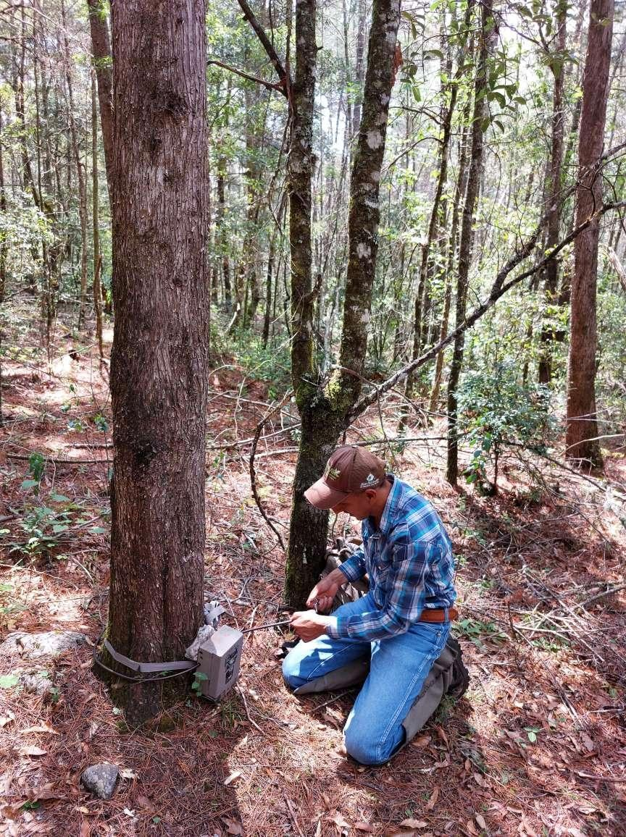

Installing camera traps, Hoya Verde reserve

