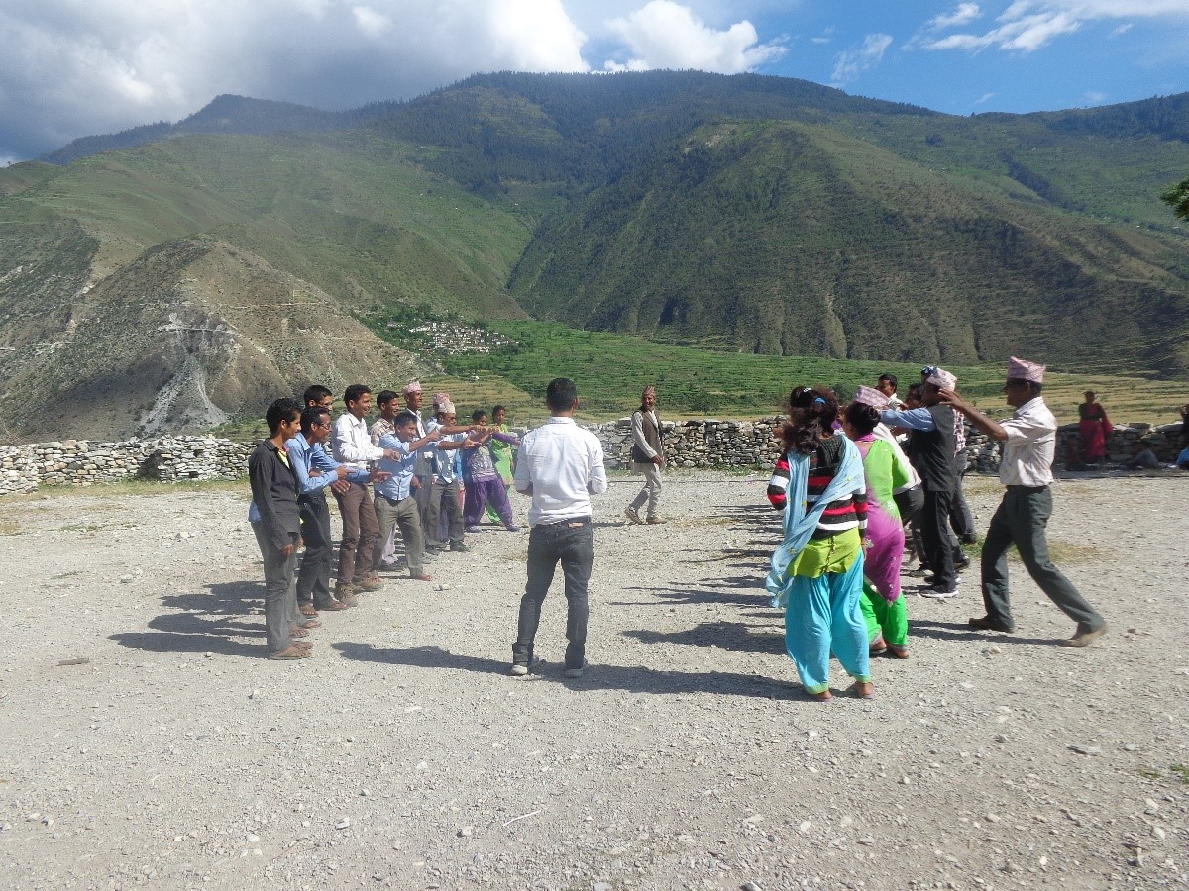
Teachers from Bandhu VDC during one of the training activity

