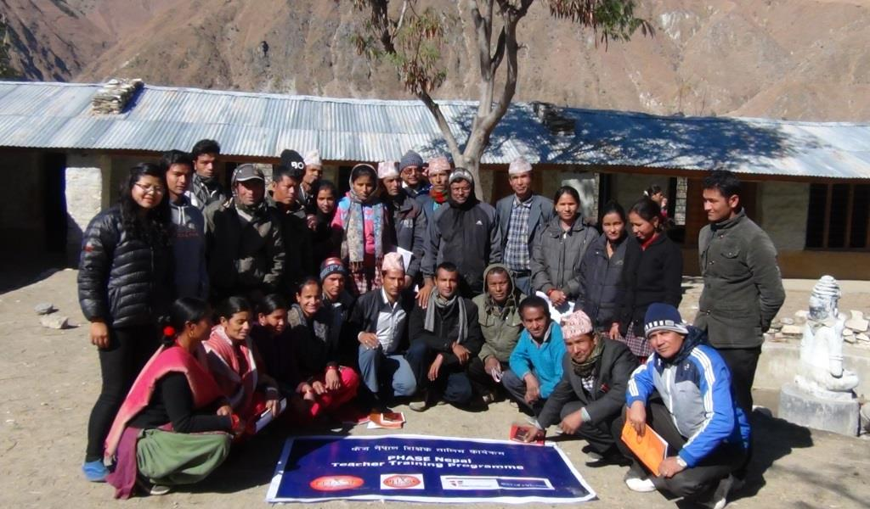

Group photo of teachers after the training

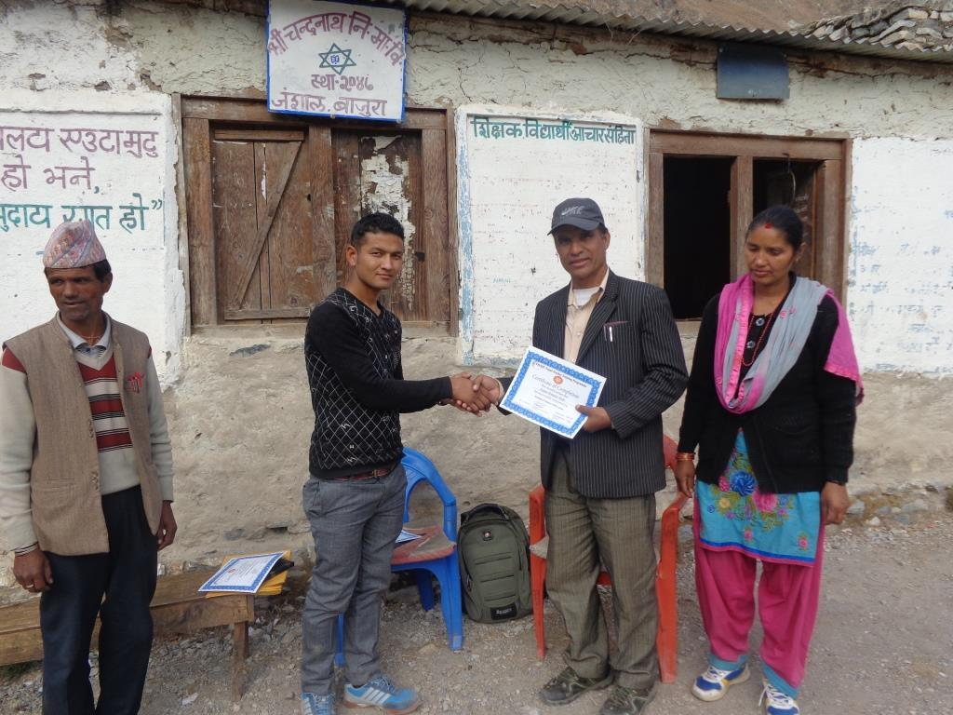

A teacher receiving certificate of participation in training