Detailed Description of the Children’s Homes (J and K House)
run by the Nepalese Youth Opportunity Foundation (NYOF)

NYOF has created two of the best children's homes in Nepal. J House (for boys) and K House (for girls) each hold only up to 30 children. These children are the most vulnerable in the country. Some of them are orphans or were abandoned by their parents, some were child beggars, and some are disabled. Many of them have endured more suffering at a young age than some of us experience in a lifetime, but have found ways to triumph over their difficulties. NYOF gives these kids not only all living, educational, and medical expenses, but love and personal attention—just as a good parent would do. NYOF commits to them for the long term, from childhood through college, and provides what is usually the first real sense of security in their lives. J and K House have provided a safe home and loving support to hundreds of Nepal’s neediest children.

The J and K House children have committed sponsors in the U.S. and other countries. Ideally, the sponsors make a long-term commitment to their children. The sponsors are able to correspond with their children regularly. Some sponsors have developed close relationships with their children, and many have visited them in Nepal.

One of the most important components behind the success of the houses was establishing warmth and helpfulness as the norm. New kids slip into this environment and learn to trust one another and treat each other with respect and affection. The culture of the houses is such that the kids help each other spontaneously, without being asked, and often without our knowledge. There's always someone around to lead the blind kids by the hand if they can't navigate on their own or to carry a child who can't walk. We have been astonished at how fiercely the children love and support each other. Maybe it's that these children simply appreciate family in a way that the rest of us take for granted. Every day these kids surprise, delight, and inspire us with their capacity to overcome their traumatic pasts. The world can learn much from them.
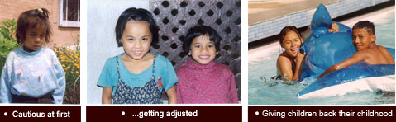
Each house has a resident Uncle and Auntie who are surrogate parents to the children, providing them with understanding, sympathy, affection and advice. When a child first arrives at one of the houses, he or she is shy and more than a little afraid. After all, these children have faced nothing but hardship, abandonment, and sometimes violence. This is when the children at the houses shine. They are tender and reassuring, remembering how terrified they themselves were when they first came to live at the houses. They help with the first hot shower these kids ever had, run to their trunks to provide clothes to the new arrival, and excitedly show the child the basketball court, the ping pong table, the playground, the television set, and his/her bed. And they tell the child how happy he or she will be in the new surroundings.
Kids are amazing in how quickly they can learn and adapt. Within a few days, these new children realize that they have at last reached a happy haven, where they will be cared for until they can stand alone. Any nuclear western family would be proud of the support, love, and help they provide to one another. They call each other “sister” and “brother” and they mean it. No one is mistreated. Gradually, and for the first time in their young lives, the newcomers begin to feel that at last they are safe. And then—they blossom.
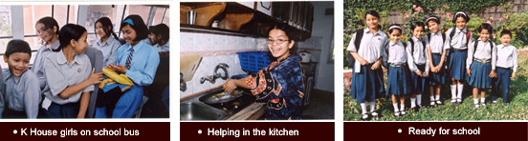
At the houses, the kids range from the highest caste to the lowest untouchable caste, yet they make no distinction among themselves because of this. So, in addition to receiving support, education and love, the children are learning lessons in tolerance and humanity.
The children study hard, and some of them—having never gone to school before—become academic stars. There's no complaining about school here, even when the homework at their private schools is tough. They know that a good education is the key to overcoming the disadvantages of poverty, caste, and lack of family in a society where family is everything.
That said, it's not all hard work and study for these kids. They have lots of outings, parties, and games—from mountain treks to slumber parties. They go swimming, and occasionally, in the humid hot season, make a field trip to the ice cream parlor.
During winter holiday from school, it’s usually a 3-4 day trip to a wildlife park or into the mountains, where they enjoy deeply discounted rates. The purpose of these outings is not only to provide the kids with a good time but to give them a chance to realize that all of Nepal is not like crowded, dirty Kathmandu. It is important for them to witness the spectacular beauty of their country and to see what life is like in rural Nepal, where 80% of Nepalis live. Often, they return from these trips counting their blessings after seeing children their age carrying heavy loads of fodder and wood on their backs, compelled to do backbreaking labor from dawn to nightfall, and unable to go to school.
The little ones especially enjoy the trips to the parks, where they ride elephants to look for rhinos in the tall grass, float down the rivers in dugout canoes as crocodiles float by (cartoon- style, with only their eyes above water), and dance in the evenings around a huge bonfire. Wherever they go, people comment on how well behaved the kids are and how caring they are toward each other.
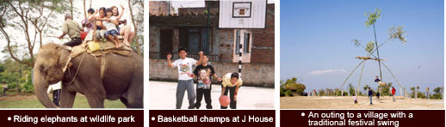

These formerly "throwaway children" are actively imbued with a sense of social responsibility. They work in the community, sharing their own bounty. They have visited villages to help teach English and basic hygiene to local kids (toothbrushing lessons were a core part of the curriculum). On special "environmental awareness" days in Kathmandu, they're out there cleaning up the Bagmati River.
These efforts seem to make a difference. J and K House children are growing up into adults with a desire to give back to their community, nation, and world.

