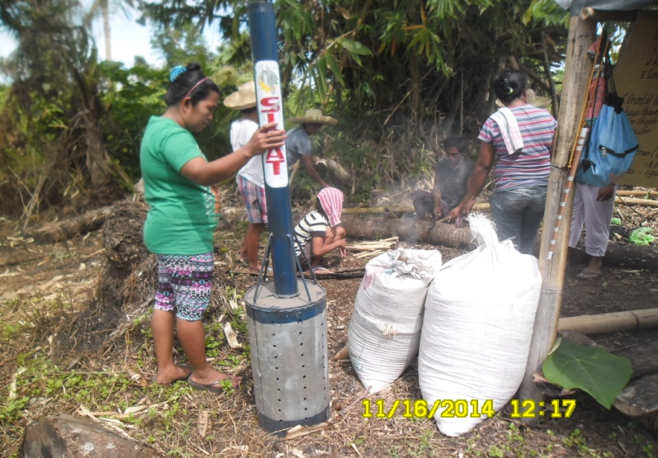

Women trainees carbonizing rice hulls as part of biofertilization