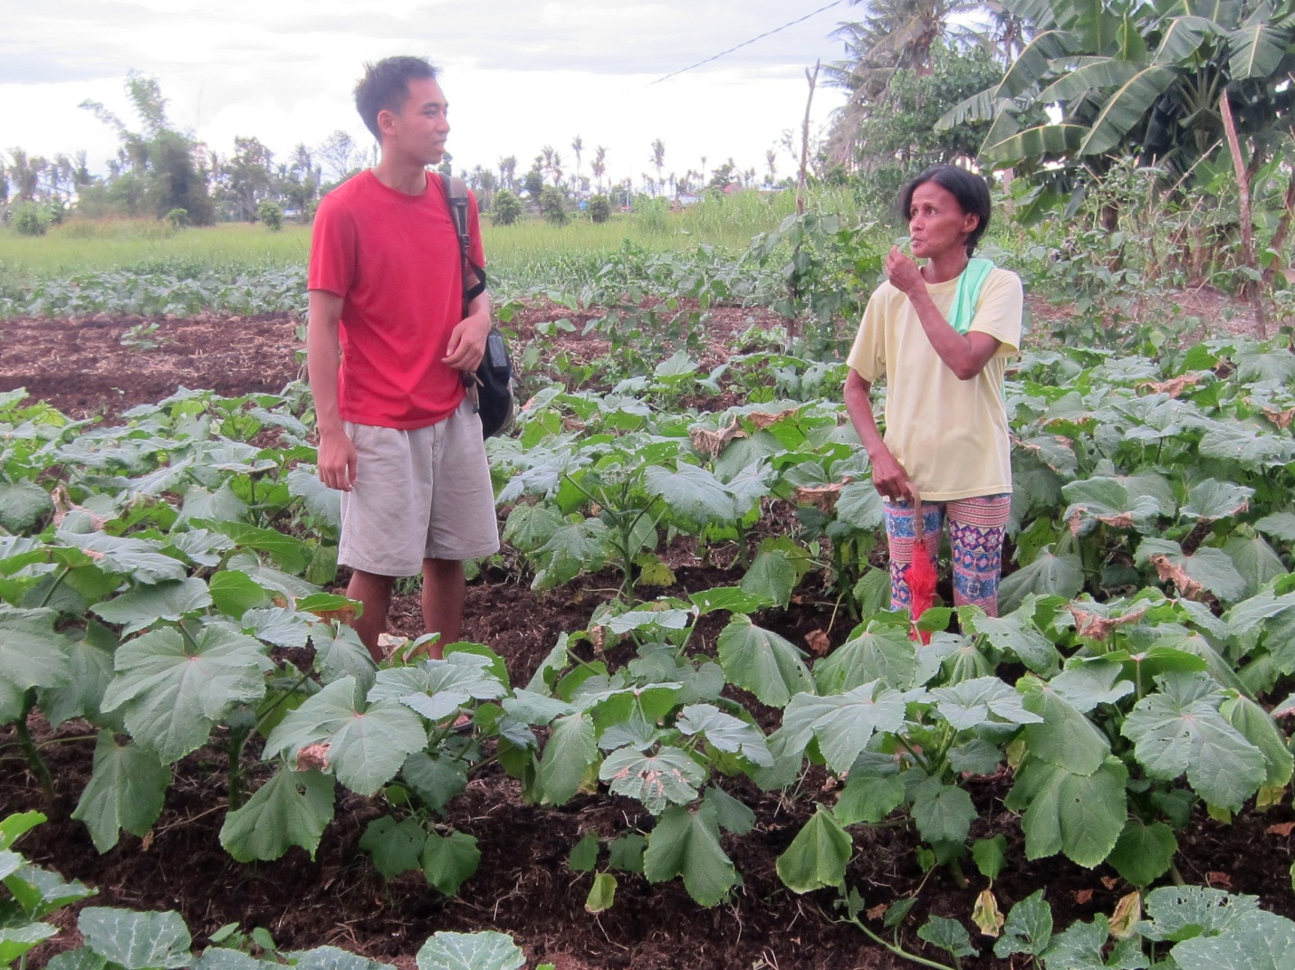Woman showing okra and squash vegetable types in one section of her farm. Other women have similar food gardens

