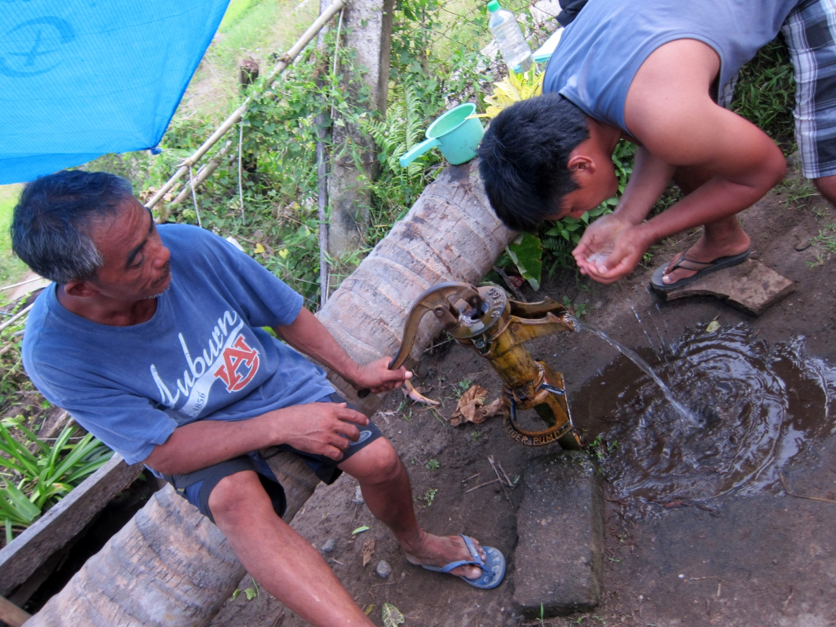
SIBAT Engineer visually examining water quality

