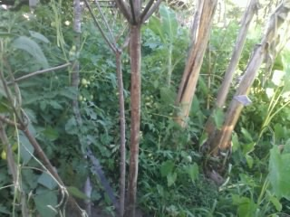

Farmers used indigenous tree branches as poles to protect crops from strong winds

