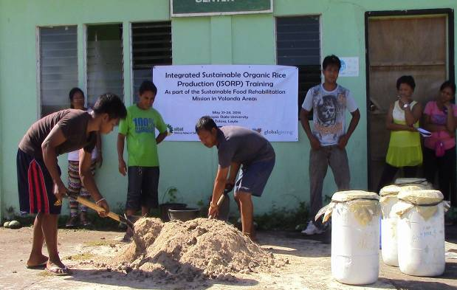

Participants from group two, the “mixer group,” mixing the media for bokashi. Four containers were filled with the newly made soil enhancer ready for fermentation. This workshop was held at the Day Care Center of Barangay Capangihan Tolosa Leyte