

A Proposal Requesting Funds from Global Giving
To support the Boys & Girls Club of Southwest Alabama
Project Learn Implementation
An educational enhancement strategy designed to engage young people in learning, encourage them to succeed in school and help them become lifelong learners

November 18, 2013

Executive Summary

For 15 years, Boys & Girls Club of Southwest Alabama has been in the forefront of youth development, working with young people from disadvantaged economic, social and family circumstances. The Boys & Girls Club of Southwest Alabama has actively sought to enrich the lives of girls and boys whom other youth agencies have had difficulty reaching. We are dedicated to ensuring that our community’s disadvantaged children and teens have greater access to quality programs and services that will enhance their lives and shape their futures.

In order to have an even deeper impact on our community’s youth, Boys & Girls Club of Southwest Alabama is requesting funding from the Global Giving to implement an educational enhancement strategy called Project Learn, which is a model designed to engage young people in learning, encourage them to succeed in school and help them become lifelong learners.

As a community-based organization, the Boys & Girls Club of Southwest Alabama is uniquely positioned to positively affect the lives of the youth we serve. To implement Project Learn, we would like to request the amount of $10,000.00.

Just as Global Giving seeks to help our community’s youth become responsible, caring, productive citizens, the Boys & Girls Club of Southwest Alabama has the staff and tools necessary to see this vision come to life. We thank you for considering this request. Together, we can assure that our community’s youth go on to have great futures.

Organizational Background

The Boys & Girls Club of Southwest Alabama is part of a nationwide Movement of community-based, autonomous organizations and Boys & Girls Clubs of America working to help youth of all backgrounds develop the qualities needed to become responsible citizens and leaders. It offers daily access to a broad range of programs in five core program areas (Character and Leadership Development; Education and Career Development; Health and Life Skills; The Arts; and Sports, Fitness and Recreation) and several specialized initiatives. All programs are designed to drive positive outcomes for youth and reinforce necessary life skills.

Today, more than 100 young people at risk and in need are taking advantage of the programs, activities and services provided by the Boys & Girls Club of Southwest Alabama. Our vision is to provide a world-class Club Experience that assures success is within reach of every young person who walks through our doors, with all members on track to graduate from high school with a plan for the future, demonstrating good character and citizenship, and living a healthy lifestyle.

To make sure that all of our members have great futures, the Boys & Girls Club Movement has adopted the Formula for Impact, a research-based theory of change that describes how individual Clubs and the Movement as a whole can increase our impact – exponentially – on the young people of America.

Our Formula for Impact begins with the young people in Clubs – especially those who need us most. It calls for us to consistently provide the most powerful Club Experience possible – by implementing the Five Key Elements for Positive Youth Development, offering high-yield activities and providing targeted programs – all of which help youth achieve priority outcomes. Then, because we also know that attending the Club more frequently and over a greater length of time makes young people more likely to achieve positive outcomes, Clubs must pursue strategies to increase attendance, program participation and member retention.

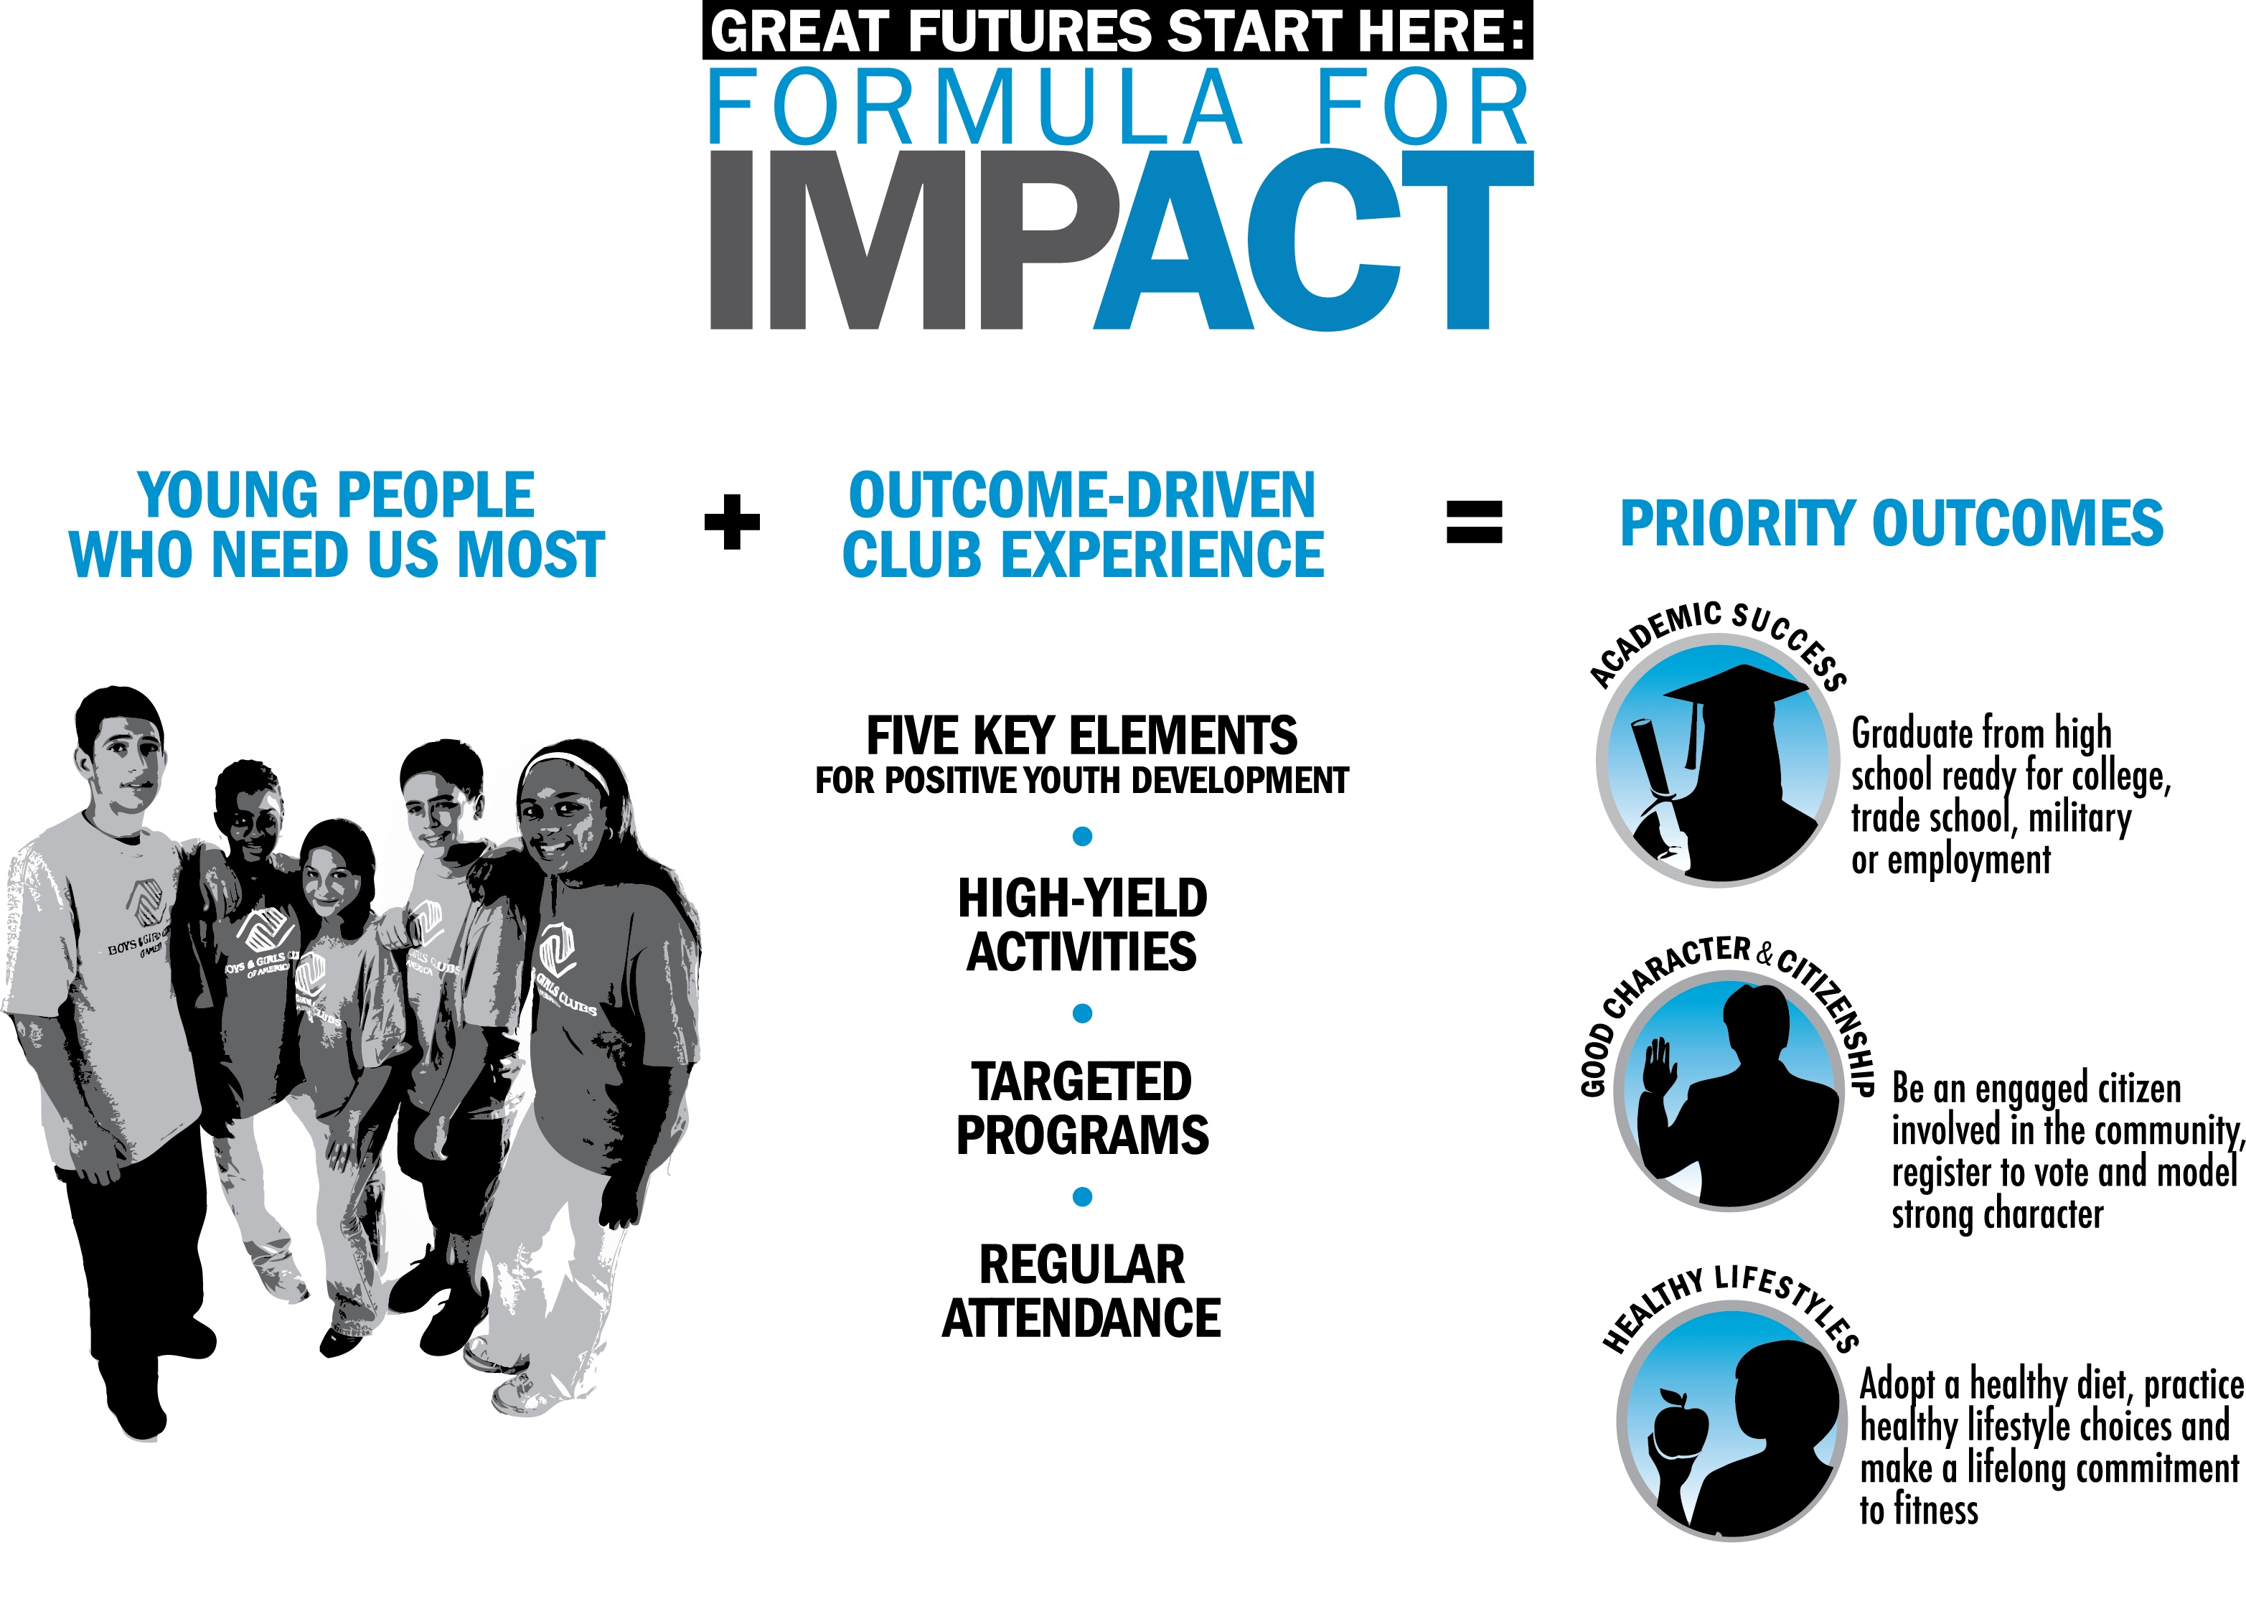
Statement of Need

Ensuring a meaningful education for every child has never been more critical than it is today. America’s young people are performing poorly in school. Despite decades of reform, the American educational system is struggling to meet the increasing demands placed on it. Young people, particularly from minority communities, are failing to learn basic skills (i.e., reading, writing and mathematics) during the school day.

Recent studies by the National Center for Education Statistics demonstrate the need for additional academic support for youth. In 2009, only 33 percent of fourth graders, 32 percent of eighth graders and 38 percent of 12th graders read at or above the proficient level. The problem is especially critical for at-risk youth. At-risk children begin their early grades believing they can achieve. By the fourth grade, many of these young people lose their curiosity and interest in learning. This is demonstrated in graduation rates with nearly one-third of all public high school students – and nearly one-half of all African-Americans, Hispanic/Latinos and Native Americans – fail to graduate from public high school with their class, resulting in more than 1.3 million American high school students who drop out every year.

We can find similar patterns of under achievement in our community. Today an increasing number of researchers are saying that nearly 1 out of 3 public high school students won’t graduate. Over the past few months the Drop Out rate in Clarke County has gone up by 3% from 14% to a staggering 17%. For Latino’s and African Americans, the rate approaches an alarming 50%. Virtually no community, small or large, rural or urban, can escape this problem. A 2002 Northern University study found that nearly half of all dropouts are unemployed. Recent studies by the National Center for Education Statistics demonstrate the need for additional academic support for youth. In 2009 only 33% of fourth graders, 32% of eighth graders and 38% percent of 12th graders read at or above the proficient level.

Now more than ever, community partners play a critical role in shaping the lives of America’s young people. This is where the Boys & Girls Club of Southwest Alabama is uniquely positioned to make a significant difference. We have access to the youth who need us most, and a program that will help youth develop positive outcomes and achieve great futures.

In an effort to ensure that members achieve great futures, the Boys & Girls Club of Southwest Alabama has chosen to implement Project Learn, which has also been identified as one of BGCA’s targeted programs. Participation in this program will help drive academic success for youth. Highlights of the program include:
- Homework help for Club members five to six hours weekly so that they will develop a daily habit of completing assignments and preparing for class;
- Individual or small-group tutoring to help youth gain proficiency and to excel in needed subject areas;
- Regular implementation of high-yield activities, in which youth participate in fun, intentional activities designed to expose young people to skills and information needed for school success;
- School-Club-family partnerships to support youth academically; and
- Recognizing all members is recognized for their academic achievements.

When young people enjoy school and feel a sense of accomplishment, they are more likely to finish school and go on to post-secondary education or additional job training- and to become the lifelong learners we want them to be.

Responding to the Need

Project Learn was developed to engage young people in learning, encourage them to succeed in school and help them become lifelong learners. This program helps drive positive outcomes for youth in the academic success by allowing participating youth to receive the following benefits:
- Individualized, structured learning experience
- Improved attitude toward learning in the school and Club
- Self-paced and self-directed learning
- Practical application of skills taught in the classroom
- Remedial support as needed
- Improved self-esteem
- Improved grades in school
- Improved behavior

Demonstrated Success

Project Learn has already proven successful. Over a three-year period, a national evaluation of Project Learn showed statistically significant grade improvements and an increase in attendance rates for program participants. Dr. Steven Schinke, of Columbia University’s School of Social Work, evaluated the implementation of Project Learn at Boys & Girls Clubs in public housing developments across the United States. Schinke’s study, funded by the Carnegie Corporation of New York, compared the outcomes of Club members ages 10-15 participating Project Learn to young people in other after-school programs.

Thirty months after the program was established, Project Learn participants had markedly higher school scores than young people participating in other after-school programs. In comparison to those young people, Project Learn participants showed a:
- Fifteen percent higher overall grade point average;
- Sixteen percent higher grade point average in mathematics;
- Twenty percent higher grade point average in history;
- Fourteen percent higher grade point average in science;
- Twenty percent higher grade point average in spelling; and
- Nine percent higher grade point average in reading.

The evaluation results clearly demonstrate Project Learns value and effectiveness. In his final report, Schinke concludes, “Boys & Girls Clubs of America can rightfully take credit for helping youth in essential areas of academic achievement, school behavior, and study skills.” Project Learn has been recognized as model evidence-based program by the federal Office of Juvenile Justice and Delinquency Prevention.

A full-time Education Director will coordinate Project Learn (please see this proposal’s Appendix to see a complete job description). His/her responsibilities will be to manage all aspects of the program, including:
- Leading the staff team in developing high-yield activities in every program area in the Club
- Establishing and maintaining a relationship with schools
- Recruiting Club member participants
- Recruiting and training tutors and volunteers
- Purchasing equipment and supplies
- Establishing parent support and activities to encourage involvement
- Scheduling
- Monitoring member progress and performance
- Keeping records
- Handling publicity
- Evaluating the programming and compiling reports

In addition, Boys & Girls Club of Southwest Alabama will hire part-time staff members and tutors and enlist and train volunteers to serve Club members in the Project Learn program. We will also recruit older Club members to serve as homework helpers.

Youth outcomes will be tracked and measured as part of Project Learn. Outcomes that will be monitored include participation in homework help/tutoring and high-yield learning activities; a positive attitude toward learning; consistent school attendance, GPA/course grade improvement; on-time grade progression; and high school graduation.

Alabama is working with other local organizations to provide for the long-term sustainability of Project Learn.

Marketing and Publicity Plan

Boys & Girls Club of Southwest Alabama will be happy to acknowledge the contributions of The J.L. Bedsole Foundation for their support of the Project Learn program in appropriate communications. This includes, but is not limited to, newsletters, e-newsletters, local radio stations, and program flyers.

Closing

As the world becomes even more interconnected, it is more critical than ever for our young people to develop the skills needed to compete in a global economy. By implementing Project Learn, we have the ability to reach over 100 youths ages 5-18 to provide them with the skills to succeed academically, become lifelong learners, graduate from high school on time and, ultimately, reach their full potential as productive, caring, responsible citizens.

Thank you for considering this request and for your support of our community’s young people. With the support of Global Giving we can ensure that our community’s youth go on to become productive, caring, responsible citizens. Here at Boys & Girls Club of Southwest Alabama, we firmly believe that GREAT FUTURES START HERE.

