Spreeha Foundation 3rd Quarter Highlights

Spreeha's mission is to break the cycle of poverty for underprivileged people by providing healthcare, education, and skills training. Our major service area constitutes urban slums in Dhaka, Bangladesh. During this pandemic, Bangladesh government, like most other countries in the world, has implemented a strict stay home order. As members of our communities live in heavily crowded urban slums, they become more vulnerable to coronavirus than others. Also, their livelihood is directly affected as most of them are daily wage earners.

Spreeha's deeply integrates within the communities, to understand the problems. During this crisis, Spreeha's core areas of services, especially healthcare becomes extremely important.

Adjusting services for this changed time

Spreeha Healthcare Center is serving the underprivileged people in the community in their health urgencies ensuring proper safety measures taken by all healthcare professionals in the center. All patients coming to the center are also undergoing disinfecting process and proper social distance has been maintained. Patients are separated into different categories and given treatment accordingly based on presence of high body temperature and other corona like symptoms.
To fight the pandemic, following measures are running continually since the beginning of this year:
- Ensure hand sanitization during entry and exit from healthcare center with 70% alcohol solution
- Ensure each patient is wearing mask. If the patient is not wearing mask, 2 layers’ cotton masks have been provided
- Ensure social distance in waiting zone and during providing service
- Monitor temperature by non-touch method (thermal gun)
- Continuous cleaning of the surfaces – desk, flood, door handle, instrument, etc. with 70% alcohol-based solution
- People with flu like symptoms are encouraged to stay home and take treatment via phone call
- Every staff in the healthcare center is fully equipped with PPEs

Difficulty to bring light of hope in programs

At the end of the Q3 this year (July to September), we could see light at the end of tunnel in this pandemic battle. The number of patients with lung disease problem decreased significantly in this quarter which is 10% of the total cases. However, there is always a risk of increasing the number of lung disease patients in Q4, if proper preventive measures are not taken by people and keeping in mind of the upcoming winter season. However, the percentage of patients with skin disease in Q3 is 13%, which was only 7% higher than Q2.
We recon that more people were staying in the slums at that time and not were not going to work which has enabled them to give their lungs rest, stay away from severe pollution. At the same time, since the slum areas are not the best place in terms of hygiene, the skin related deses went up.
One of the main focuses of our healthcare is to aware underprivileged pregnant mothers about the importance of health seeking behavior during pregnancy. No maternal deaths were reported among the 38 cases of safe delivery in this quarter. Maternal mortality number of this quarter was zero. However, we started to slowly observe that the families in the slums have started thinking back about ‘Child marriage’. They are trying to solve the issue of poverty by minimizing family members and trying to get the girls married. Since Spreeha team has observed this, they have started counselling and awareness building to stop the girls to get married as minors.
Screening for malnourished under 5 children is part of our project regular activity. Due to COVID-19 outbreak Spreeha’s schools are closed now, our community workers are conducting malnutrition screening at their homes with uppermost precaution and reporting our doctors time to time.
Stunting is the impaired growth and development that children experience from poor nutrition, repeated infection, and inadequate psychosocial stimulation. Children are defined as stunted if their height-for-age is more than two standard deviations below the WHO Child Growth Standards median. It generally starts before the age of two. Once stunting happens in a child’s life, the result is mostly irreversible which is more likely to result in delayed motor development and cognitive development.

In Spreeha Bangladesh, kids are often found with stunting symptoms and it increased during the pandemic 2020 due to more infections around, and less availability for nutritious foods due to job loss of the parents. Spreeha’s ground team is constantly fighting Covid-19 and poverty and continuously checking the childrens’ health and taking proper measurements as needed.

The ground workers are also going door to door for empowering adolescent girls through developing soft skills, sense of rights and responsibilities towards communities, and the provision of sound knowledge on Sexual and reproductive health and right (SRHR). Same for kids education. Teachers are carrying the books and other education materials with them to the kids and giving them lessons one student at a time at their slum rooms. The physical work has increased enormously for the teachers and the community workers.
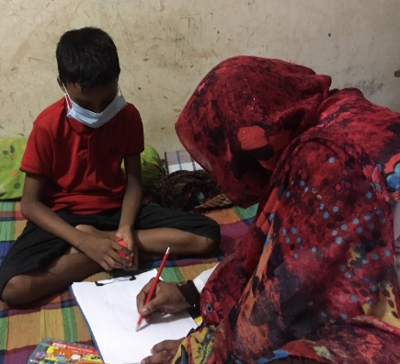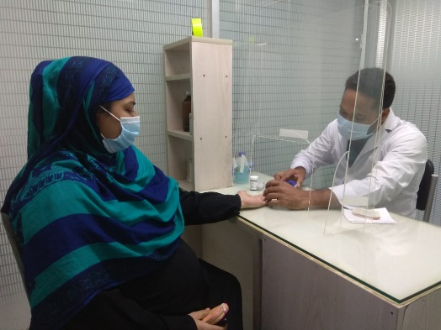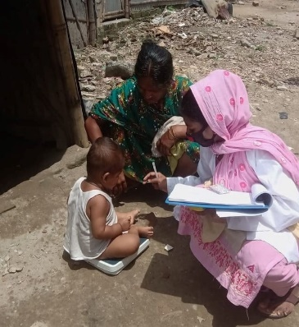

Annual Fundraiser (this year- virtual)

Spreeha USA team (Seattle, Dallas, Richland, Boston and some other locations) did the annual fundraising this year together instead of doing one for each location as this year it had to be on a virtual platform. It was a great effort by all the volunteers and donors who made self-less efforts to transform lives and empower people.
See the event here: spreeha.org/joh2020
Or,
https://www.facebook.com/events/287713272312224/?acontext=%7B%22action_history%22%3A[%7B%22surface%22%3A%22page%22%2C%22mechanism%22%3A%22page_admin_bar%22%2C%22extra_data%22%3A%22%7B%5C%22page_id%5C%22%3A311577298952465%7D%22%7D%2C%7B%22surface%22%3A%22events_admin_tool%22%2C%22mechanism%22%3A%22events_admin_tool%22%2C%22extra_data%22%3A%22[]%22%7D]%2C%22has_source%22%3Atrue%7D

Some drawings by our kids in Spreeha Bangladesh
