PROJECT REPORT FOR 'MEDICAL RELIEF AND SUPPLIES FOR YOLANDA SURVIVORS' TO STAY ON GLOBALGIVING

Introduction:

On November 8, 2013, a Super Typhoon named Haiyan/Yolanda struck

Eastern Visayas particularly Eastern Samar and Northern Leyte. There was and up to now no definite numbers of deaths and injuries caused by the catastrophe.

KAKAK FOUNDATION and its sister foundation ARADO with the funding from Global Giving in the amount of $2,500 dollars or approximately P107,500.00 (Philippine peso) was able to help Divine Word University Hospital (DWUH) located in Tacloban City and run by the Benedictine Sisters in attending to patients with typhoon related injuries caused by falling, flying debris,roofings and all the debris brought by the flashflood of the super storm. The medicines of the hospital was already limited to their own patients who were confined prior to the super typhoon and there were no money available in treating the victims of the typhoons who suffered from minor cuts, fractured arms and legs and other penetrating injuries where parts of their bodies have open wounds.

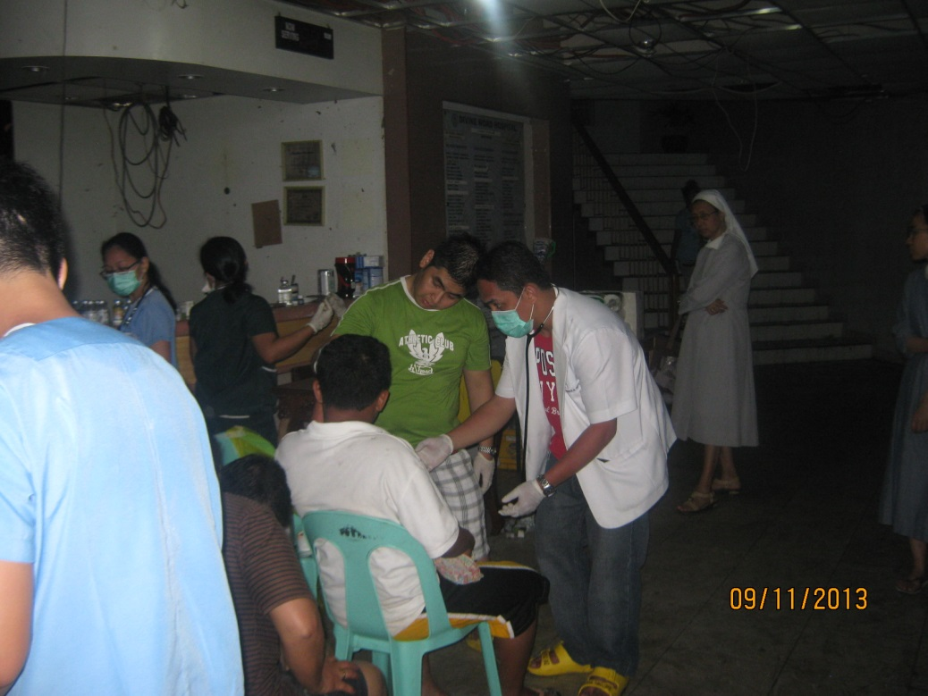

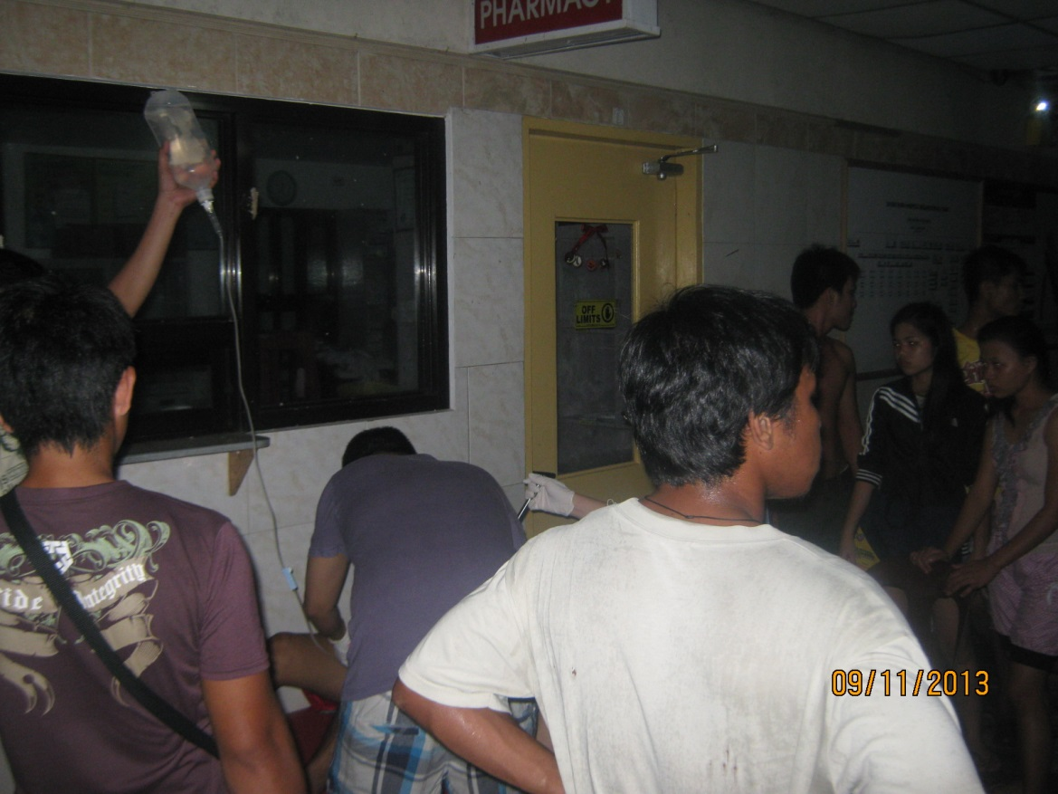

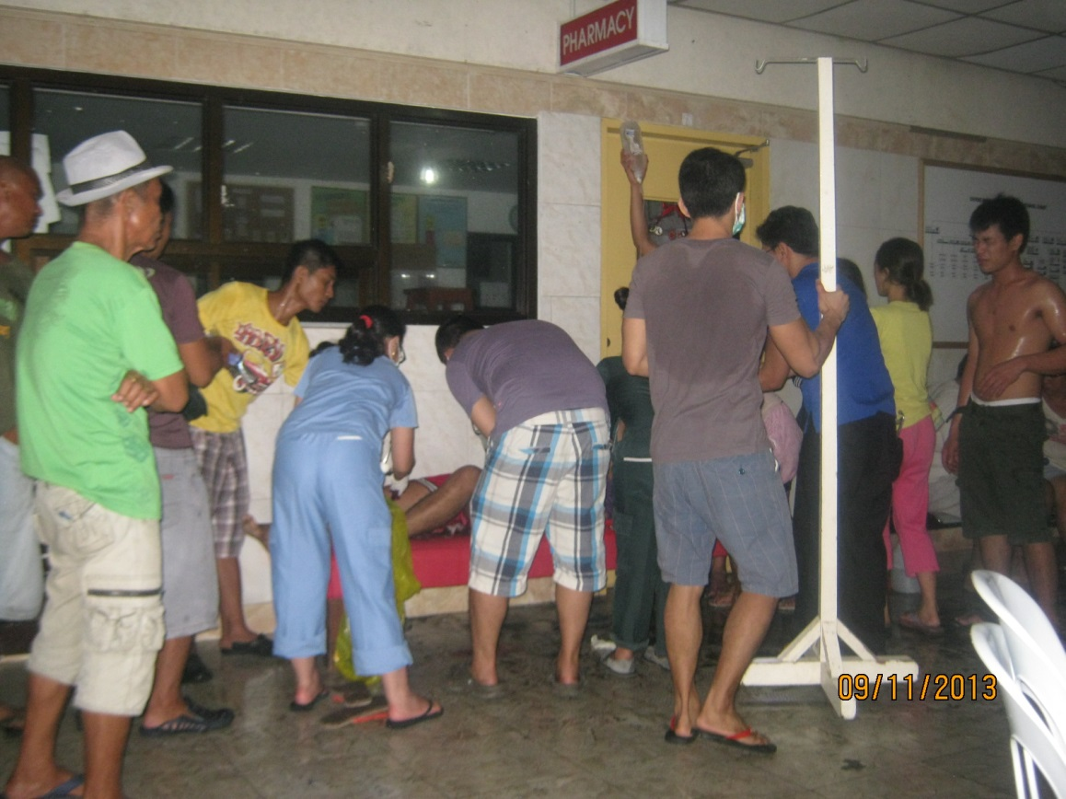

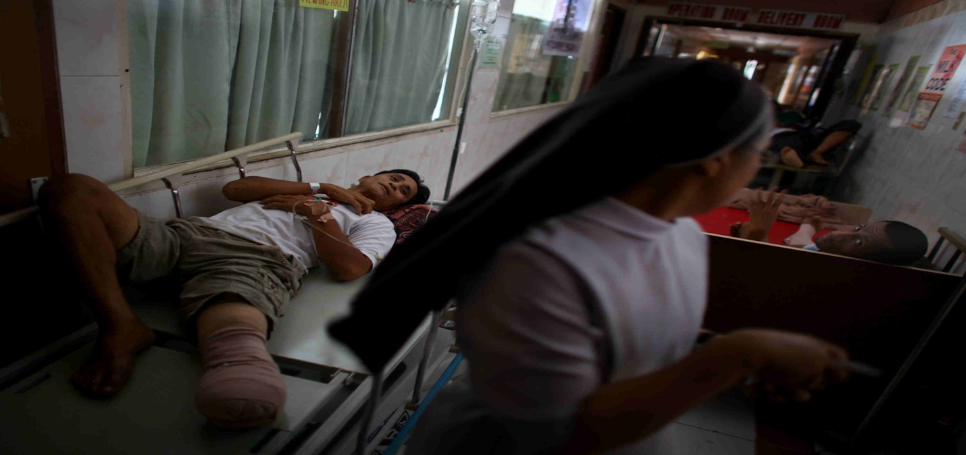

This is the second floor lobby of Divine Word Hospital occupied by victims of Yolanda*

KAKAK and DWH has to source out its additional medicines outside Tacloban City since all the pharmacies were destroyed during the surge.

The medical relief operation were held basically in DWH with volunteer doctors and nurses that formed the instant trauma teams of kakak .

On the first week KAKAK ordered antibiotics ,antiseptics, supplies needed in minor operations done in the emergency room since their was no power in the whole city and it took some time before the generator of the hospital could function .The flash flood reached DWH and was almost two storey high. It damaged all hospital equipments including the generator.

On the first seven days after the storm , Kakak trauma team was able to treat around 400 different types of injuries mostly in the heads, upper arm and lower legs in victims trying to swim their way to safety during the surge. There were patients who walked a day or two before they could reached DWH .The roads were unpassable to any type of vehicles with posts, trees ,rooftop blown by Yolanda in the middle of the street aside from the debris brought in by the flashflood.

During the second week when the roads were already passable ,Sister Eloisa David, the head of KAKAK and during that time was the administrator of the hospital used some of the funding in getting potable water from Alang Alang ,Leyte to the hospital. Transportation was provided by then Leyte Governor Jericho Carlos Petilla. Sr. Eloisa passing by a mentally ill person along the highway going to Alang Alang did not have the heart just to leave her behind shivering, wet and also wounded.

Upon reaching Alangalang,Leyte where the office of its sister foundation ARADO was located, Sister Eloisa who is also a medical doctor conducted an on site medical assistance mission giving the coconut farmers of the area clean potable water, over the counter medicines for fever, cough and

Supplies to clean wounds mostly for children aged five years old below. The female mentally ill patient was treated and later brought to Asilo de San Benito in Babatngon, Leyte, a sanctuary for mentally ill people found in the street of Leyte by Sr. Eloisa .

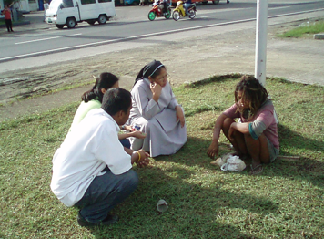
BEFORE

The challenge to give the victims of ST Yolanda the proper medical care was paramount compared to any previous storm that rampage the Philippines. Anywhere you turn someone, a child, an old woman,men, women needed some sort of medical relief.

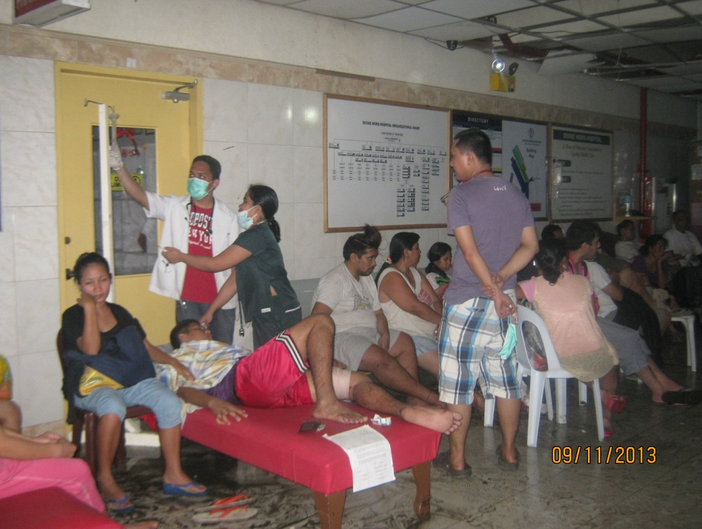

Patients at the main lobby of Divine Word Hospital after ST Haiyan/Yolanda*

All of the medicines ,OR and other medical supplies, potable water bought for the victims of Haiyan through the funding of global Giving , KAKAK Foundation and other private donors amounting to P250,000.00 were consumed by the end of November, 2013. It helped around 1000 injured victims and 200 households in Alang Alang leyte for the potable water.

