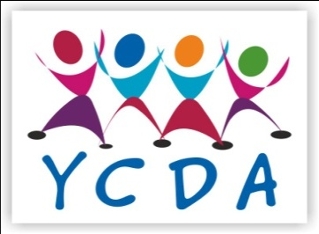
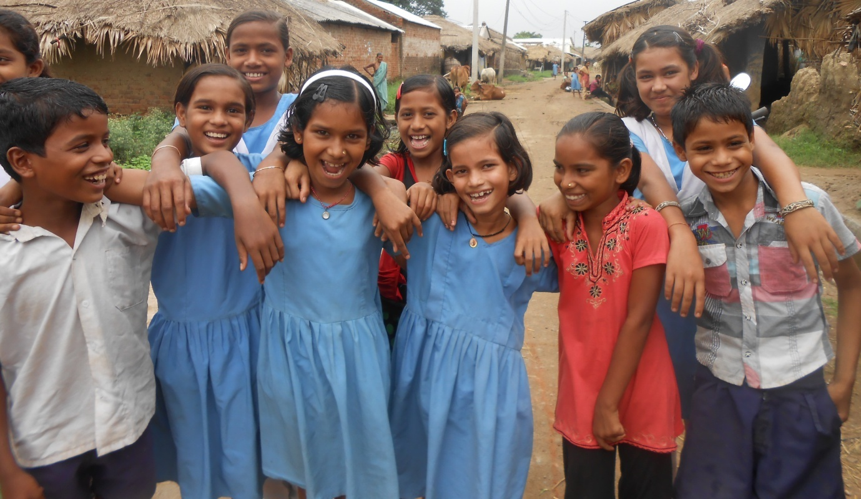

Implementing Agency:
Youth Council for Development Alternatives – YCDA
Baunsuni, Tikirapada Road
District – Boudh – 762 015, Orissa, India
Tel. - 7750018377
Email – ycdaboudh@yahoo.co.in
Website – www.ycdaindia.org
YCDA – Creating Alternatives … Changing lives…

Foster Care for Orphan Children
Summary
Families offer the best protection of children and are more likely to provide the healthy development. Children who have been separated from their families are more vulnerable to abuse, exploitation, and neglect. The lives of those children who lose their father/mother and even both parents are really in a difficult position, consequently nobody looks after them.
To address these issues, YCDA has initiated Foster Care programme with the key focus on care and protection through community based rehabilitation and family focused alternative care to ensure the best interest of the child. YCDA promotes alternative care arrangements with the promotion of safety nets and well being of the child and family.

To ensure the safe livelihood, continue their education and ensuring all-round developments of the children some programmes have been intervened.
Intervention during the Period:
Follow up Visit & support to the foster care children:
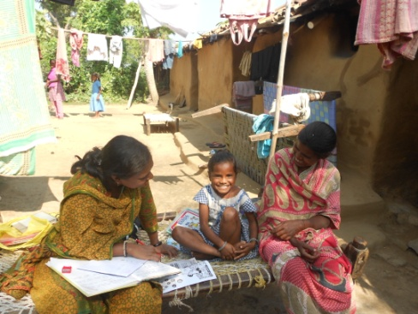
We encourage the children to voice their feelings & Opinions. Our staffs are regularly visiting and giving support to the foster care children. They monitor every child progress & supervising their academic progress & records through ICP Individual care plan. Now, All 100 children are going to school & getting tuition regularly. Their performance has been increased & secured good marks in their class examination. Now they are preparing for annual examination. Based on the need assessment of the child, Sweaters, Slippers, Tuition fees & Food packets have been provided to the these 100 children.
Health Camp for children
A 2nd Unit health camp has been organized for the checkups & follow up for the children in the month of October .During the camp 100 children checked up their health & different disease like skin diseases, Sickle cell, Anemia, Worm infection, Cold fever , fracture were identified . Medicines are provided to the children for cure the diseases & health improvement.

Organise Children Festival for children
YCDA has been organized children festival for children in the month of November. It is a platform for the children to show their potentiality and an option to exchange the idea among the children’s. 200 nos. of children were participated in the programme from different villages. All the children got opportunity to enjoy in their participation in different events and competitions. They got the scope of learning. In the festival all the children were gifted by take home gifts.
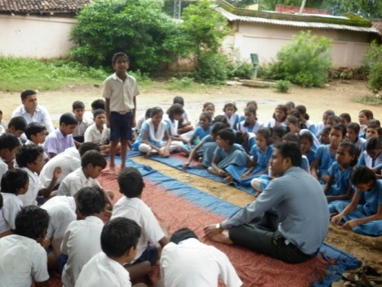
Formation of Children Club
20 children clubs have been formed in their villages for Children where they sit together in a schedule day, discuss the issues related to them and its solution.100 children are regularly attend their meeting where they have got opportunity to know their rights, discuss the children issues like drop out ,school irregularity and issues of the school environment. Then they make action plan & doing advocacy for their rights.
Art & Craft workshop for Foster Care Children
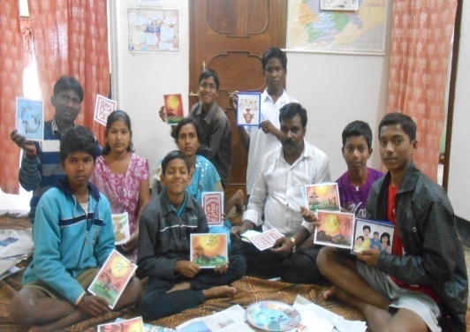
YCDA has conducted Art and Craft workshop for the foster care children where they got the opportunity of learning different art & crafts work .40 children got training and learnt the techniques of preparing some paper art, mask, painting and designing. These children prepared the Mask, greeting cards, ceramic pot art with painting & designing.

Interface of Children, Care givers with Child Welfare Committee & District Child Protection Unit
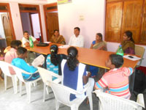
YCDA has been conducted an interface meeting with CWC & DCPU of the district for family strengthening. This opportunity was provided to the care givers, children & community leaders with an objective to take advocacy and demand for the children living with difficult situation .30 nos. of Orphan & Vulnerable children who were living in Alternative Care Arrangement ,Care Givers and Community leaders have participated in the interface & shared their problem of getting Birth certificate ,Linkages with Sponsorship & Poverty alleviation schemes with DCPO and CWC .They demand their rights & gave a Memorandum to solve their problem.
Training to Village Child Protection Community
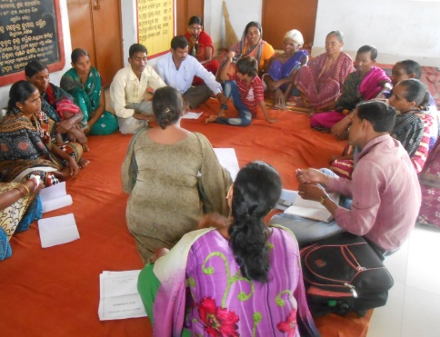
VCPC is the important structure to identify the vulnerable children and to recommend for the rehabilitation and re integration of the children who need of care and protection. Particularly their capacity building is needed for their best. To add on this YCDA has organized different training for the VCPC members for their capacity building. 200 nos. of VCPC members have participate in the training .They have got aware on Foster care & gain skill and knowledge on Integrated Child Protection Scheme, their role and responsibility, the method of vulnerability mapping and social reintegration.

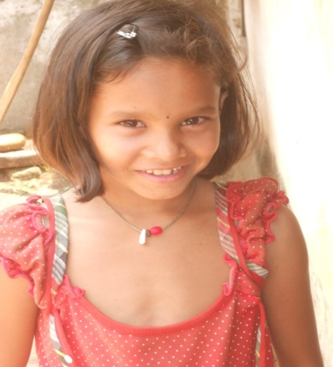
Hiii!!!
Thanks for your support…
I am a 8 year girl living happily with my grandparents. I am reading in class-III. They gave me lots of love & affection. I love to play with my dolls. I want to be a Teacher. I was irregular to school but YCDA didi taught me to understand that education is very important for me .They provide me wring materials, dresses, dolls. Now I am going to school & tuition regularly& also actively participating in different school co curricular activities.

