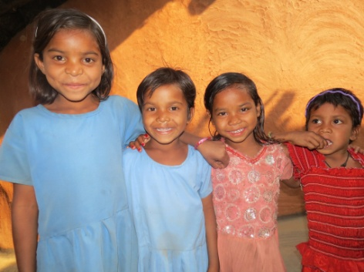
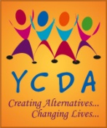
Foster Care for Orphan Children

Updation of Individual Child Care Plan & Support the foster children:
All 100 children individual care plan has been updated by assessing the vulnerability, counsel the child interact with caregivers and stakeholders. Need and planning of every child is different. Based on the planning & need assessment of the child reading & writing materials, Slippers, Tuition fees & Food packets have been provided to these 100 children.
Follow up visit to Foster Children:
Our staffs are regularly visiting and giving support to the foster care children. All 100 children are going to school & getting tuition regularly. They are regularly attended the classes and now preparing for annual examination. All the 100 children have been supported reading and writing materials for their examination.

Training to Caregivers:
78 nos. caregivers actively participate in the training and gain knowledge on child care, Protection and accessing point regarding social security scheme available with govt.

Study Camp
3 days study camp was organized for foster care supported 100 children for enhancement of their learning capacity and prepares them for annual examination. Children practice the question set as per the experts’ suggestions.

Introduction:

Every child should live in a supportive, protective and caring environment that promotes his/her full potential. Children with inadequate or no parental care are at special risk of being denied such a nurturing environment. Children who cannot live with their parents should still grow up in a loving home and enjoy all their rights.

To address these issues, YCDA has initiated Foster Care programme with the key focus on care and protection through community based rehabilitation and family focused alternative care to ensure the best interest of the child. YCDA promotes alternative care arrangements with the promotion of safety nets and well being of the child and family.

To ensuring all-round developments of the children some programmes have been intervened during the period:

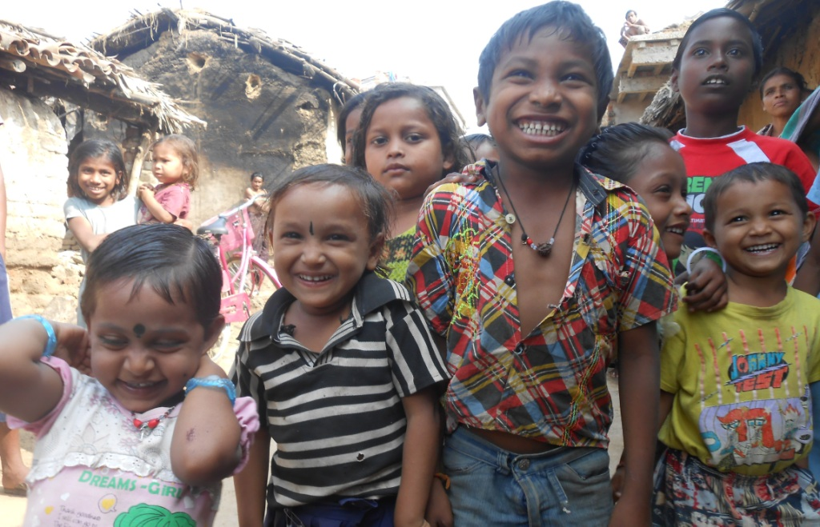

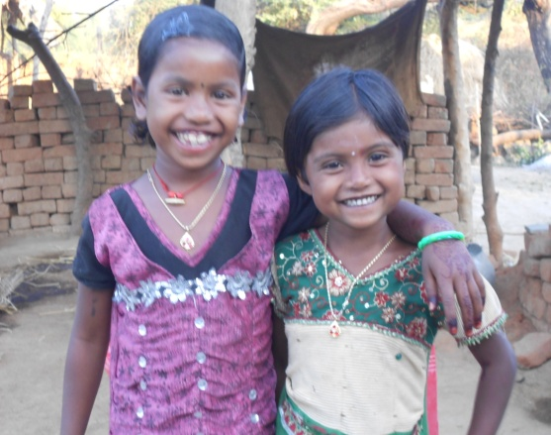
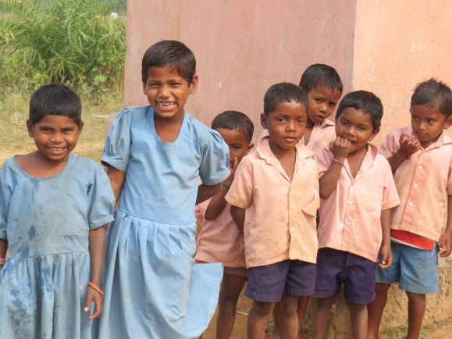
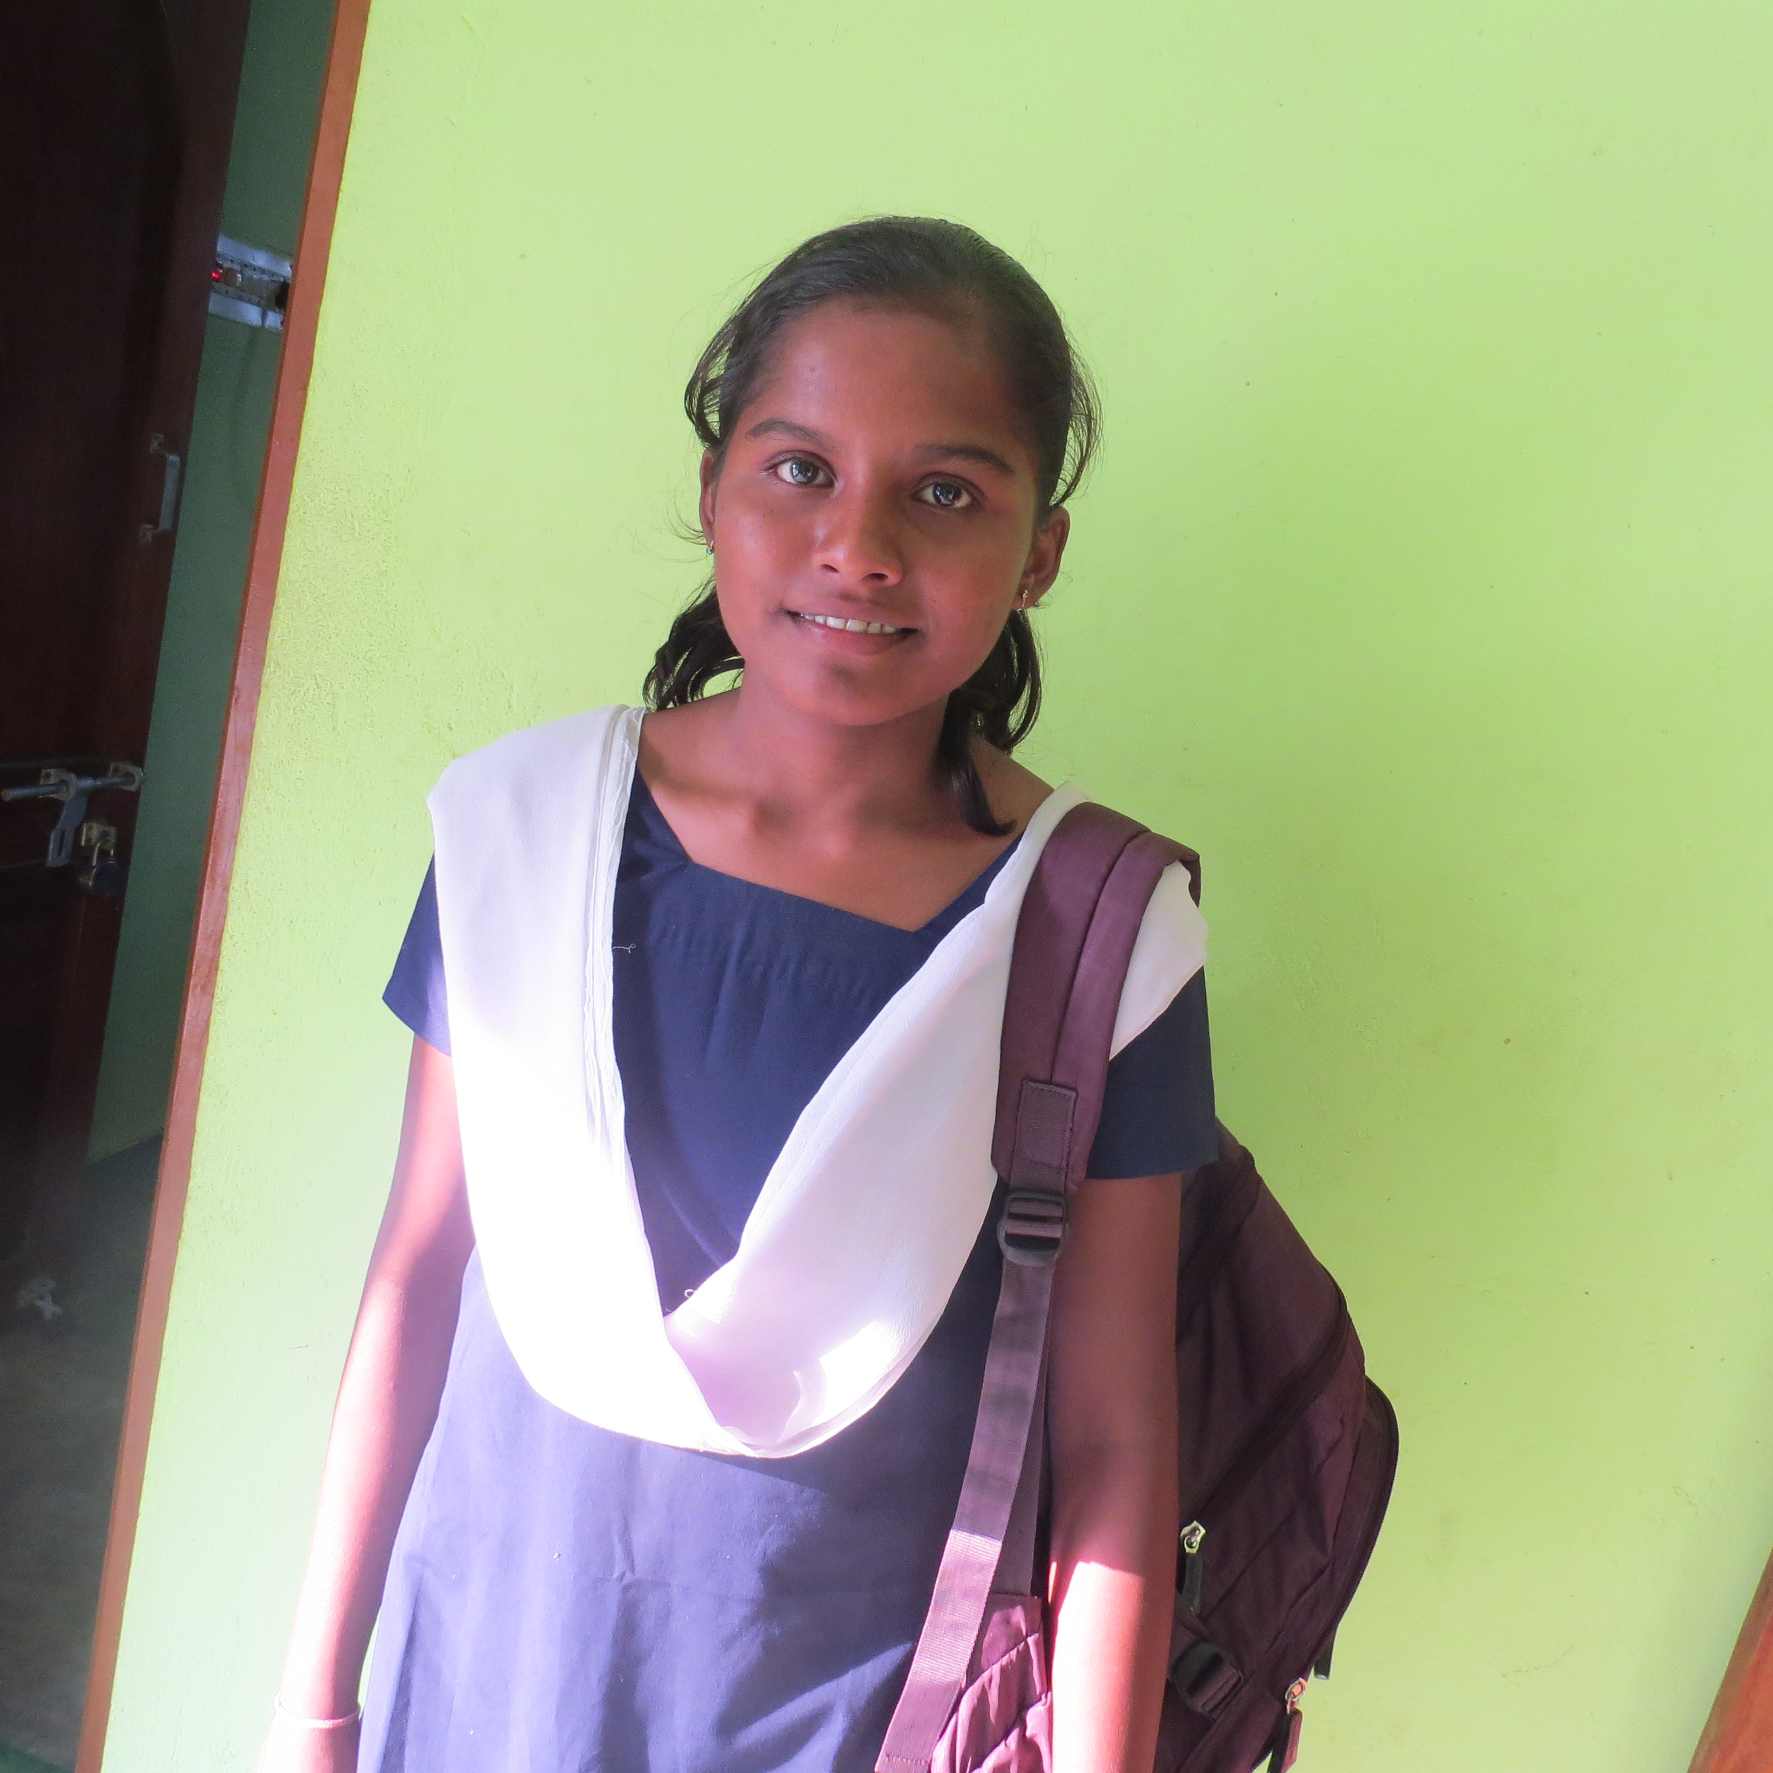
Thanks to all supporters for your support…
I am a 16 years old girl, live s with my old grandparents in a village of Boudh district. They give me much love & affection and fulfill my daily needs. With your blessings & support, last year I passed my 10th exam with good marks & now I am studying in class 12th.
“I want to continue my further studies and get a decent job to help my family. Thanks also to YCDA support to achieve my dreams….”

Children Camp

The children camp has been conducted for foster care children. 100 children have been actively participating in different competitions and share their views with their peer groups. This camp has created a platform for the children to access equal opportunity to enhance their capacity and make them efficient on leadership quality. This programme provides techniques regarding life skill & child right.

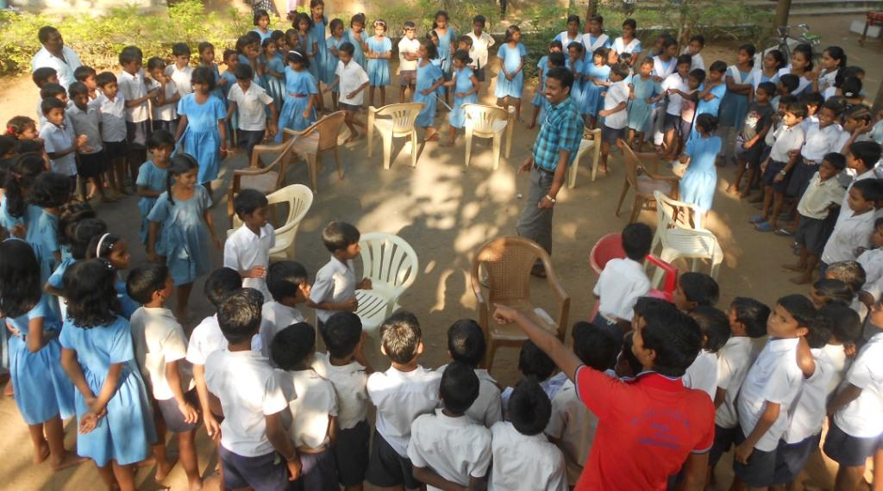

Annual Meet with Children:

This quarter Annual Meet of 100 children with stakeholder was conducted in picnic mode at Balangir and Boudh district where children enjoyed the picnic by singing, dancing, storytelling, jokes telling, playing and talking. Stake holders from CWC, DCPU, Teacher, VCPC took active part in the picnic and appreciated children participation & encourage them.

