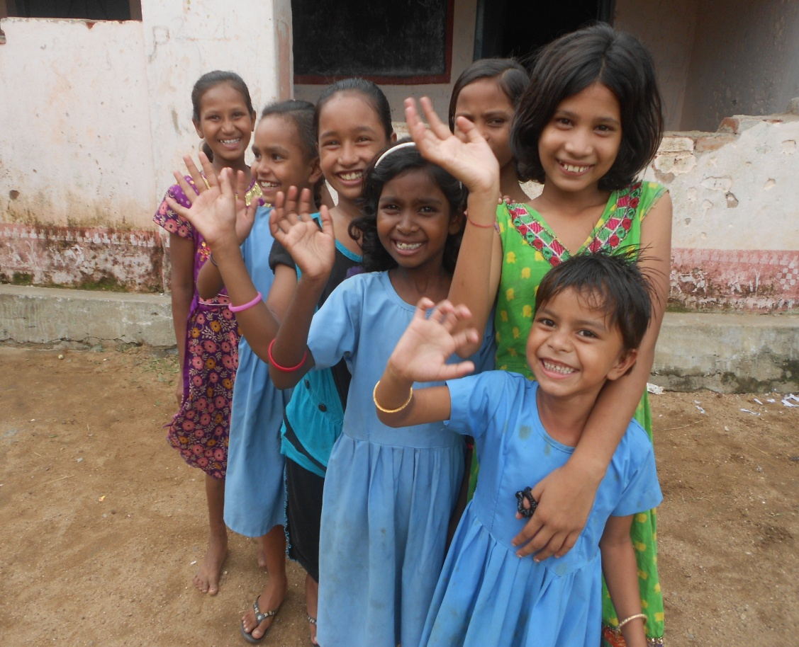
[ Report on Foster Care for Orphan Children ]
Implementing Agency:
Youth Council for Development Alternatives – YCDA
Baunsuni, Tikirapada Road
District – Boudh – 762 015, Orissa, India
Tel. - 7750018377
Email – ycdaboudh@yahoo.co.in
Website – www.ycdaindia.org
YCDA – Creating Alternatives … Changing lives…

Summary
Foster Care Provides Care and Protection to children outside family:
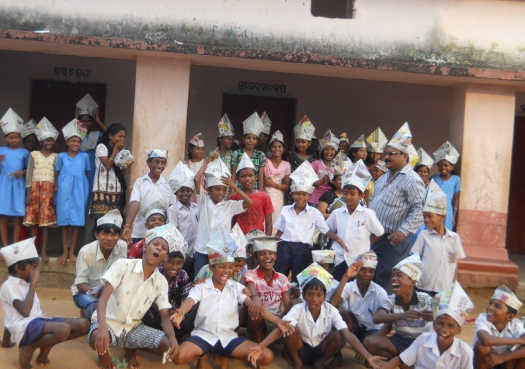
Children are the most vulnerable members in a family and community. When one of their parents or both of them die they suffer a lot .They also suffer the most by various disease, domestic conflict, and natural calamities. The lives of those children who lost their father/mother and even both father and mother are really in a difficult position, consequently nobody looks after them.
Children without parental care are at greater risk. The numbers of children without parental care are found in both rural and urban areas. It is a common to find the children in normal families are struggling to realize their full development due to many factors including parental care, financial constraint and poor economic condition.
In spite of all this, children are living and still trying to achieve their rights.
The most important task is to ensure the safe livelihood, continue their education and ensuring their all-round developments.
Intervention during the Period:
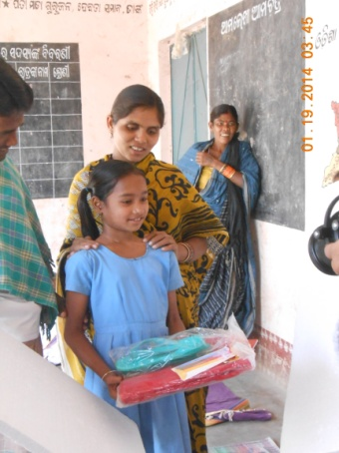
COUNSELING TO THE FOSTER CHILDREN & SUPPORT:
50 children who are in the emotionally disturbed are having the counseling support. Now 50 children are going to school regularly and getting education. Children are getting additional support for their education and livelihood. Dress materials, school bags, read ing and writing materials, tuition fees and food packets are provided to the children as per their needs. Staffs are regularly visiting and giving support to the children.
FAMILY STRENGTHENING PROGRAMMES
For sustainable socio economic development of vulnerable family various income generation activities (IGP) support has been provided to 20 families. The families are getting average income from the IGP support and spent for the children’s education. Different initiatives have been taken for linkages these families with govt. entitlements. During this period families 15 have availed facilities under different schemes BPL, Old age pension, Widow pension , Indira Awas ,Free rice scheme, Disability certificates

Training to Care givers
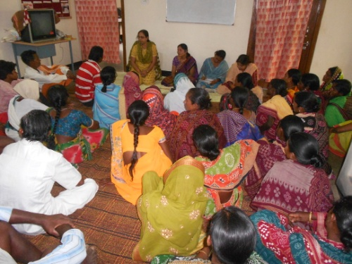
100 caregivers have been able to aware on the care and protection of the children, got orientation on parental skill, developed capacity on child nurturing. In the training programme different topics like four rights of the child, Growth and Development of children, Love and affection enriches child’s personality has been discussed. They gain knowledge on various poverty alleviation schemes and how to avail that.

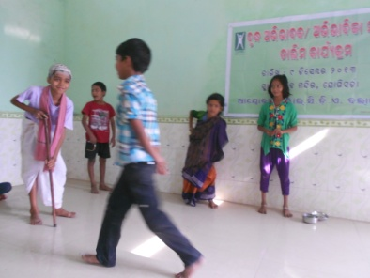
Children Camp
The children camp has been conducted for 200 children where they can come together to a platform to enhance their capability. This camp has created a platform f or the children to access equal opportunity to enhance their capacity and make them efficient on leadership quality.

Advance life skill training
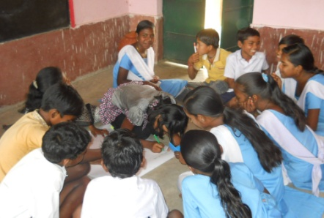
100 Vulnerable children have got orientation on the life skill training. Children could learn the stress management, copping attitude, decision making and self awarene ss.
Children have got different techniques regarding life skill & child rights Children could learn the need of Participation, Protection, Survival and Development.
Story of Changes
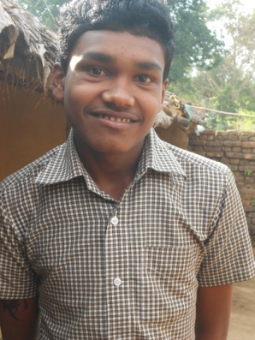
A 16 year old boy was living a happy life with his parent and 3 sisters Unfortunately he lost his parents and got extreme vulnerable to get education and livelihood with his sisters, with the support of YCDA he could manage to pass the higher secondary education but there after he failed to get the technical education for his self estimate .In the mean time the Global giving opportunity could support to take the admission in technical education.

Hii “Thanks to Global Giving for his kind support and help me for which I could fulfill my dream of continuing my education and confidence to support my family.

