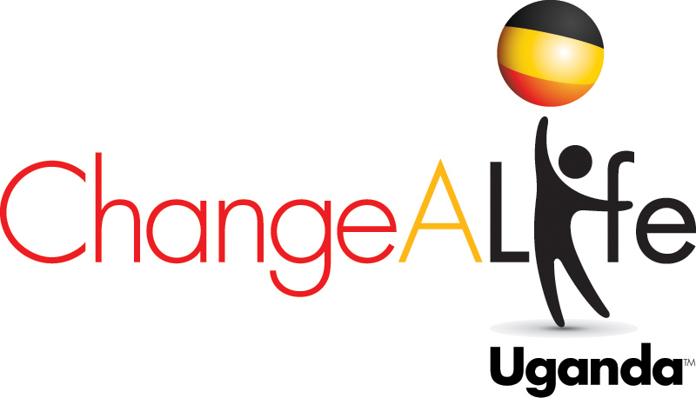

Quarters for Water
Clean Water for Migyera, Uganda
www.changealifeuganda.org

Quarters for Water addresses the very serious challenge of access to clean water that is extremely limited in this semi arid climate of Migyera. Women and children spend hours walking to streams and ponds to collect small amounts of water, much of which is contaminated, making it the source of life-threatening illnesses such as typhoid and malaria. Shallow wells have dried up and lack of water is critical. Through donations to our “Quarters for Water Program” from US school children and individuals we are raising the money to provide a permanent solution to bring clean, on-site drinking water for students of St. Lawrence School, the health center and their rural village of Migyera.

Progress:
- A new roof water collection system has been installed on the school consisting of four tanks along with one at the health center.
- The new well site is just 1.5 miles from the school on land purchased with funding from this program.
- In November 2011, a 510’ well was dug.
- In 2012, a pump house and 50,000 L water tank was constructed and electric poles and lines were installed.

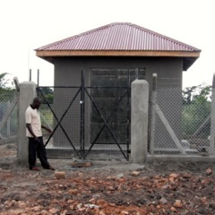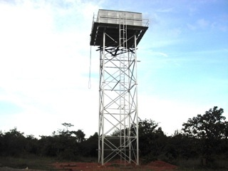

Goal: The project balance is $93,0000 which is the cost to purchase a submersible pump, lay the pipes to connect the pump house with the water tower, a distance of 1.5 miles, and distribute the water to the school and health center before the next dry season. CALU has $81,000 toward the goal.

Background: This is our priority 2013 project. When finished it will bring clean water to our school of more than 500 children and the new health center in addition to the village of Migyera. The project was started in 2009 with brainstorming on how to bring water to this semi arid area. Drilling a shallow well was unsuccessful and the few that exist in the town dry up. We hired a hydrologist from Ethiopia who found water in NOV 2011 at the first drill site down 512’ into the aquifer! After the engineering plans were drawn up and approved, the 50,000L tower and the pump house were constructed in 2012. Now a submersible pump and the pipes to connect the water tower and pump house are needed. School children in NJ have contributed over $55,000 of the $159,000 we have already funded to bring the project to its current level.

Future Components of CALU Water Project:
Water for Education educates children on the most modern means of water usage and conservation, water harvesting, water purification and water storage.

Gray water system installation to be used for irrigation
With this the school will be able to implement the following irrigational projects, because of the water supply will be constant from the gray system.

- Bucket method for demonstrations at school
- Keep environment green program: (this maintains the grass, planting tree etc.)
- Provide water for Animal Farming –demonstration Nabbingo
- Lying irrigation pipes within the school compound, sports grounds, the school gardens,

WATER FOR HEALTH (WFH)
CAL through the Water for Health program would use water to improve the health, living conditions and hygiene of the children and their families. Within this component, CAL intends to supply water to the health facility, to public facilities like toilets, improve the sanitary use of water e.g. improve the bathrooms of the patients at the health center, the bathing facilities of the children at the school, and the bathing facilities in the homes of the children.

WATER FOR INCOME GENERATION (WFI)
CAL through the water for income generation would educate families in methods of collection, preservation and water usage for improved income generation. Within this component, CAL would encourage all families to have a water harvest system, a simple gray water management system, and an irrigation system as demonstrated at the school.

ChangeALife Uganda Water Project October 2013
Water Project Remaining Balance:
Balance Phase One: | $40,084
Phase Three (Raw water pumping main to reservoir) | $35,076
Phase Four (distribution) | $17,237
Total amount remaining | $92,397
The work to be completed:
Balance on Phase One: | $40,084
Major Works at the pumping station (Under current Contract)
1. Assorted pipe work, fittings and valves (plastic pressure pipes will be used as opposed to metallic pipes in the borehole since they are much lighter and therefore easier to install and maintain) | $5,153
2. Four (4) isolated pipe supports @$67 | $266
3. Painting of interior and exterior wall surfaces (67m²) of the pump house | $259
4. Grundfos submersible pump set with 3-Phase motor complete with all necessary controls (7.5kw, discharge=6.5m³, head=219meters) | $14,873
5. 3 phase power connection to pump house including application fees | $2,725
6. Power control unit for submersible pump | $1,731
7. Cabling from power control unit to water pump | $2,975
8. Control electrodes, lightening protection and earthing | $1,541
9. Tools and equipment | $346
Major Works at the reservoir site (Under this Contract)
1. Land scaping | $347
2. Pipe work manholes and pipe work ancillaries | $936
3. Pavings | $138
4. Fencing of the reservoir including gate | $1,612
5. Reservoir plumping works | $7,183
Phase Two: Power Line Repair and Repair of Transformer
Phase Three (Raw water pumping main to reservoir) | $35,076
Demolition and site clearance | $1,082
1,575 meters of plastic pressure pipes @$17 | $26,703
Assorted pipe work fittings and valves | $2,967
Assorted pipe work manholes and pipe work ancillaries | $1,293
Assorted pipe work supports and protection, ancillaries to laying and excavation | $3,031
Phase Four (distribution network from Reservoir to users) | $17,237
Demolition and site clearance | $398
661 meters of plastic pressure pipes @$14 | $9,551
Pipe work fittings and valves | $2,510
Pipe work manholes and pipe work ancillaries | $738
Pipe work supports and protection, ancillaries to laying and excavation | $4,041

Help Her Sleep Well

Meet Najjemba. Najjemba is a 12-year-old student at the St. Lawrence School in Migyera, Uganda. Her education and dormitory fees are sponsored by a family in New Jersey through ChangeALife Uganda.

What would access to clean water mean to Najjemba and the other 55 girls in her dorm? A better night’s sleep and eliminating health concerns related to water and sanitation.

What do sleep and access to water have to do with each other? Well, our students do not have access to clean running water or indoor lavatories. This means either unsafe, scary trips in the dark to the outdoor pit latrine or improvised solutions like unsanitary buckets kept under the bed. It also means no sips of water to soothe a coughing or thirsty student. No easy access to personal or menstrual hygiene and hand washing opportunities. These conditions lead to health issues like urinary tract infections, diarrhea, parasitic worms and typhoid and make getting a good night’s sleep challenging. All of the issues related to clean water and sanitation ultimately affect the girls' ability to excel in school.

Access to water will help improve Najjemba and her fellow students' health and daily living conditions. We are so close. We have drilled the well and built the water tower. We need to raise a final $12,000 to connect them and complete the project.

In Migyera, the new school year starts in February 2014. Imagine how excited Najjemba and her fellow students will be if they can turn on the faucet, use indoor plumbing and shower for the very first time.

Please help us help Najjemba sleep well. Every donation helps. Let’s finish the water project.

Contact: Jean Semler
President ChangeALife Uganda
46 Oakmont Lane
Jackson, NJ 08527
jsemler@changealifeuganda.org
Cell: 732 779 1

