February cases

Case 1 Epilepsy in children
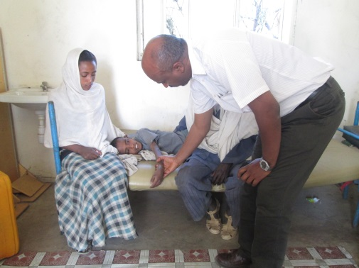

An eleven year old boy had seizure since 6 months from birth. The boy was brought for medical attention when he was 8 years old and when the seizure got worse. The father who brought him to the Maksegnit said that the by showed remarkable control of seizure after he was prescribed phenytoin 100mg /day. The boy developed skin rush within two months but the family stopped when rush was worse and restarted when it improved until two years ago when they finally stopped the antiepileptic as he developed rush all over that turned out to be serious. For a year they avoided the drug and the boy restarted to have his convulsion. Finally when the convulsion was too frequent (persisting day and night), he was again brought to the health centre. The boy doesn’t go to school because of mental retardation. His mother had a prolonged labour of over 12 hours according to the father, who brought the boy to the health centre accompanied by his daughter. The seizure was stopped with Diazepam and he was started on 60mg of phenobarbiton rather than 30 due to the frequency of seizure

Case2 epilepsy in children

A 13 years old boy from rural maksegnit area had seizure for 4 years and was on treatment for 2 years and is now seizure free unless he discontinues medications due to the distance from his house to the health centre. The family lived about 3 hours walking distance of about 20kilometers by short cut or 1 hour driving(100km) plus one hr walk 7 km) for the Maksegnit health centre. The boy had discontinued school at grade 1 due to his seizures but now is planning to start school next academic years as he is no more afraid of his convulsive attacks while he is in classroom. He and his falimly had also now believe that seizures are controlled while still on drug and therefore promised to adhere to drug and discontinue when he gets better like he and his family did until now.

