1. Mother of an epileptic infant, Asendabo

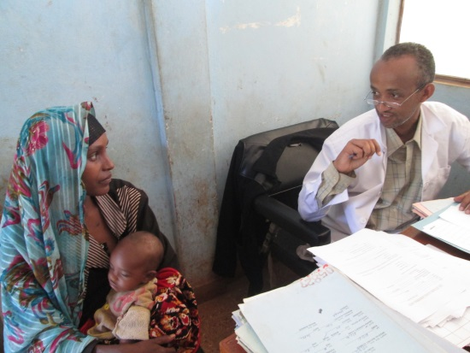

Epilepsy among children is also common. Perinatal injuries, post infection such as meningitis and malaria may be the common risk factors in rural Ethiopia, such as a Asendabo, Jimma area, shown above. Asendabo is malaria endemic area and a large number of cases can be prevented through prevention, early detection and treatment of malaria. Through prevention and control strategies the incidence of malaria and large scale epidemics has been almost eradicated and this is expected to have an effect on incidence of new cases of epilepsy in children. Prevalence of Seizure associated with fever but without CNS infection is 3-5%. This occurs below the age of 5 years and peaks between 18-24 months. Development in such children would be slowed and some may develop problem of learning and social interactions in schools

2-Rare epilepsy case

The girl whose picture is shown here is from Agaro area some 400 km west of the Capital Addis Ababa. She has a relatively rare epilepsy referred as psychomotor (complex partial) epilepsy. She never falls losing consciousness completely but has strange incessant activity with her hand and she losses awareness to her surrounding during the attack. As a result her family and neighbours though she has evil spirit possession and probably mental illness and were resorting only to traditional medicine and religious rituals.

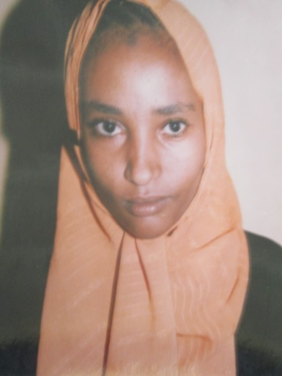

Picture 3 : Kwashakoir baby and an epileptic mother

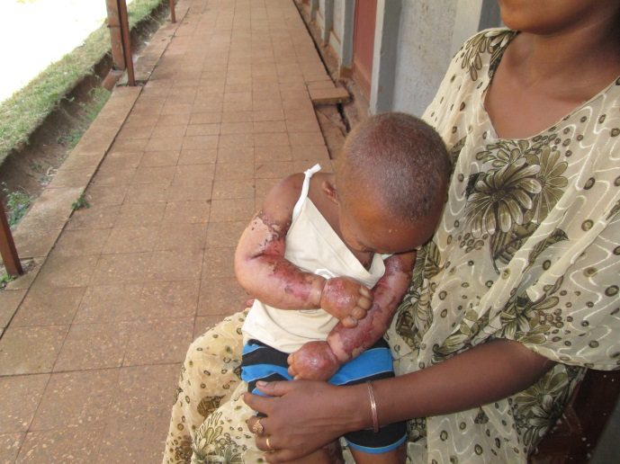

Neglect has resulted in Kwashakoir, a protein energy malnutrition in 2 years old boy raised by an epileptic mother. The mother because of her seizure disorder has been apparently preoccupied with her illness and unable to breast feed the child properly, wean him on supplemental food on time. Additional reason was that the mother was poor with no support by her husband. He has left her because of her problem which was obviously attributed to evil spirits and curse

Picture 4: red hair of kwashakior in the same child
