Diabetes in a village man

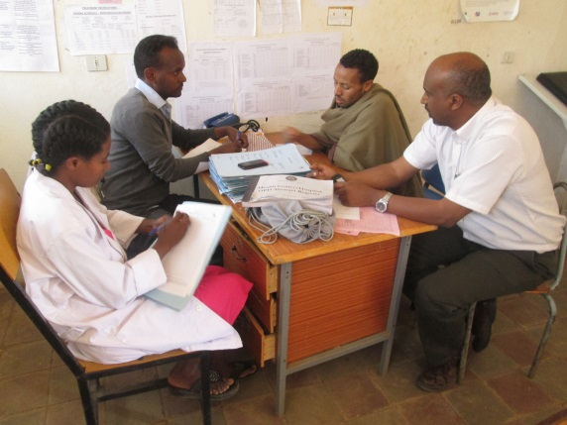

A 24 years old man from Enfranze presented 3 month ago within 15 days of onset of polyuria, polydipsia, and generalized body weakness. His blood sugar was 360 and he was started with hypoglycaemic agent at the local private clinic. His condition deteriorated slowly until he lost 10 kilogram (52 to 44 kg) and also his blood sugar level rose to 444, so that he decided to go to the health centre to see the chronic disease nurse. The nurse, after evaluating the patient, concluded that the patient is most likely a type one diabetes and had erroneously been prescribed hypoglycaemic agents, instead of insulin or a referral to the Gondar hospital for workup. He was therefore given instruction about his condition and was referred for further work up and education to Gondar teaching hospital. This must have saved his life. He went home from Gondar to his village, accompanied by his two friends and his mother. Yet again, this patient illustrates the vital part played by nurses who have been trained through the chronic disease programme, where their critical skills save lives.

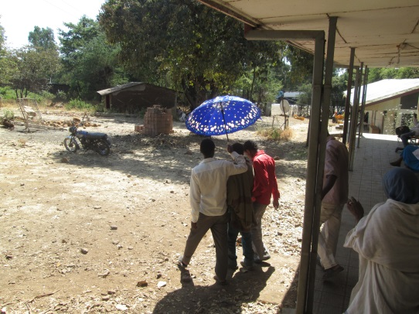

A 35 years old Diabetic whose sight was saved
A 35 years old young man was sent to Gondar University hospital from a Health Centre after a wound in his right foot has failed to heal for more than 2 weeks in spite of treatment locally with dressings and antibiotics. The nurses team in the polyclinic thought that he had Diabetes Mellitus, which was indeed confirmed by his high blood sugar level. Examination of his eyes showed that he had damage to his retina, with easily seen exudates and haemorrhages which indicated that his disease already had one of the feared chronic complications of diabetes, which could later result in loss of vision. Fortunately, the ophthalmology department was able to give laser therapy so that his sight was saved and he is being cared for at Gondar university Hospital.

The fact that diabetes in this man was first seen when he had advanced disease, because he did not complain of symptoms of disease, apart from the lack of healing of an infection, shows how alert the health team has to be. Such patients will continue to be seen until we have been able to give many more public health messages at Health Centres so that disease can be detected earlier in future. He was fortunate because the high awareness of nurses trained by our Programme in the Health Centre was their reason for referring him al for further investigation; it was they who noticed that the foot ulcer was not healing as expected.

