Developing nurse leaders in advocacy for building Chronic and Non-Communicable Disease care,
an Ethiopian experience.

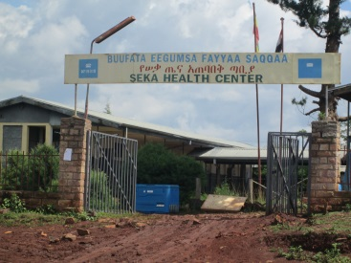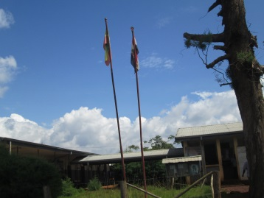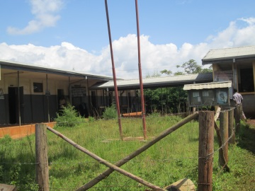

The story of the development of four nurse leaders in chronic disease care for the rural poor.

Etalem Seid, is a woman who has always excelled at climbing the leadership ladder. We began working together in 1999 while she was a diploma nurse at Shebe Health Centre in south west Ethiopia. We noticed early-on that Etalem was a sharp learner who quickly absorbed the training and information given to her on managing epileptic, diabetic and hypertension cases. Her evaluations and follow ups with patients, excellent record keeping and the coaching of a junior nurse to assist her, were all impressive efforts and embracing of the spirit needed to work independently as a nurse leader. Picking up on Etalems’ ability to organize and lead, we recruited her to become the projects co-ordinator based in Jimma, from where she coached and supervised nurses in other health centres. Given further encouragement to study, Etalem went on to complete a Bachelor of Arts in Heath Services Management, swiftly followed by the completion of a THET-funded, Master of Arts in Health Services Management.

Etalem is now Associate CEO at Jimma University Hospital. She is a mother to two boys, aged 8 and 10, and is looking for promotion to CEO of a large public hospital in Addis Ababa. She has developed several competencies and her career, in health services management field, has blossomed.

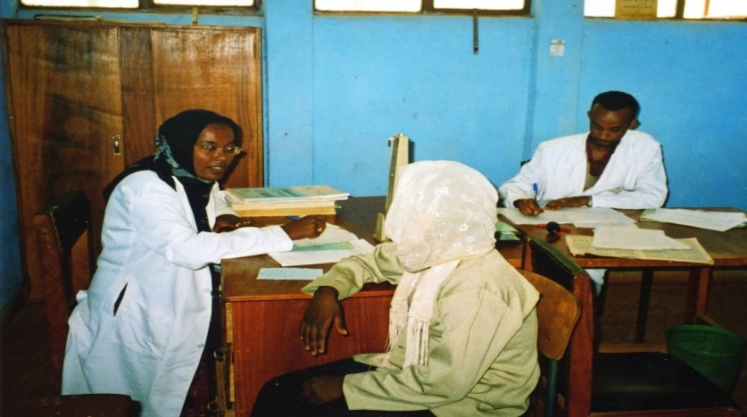
Picture 3:Etalem independently in a chronic disease clinic at Asendabo, Jimma area.

Getachew is another leader, who started as a diploma nurse in south west Ethiopia, this time in Agaro. When I met him first in 2002 he was very enthusiastic, keen to help patients and be involved as a chronic disease nurse. We were bitterly disappointed when he was unexpectedly moved to Sigmo Health center, over 100 km away to the north west of Jimma. Despite complaining to the health bureau that our significant financial investment, as well as the time and energy spent to train him in being an effective leader and independently practicing nurse, was being torn apart, our pleas fell on deaf ears. We had to train another nurse to replace him. One day several weeks later, Getachew walked into my chronic disease clinic at Jimma University hospital. I greeted him rather coolly and asked him why he was there. He told me that at Sigmo health center, where he has moved to, he had lots of cases of epilepsy and needed our help in getting phenobarbitone (epilepsy medicine). I asked him “How come? We didn’t send any epilepsy patients in your direction’. He explained that he had witnessed epilepsy sufferers being chained in dark rooms within family homes, to hide them from the predominantly-Muslim community that has stigmatized them as possessed by evil spirits. Having conducted a series of community health education sessions, demonstrating seizure control using phenobarbitone (his old colleagues in Agaro had sent him some), news quickly spread all over the country-side. Now, many epileptic patients are showing up at his clinic doorstep from far-away areas and being so overwhelmed, he had to come to us in Jimma for help. What a protégée!

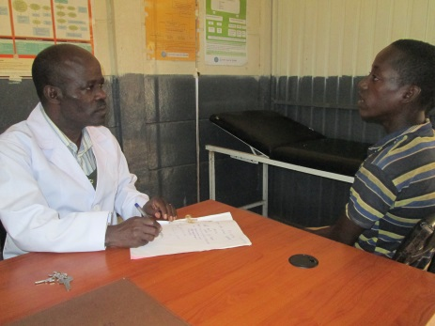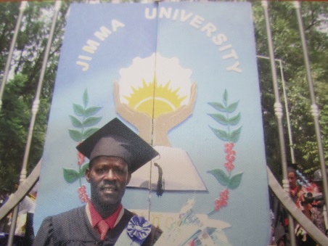
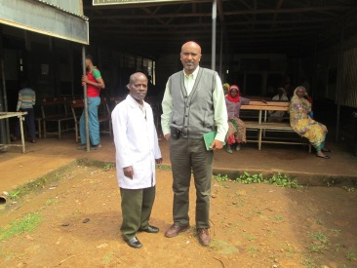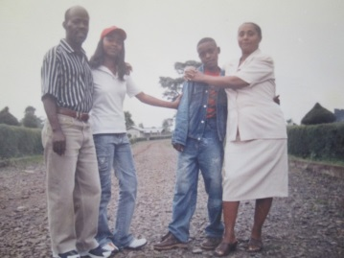

We were all impressed by his efforts and started to support him with drug supply, mentoring and supervision, all of which are standard issue when we start to support a nurse and health centre in chronic disease care. He was not lost to the cause after all. He has merely moved to a different community, which is in fact an even needier one.

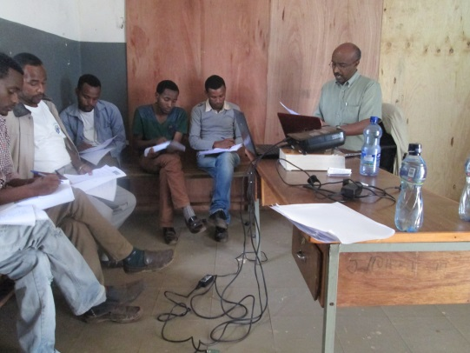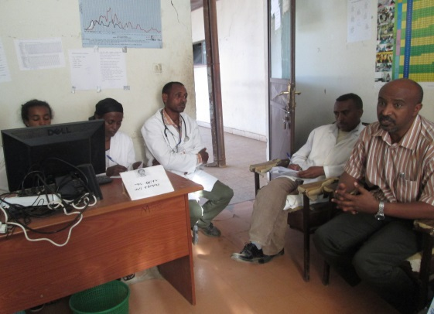
Pictures: Mentoring and case discussions in health centres.

Getachew later moved back to Agaro and upgraded his professional nursing qualifications with a Bachelor of Science and has continued to serve patients at the town health center. His children have grown up and are themselves now studying at university. From interacting with Getachew, I have come to see not only how his abilities to collaborate to solve local problems have sharpened, but also his communication and persuasion skills, which he used to convince his community to bring out their epileptic sufferers. Even here in Jimma, we now venture 100 kilometres out from our base to reach epileptic sufferers in need. He has also taken with him his skills of caring for chronic disease even when he is not supported by a physician. He said to me once that he is now stuck with chronic disease, that he can’t stop caring for patients, even if no help were to come from Jimma, because he has found out once and for all, ‘Yes! He can’ help.

Fuad is another committed nurse, who continues to work with us and take care of chronic disease patients in Asendabo health centre. He also started working with us as a diploma nurse, although he upgraded his skills by studying for and completing a Bachelor of Science course. Faud is still in Asendabo, serving patients, making him among the very few to continue faithfully serving his people, despite the rural and isolated location of the community.

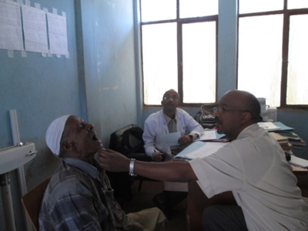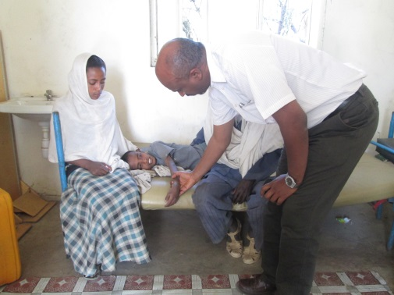
Picture 1: Diabetic patient with dental and oral problems. Picture 2: An epileptic child during attack at Asendabo under the care of nurse Fuad, in gown.

Fuad is a meticulous record keeper, an excellent patient evaluator, enjoys consulting with us on problems and takes criticism very well. He is particularly good at patient care and handles emergencies, as well as new cases, with confidence. He has many elderly patients who suffer with diabetes and yet still smoke cigarettes and use khat, which he has had some successful in counselling against, bringing about positive behavioural change in some of his patients.

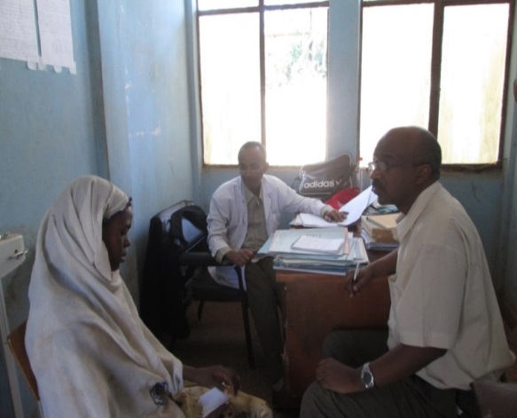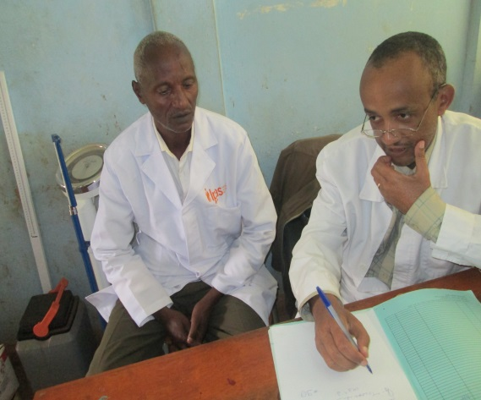
Picture: Fuad (in white gown) talking to a patient at Asendabo clinic in the presence of his mentor physician, Dr Yoseph (short sleeve).

Last but not least is Kebebush who started at our central chronic disease referral clinic at Jimma University Hospital as a janitor. She was promoted to data and records clerk and noting her conscientiousness, supported her nursing training which she passed with flying colours. She is now a project coordinating nurse, have succeeded Etalem and is currently upgrading her professional qualifications through a Bachelor of Science nursing programme.
Kebebush utilizes various non-monetary incentives to keep the health centre nurses motivated at work and uses her personal charm, genuine concern and listening skills to support the nurses with any personal problems. She has built a close personal relationship with the nurses and they are free to tell her their honest thoughts. She always comes up with creative ideas about how to keep the nurses’ moral high and motivate them to keep caring for patients and maintain accurate records. One of her suggestions is to refresh nurse’s knowledge with classroom-based teaching and also to hold review meetings with health extension workers during her supervision visits, so they can discuss any practical problems with identifying and referring cases to the health centres.

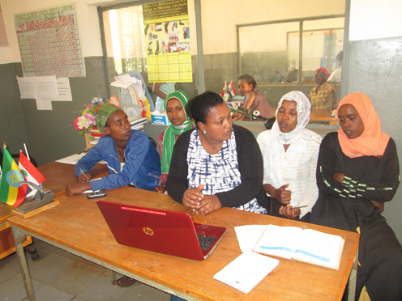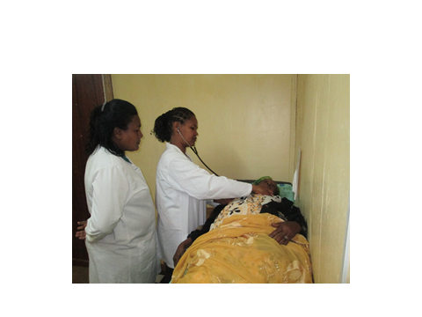
Picture 1; Kebebush discussing with health extension workers the importance of identifying cases and referring them from the community health centre. Picture 2: Kebebush examining a patient with Sister Fantaye, a Head Chronic Disease nurse.
Mentoring and supervision are essential parts of this initiative. We cannot abandon health centres and their nurse once the project has begun, unless the health centre is considered a candidate for graduation from our support. This would be unethical and we have a responsibility to these health professionals, who by law are not certified to prescribe drugs directly to patients, but work under the doctors’ supervision and mentoring.

The health centres can graduate and operate independently only once a doctor or a health officer is assigned to the health centre, or a hospital is opened in the same town. In these cases, physicians who are adequately trained professionals will be available to handle patient’s problems independently without our support, mentoring and supervision. Kebebush is the core person coordinating all these essential activities and keeps the process running smoothly.

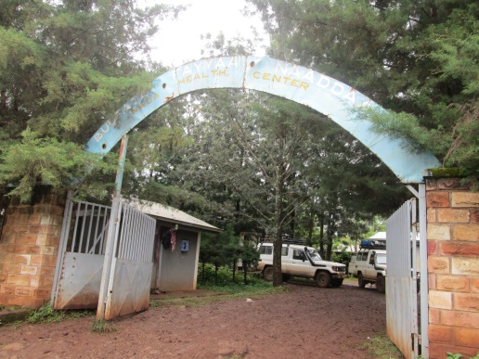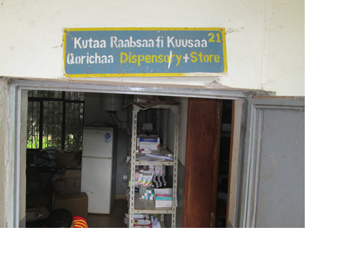
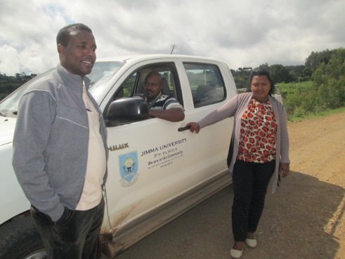
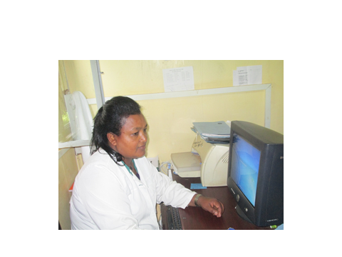
Picture: Kebebush (current Jimma project coordinating nurse) with physician and driver on the way to supervision and mentoring visits with Dedo health center nurses. Picture 2: Kebebush compiling data at the office in Jimma.

