EMERGENCIES in Diabetes

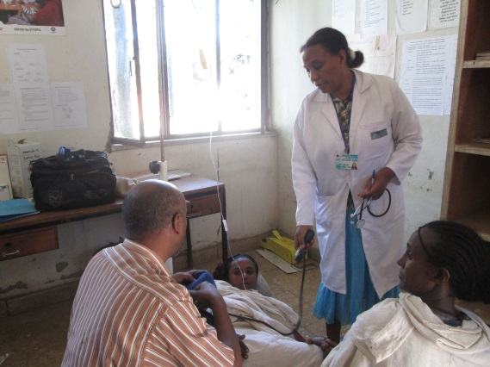

A young women from Rural Gondar, farming is type 1diabetes and on high insulin dose. She had developed hypoglycaemia and came in coma. The health centre nurses were trained in emergency and were able to save her life. Type 1 diabetes is common and patients often develop acute crisis, which is often a cause of premature death unless emergency interventions are possible and delivered promptly.

Patient may miss their meal , or do rigorous farming work ,or take a higher dose of insulin by mistake this will lead them to low blood glucose level which may lead to fainting or at worse coma and if not addressed promptly, this is fatal outcome of treatment. Health education is given to patients to never miss a meal, and always to carry a piece of bread even while working in the farm field

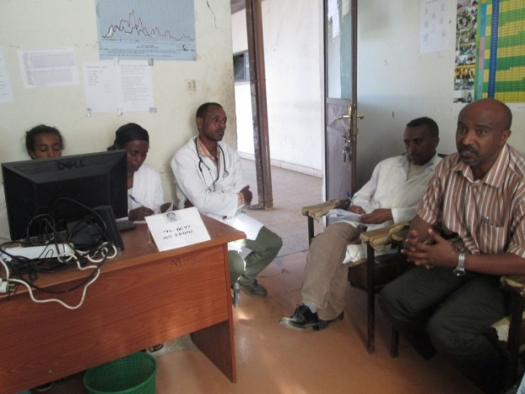

Training of health centre nurses with practical management of emergencies such as the above case saves lives, here discussion is being made the reason why the patient went into coma and how to manage her and whether she needs a referral to hospital. In this case it was concluded she had a hypoglycaemic attack due to high dose prescribed and also rigorous physical activity of the young woman. She was managed with intravenous glucose and after regaining consciousness information was given to her and family on how to prevent such episodes again, Insulin dose was reduced and patient given referral to check with her physician in 3 days to review the dose of insulin administered.

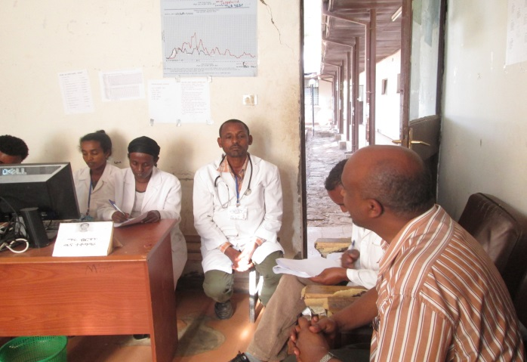

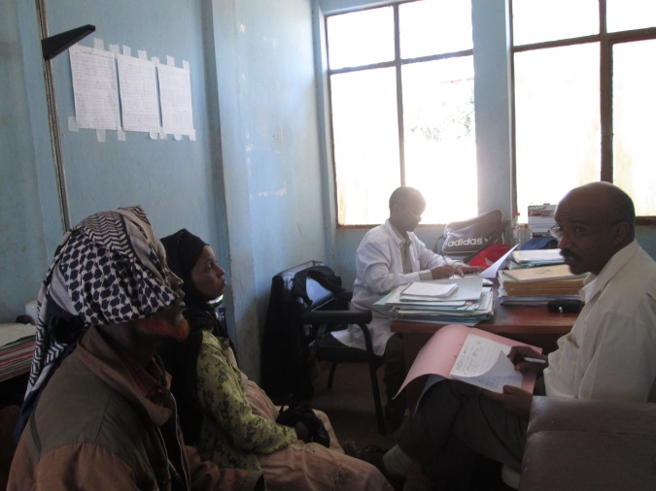

Dr Yoseph Mamo
4 April 2014

