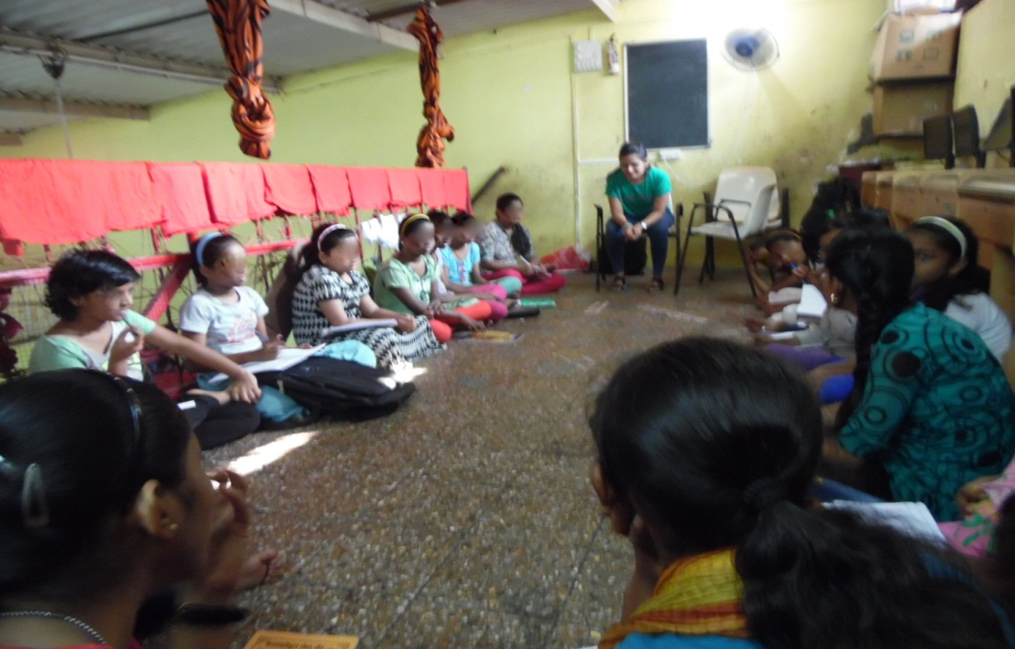GROUP COUNSELLING AND DISCUSSION

