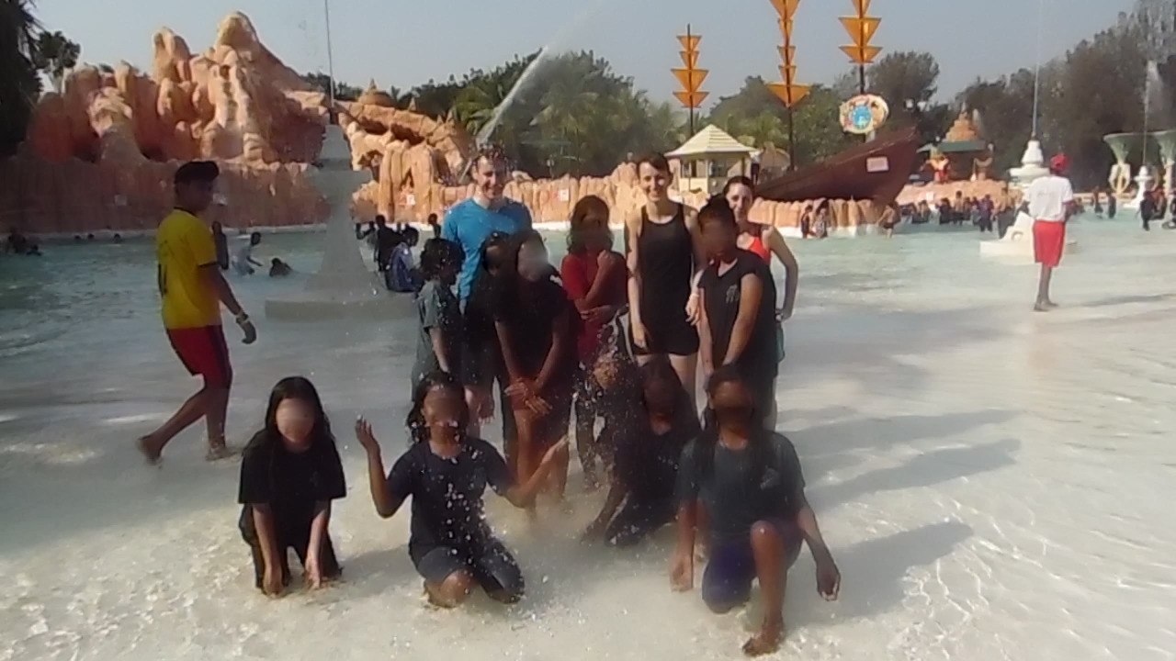VISIT TO WATER KINGDOM

