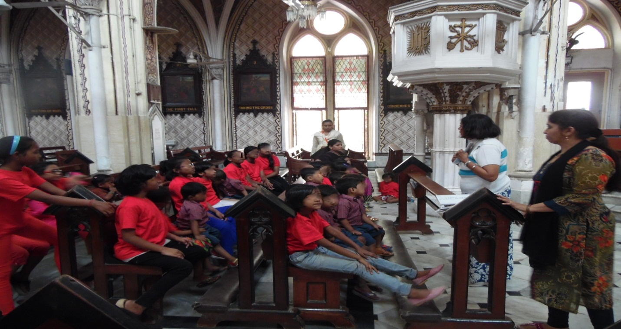EDUCATIONAL EXCURSION TO THE HOLY NAME CHURCH TO UNDERSTAND GAUTHIC ARCHITECTURE

