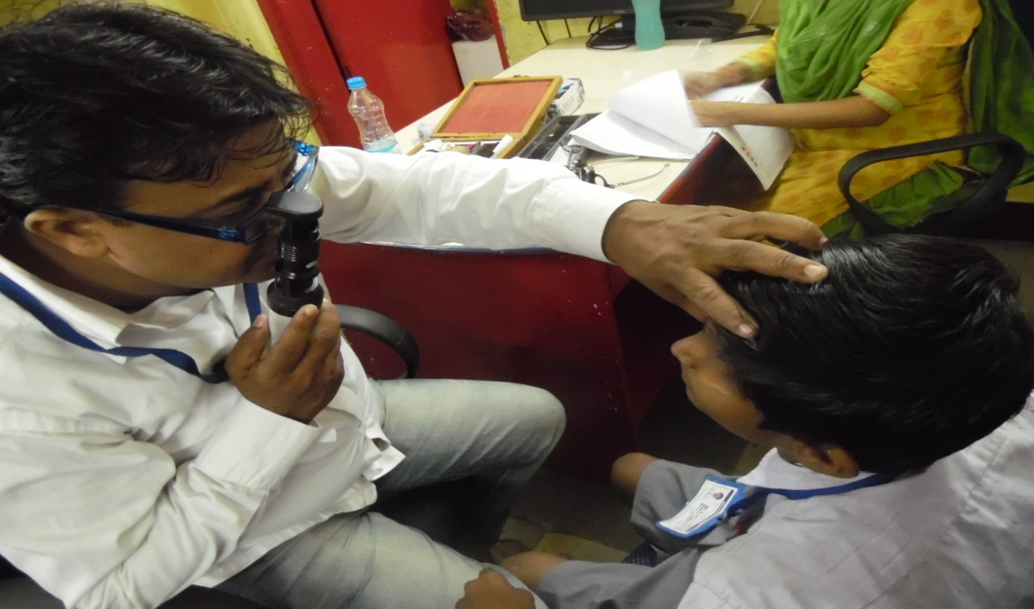EYE CHECK-UP CAMP

