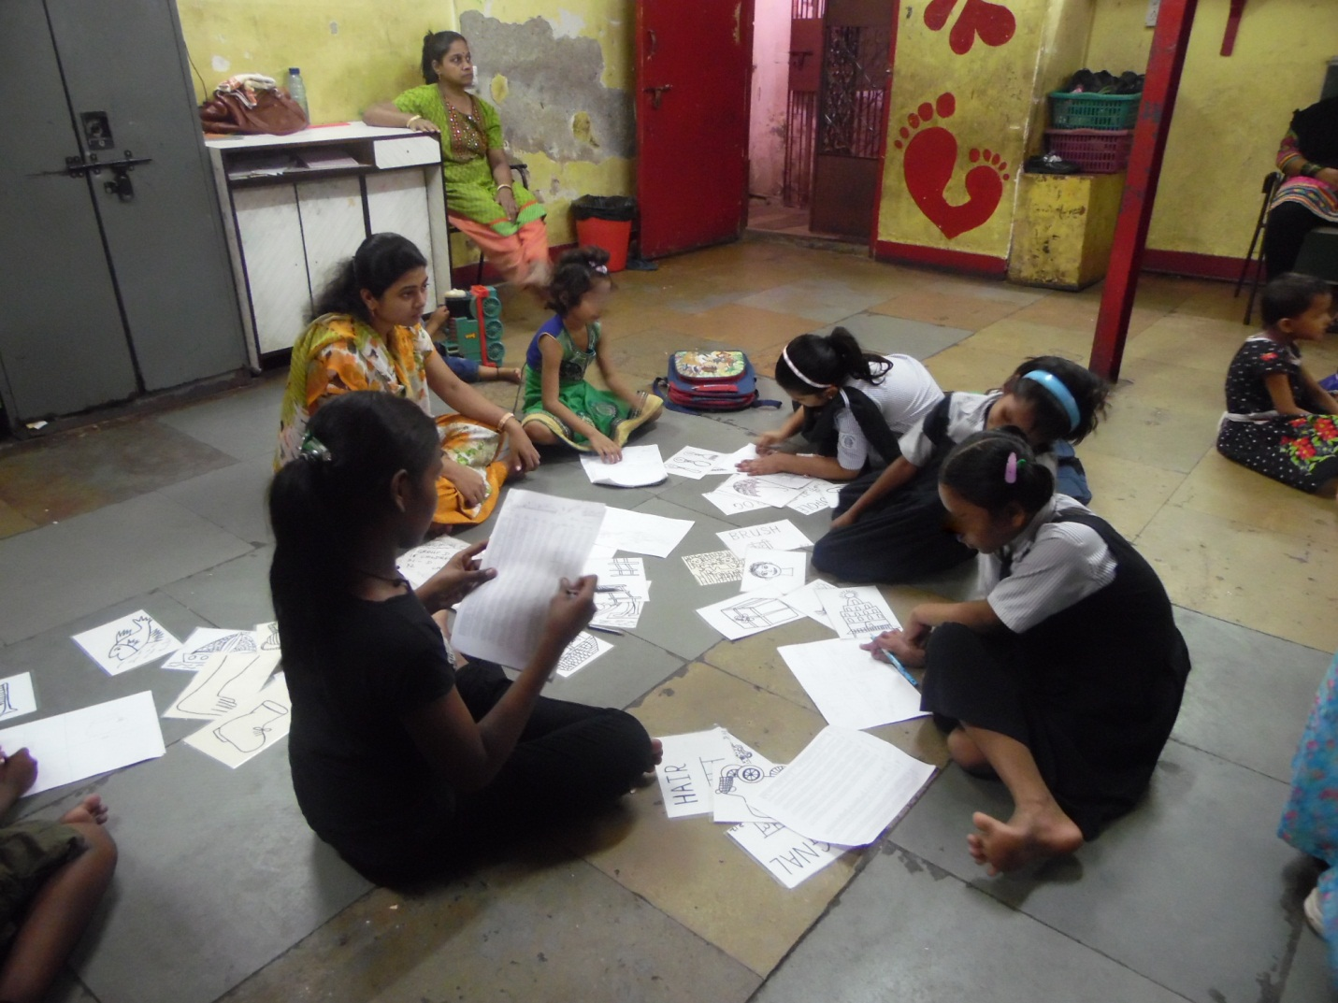GROUP TUITION CONDUCTED FOR UDAAN BENEFICIARIES

