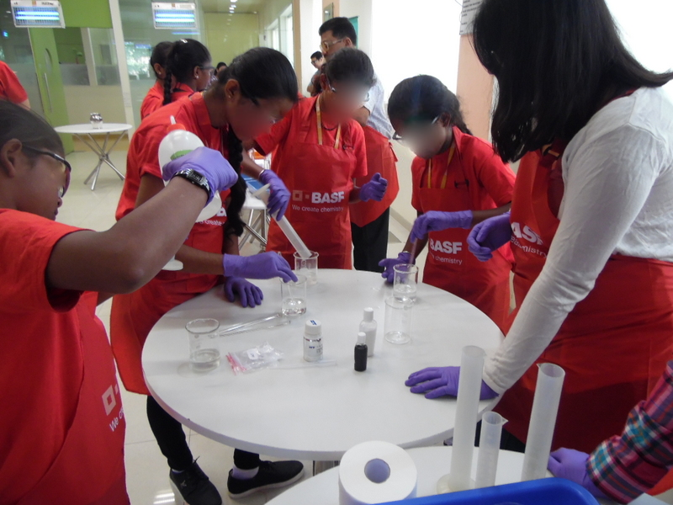 UDAAN BENEFICIARIES MAKING SHAMPOO AT Baden aniline & soda factory

