UDAAN PROGRAM JANUARY TO MARCH 2017

Success Story – UDAAN:
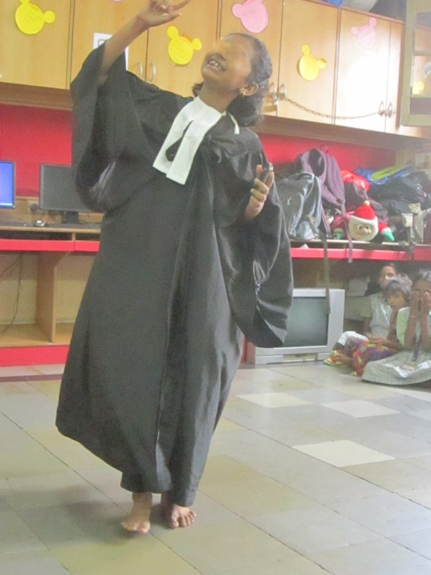

Sangita* is a 9 years old girl and studies in a Hindi medium school. Her mother used to stay at a brothel in at Kamathipura. She worked as commercial sex worker for 6 to 7 years. After she got married she left the profession but worked sometime in the area whenever there is a financial crisis. Her mother’s partner takes care of her children when she has to work and he is fond of the children. Because of the financial issues, they lost their house and had to live in very unsocial situations and surroundings. This caused a lot of behavioural issues in Sangita. As a reflection of that, she started to intimidate other children at the centre and has a habit of hitting and verbally abusing others.

Understanding her behaviour pattern, we at AAWC created a special routine for her and took help from a counsellor. All the AAWC staff members were instructed by the counsellor on how to help Sangita in curbing her behaviour.
Lately, Sangita has shown a lot of improvement. She studies regularly. She also completes her homework on time now, which she never use to finish before. Her teacher and AAWC staff gave extra attention to her, made her sit and learn the tables and make her complete the homework assigned to her. Now, Sangita does everything on her own, the teacher don’t have to tell her several times. She is still naughty but without hurting or harming anyone. She helps her fellow mates and shares her things (eraser, pencil, etc) with them. She does her duty very efficiently whatever assigned to her. Sangita also enjoys playing and dancing.
*name is changed to protect the identity

Organization update:
- Apne Aap Women’s Collective (AAWC) have been rewarded the top ranked organization of 2016 by Global Giving for being active, approved, top-ranked member of Global Giving Network and for doing a fantastic work on & off Global Giving. We wish to express our sincere gratitude to Global Giving for this award.

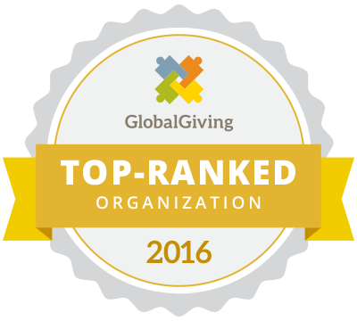

UDAAN PROGRAM UPDATES DURING JANUARY-MARCH 2017

EDUCATION: Regular Tuition classes with our Udaan girls are preparing for their exams. The internal assessments were done and as they have scored good marks. Also they attended Computer classes where the beneficiaries learnt how to type on Word Document and how to save their individual files on the computer, laptop and tablet.
EXPOSURE VISISTS AND SESSIONS: The mentors from the Lighthouse Project their mentees from Udaan to Kala Ghoda Fest in February, 2017. The girls saw a black horse made of koyla (charcoal) and an artist making live painting. Also, they went to the voice recording room and sung songs. The outing was sponsored by the mentors from the Lighthouse Project, our Udaan beneficiaries enjoyed this outing.
Additionally during this quarter nine of our Udaan beneficiaries along with the Senior Program Manager were taken to Mehboob Studios at Bandra to meet Shahrukh Khan (Famous Indian Filmstar) . This was organized by Red FM for Bajao for a Cause. Beneficiaries were very excited to meet Shahrukh Khan, they all spoke with him and had spent quality time.
Beneficiaries have also enjoyed a picnic at Water Kingdom with Loyola School and a visit to RED FM – Radio Station.
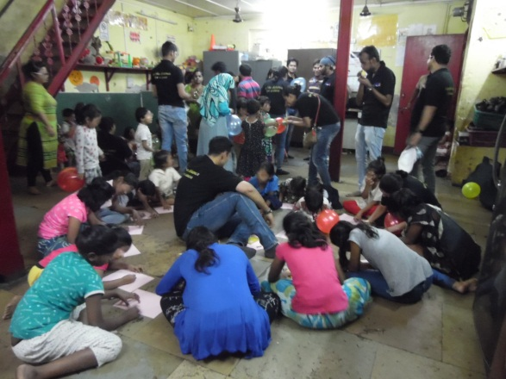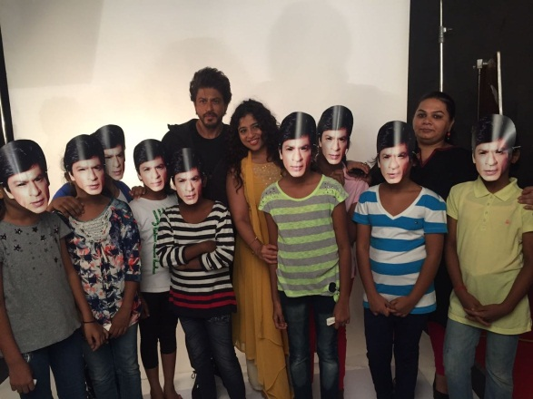
Udaan Beneficiaries with Shahrukh Khan (Famous Indian Filmstar)
Employees of TravelX spending time with our beneficiaries.

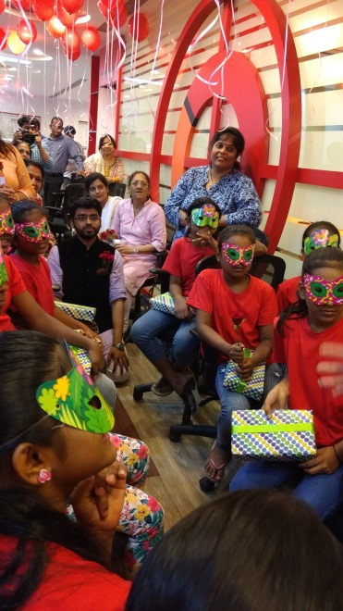
Udaan Beneficiaries at RED FM – Radio Station and other listeners

RECREATIONAL EXCURSIONS: During this quarter Udaan beneficiaries visited garden, art galleries and 11th Lane Ganapati Pandal temple. At Akara gallery Udaan girls were shown photographs taken by Photographer Master ji and Rajni Soori. Beneficiaries were asked if they find any difference in the photographs. Beneficiaries were shown black and white photographs and explained how they are made.
EXTRA CURRICUAR-ACTIVITES: On 21st January, 2017 we organized our Udaan Annual Sports Day at 12th Lane Kamathipura ground, combining both the centre. They participated in games such as lemon and spoon, three-legged, book-balance, tortoise/slow run, running race (75 meters, 100 meters and 200 meters), skipping race, kangaroo jump race, relay, were conducted. The girls’ were full of energy and enthusiasm throughout the event.
Our volunteer Johanna Knaack from BASF, organised a picnic for the girls to Priyadarshini Park and Hanging garden. She gifted t-shirts to the beneficiaries and they did morning exercises and along with a hearty breakfast.
Other extra-curricular activities that were conducted this quarter are Republic Day, Social Work Day, visitors from Travelex. A very ardent Japanese donor Mikiko spent time with the beneficiaries in making art from waste and a session on Origami. Weekly drama, music and art classes were conducted as planned.
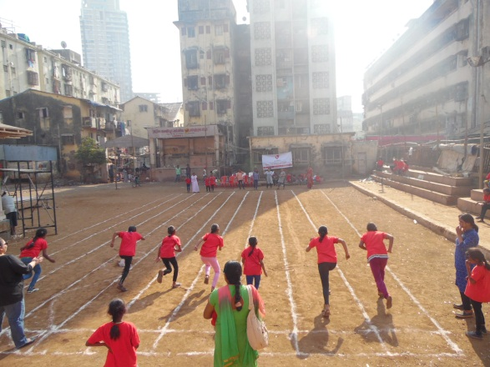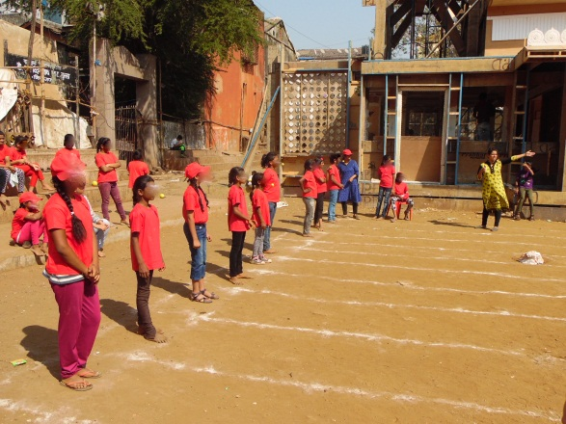
Sports Day Celebration

COUNSELING: ABT (Art Based Therapist) Mona Doctor conducted individual Counseling with beneficiaries to motivate them to attend school, to be respectful towards others, to help cope with death of closed ones and to help channelize the emotions in a positive manner.

CELEBRATIONS: There has been a lot to celebrate this quarter, such as; Republic Day Celebration, Rose and Chocolate Day Celebration (Valentine’s Day), MakarSankranti (Harvesting & Kite flying festival) and Blessing Ceremony of 2 beneficiaries who are appearing for their 10th standard exams together with their Lighthouse Project mentors and Holi festival.
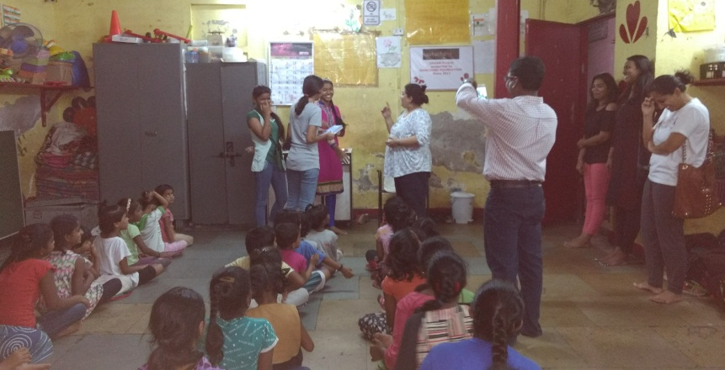
Blessing Ceremony for 10th Std students along with Lighthouse Project Mentors.

QUOTE:
- We enjoyed a lot. We want to go for outing more – Udaan beneficiaries
- Teacher, hereafter, I will go to school every day and attend the tuitions as well after school. - Udaan Beneficiary
- I entrust my child into your hands (AAWC), you do whatever is right for my child! -Udaan Beneficiary’s Father

