NEWS FROM GOD’S LOVE HOME BY JAMES MUKIIBI, A PROJECT LEADER
GLH started a school to support orphans; it is now nearly two years old. See Julius in picture the head teacher addressing the school  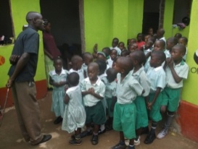  Matron serving breakfast to some of the younger children  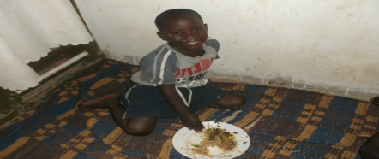  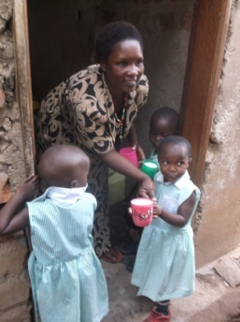  In picture is Michael enjoying his meals. He was born in 2009 and is studying at GLS, he likes playing football, boxing plays. He wants to become a teacher. Michael’s questions are only on Jesus. “Musumba (pastor) when will Jesus come? I always go to church but the pastor tells us that Jesus is in our midst but when I open my eyes, I don’t see him. Please, let us plan visiting him one day.”  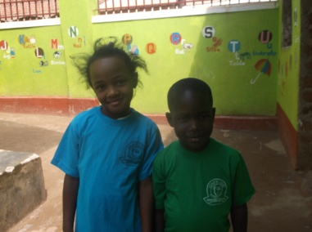  Elizabeth and Michael wearing GLS t-shirts brought for all pupils. Elizabeth says,” I love the school T-shirts and now I am smart!”.  Michael says “musumba(pastor) is this mine permanently ?”  Mugisha is an orphan who is also HIV positive. He is in primary two and is very disciplined and hardworking .  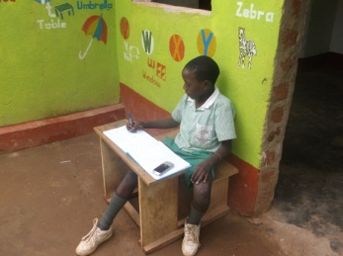 He has the visitor’s book welcoming guardians/ parents to GLS .He likes playing football in our small school compound and is good at taking his retrovirals on time. He plans to become a lawyer in future. Mugisha recently developed wounds in the mouth and serious malaria and we took him to hospital immediately. Please pray for Mugisha.  Challenges we get with HIV positive kids is we need all of them to possess watches with ringtones to remind them of their drug taking time. Some forget more especially when far from matron/guardian who must remind them about taking. We need watches with ring tones  Global Giving money has deeply helped GLH in the ways below;  1-Improved diet at GLH. We can now afford eggs, fruit, meat ….kwashiorkor in GLH is now a thing of the past.  2-Paid school fees bills for a full year 2014 for our children in P3, and above, who are in other schools  3-Paid salaries for workers at GLH and GLS (teachers at GLS, matron etc,………and allowances to guardians.  4-Met some big medical bills which happened unexpectedly.  5-We have maintained hygiene in our home to the maximum. We can now afford to buy soap for cleaning our toilets, wash children clothes, buy water during dry months,………..paint our younger school.  6-We have bought scholastic materials for our kids like exercise books, pens, pencils, school uniforms, shoes,………….and study trips ,..  We have also received support from  A church in Moshi Tanzania  GLS primary task is to teach GLH children but other children attend and they pay fees which helps support GLH.  A landowner in Masindi has loaned land for 5 years so the proceeds from the sugar cane can support the orphans  Friends who give via Mark who then sends me the money  Thank you , each of you, so much | Kaitesi Elizabeth (3) below in the picture –She has asthma due to less support she got when she was a baby. Her father died when she was 9 months.  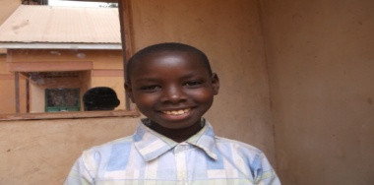  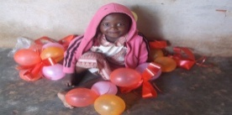  Jabarah is 10 years old. He is in p.2 at GLS . He is an orphan of both parents-He plans to plans to become a civil engineer. Jabarah says “It is of recent when I realised that my parents died. All along I knew James is my true father and matron is my mother. It is when I asked James why he produced so many of us “. James tried to explain that “God told me to help orphans like you”. “Who is an orphan? What differentiates you from my parents whom I did not see?”  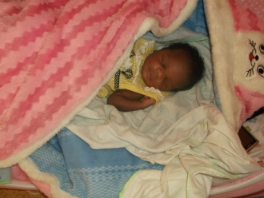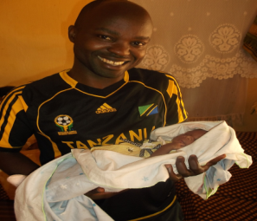  I started taking care of Jackie at a baby stage in picture below and I am now glad seeing Jackie holding a cup of porridge from matron. She is now 2.5 years! She is struggling with talking. Jack is in baby class. She is a lovely orphan girl. Her late father was killed in cold blood one night. Now mama Jackline roasts maize in kibwa selling each at 500= during maize season and unemployed after maize season. Her working capital is 10,000= she cannot afford renting a house at a fee of 70,000= a month, the least in kibwa area. She sleeps in some one’s kitchen paying 30,000= monthly which she gets from GLH as a small monthly allowance. This means our monthly allowance is still small to help Jackie and many others of our guardians. The cost of living is high due to inflation. The current Uganda budget reflects this.  Please help us go further ;  1-Increasing guardian allowance from 33000=monthly to 50,000= monthly-We have realised that GLH diet is clearly good compared to our other orphans diet under guardianship. Our guardians meeting reflected this.  2-We need another classroom to take P3 next year. It would be sad if our leavers from P2 had to go to P3 in other schools and it will definitely affect parents morale.  3- Our staff need computer knowledge to serve better. We have one computer and need others and training for all our staff.  Comments from Mark  At risk of repeating what James has already said can I thank you for the enormous impact your money has made.  - In the past there have been kwashiakor (vitamin deficiency) cases in the home due to the very limited diet: now your money has improved the diet.  - In the past James was sitting under an impending avalanche of debt due on school fees: this year he is up to date.  - He is trying for local sources of income as you have read.  What he has only implied is that they are in a real bind over growing the school. Present buildings are well used. Where does he get the space for more classrooms? Land is expensive and buildings don’t come cheap.  What he has not said is that the money for food and fees for the orphans via Global Giving runs out in October. Do you have friends who might support this project?  You can access details of the project from Global Giving at http://www.globalgiving.co.uk/projects/support-40-orphans-kampala/  Or via Mark Shaw-Hamilton at markshawhamilton@hotmail.com  Tel 01633 615339

