Show meyour ways, Lord, teachmeyour paths. Psalm 25:3-5
Dear Friends
We are thankful for a strong finish to the 2014 school year and look forward to a successful year in 2015. 2014 has been a really happy year with improved diet (banishing kwashiorkor) and with school fees paid thanks to your generosity. You’ll see some of the highlights of Term 3 events in the photos below.
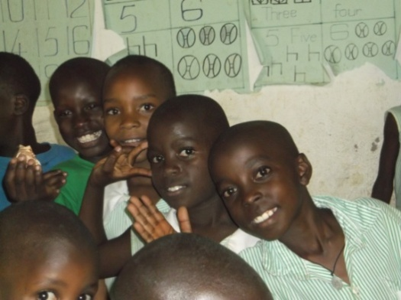
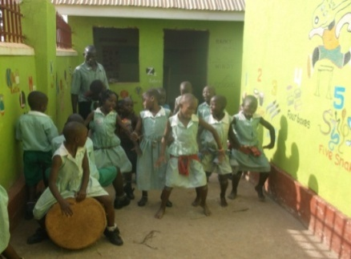
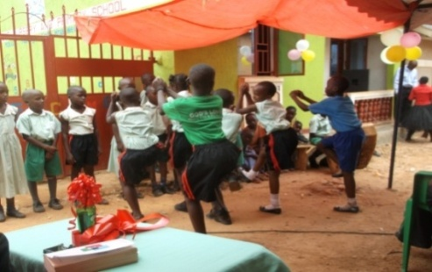

GLS graduands on 19/11/2014 dancing/ singing “Oh Happy Day”
Sports day

David from Australia visited GLH on 08 November. We spent time together discussing the GLH project and he advised on building plans for GLS. We are thrilled that he brought us learning materials, kids plays, and childrens’ hair cutters. ( Now we are able to save on hair trimming). We shall save more if we get electricity connection in our home as we currently use neighbours electricity at a small fee. Thank you so much Mr. David!
We have come to the end of our school term and next term opens on 02/02/2015 .We want to thank all our supporters who have given to us through Global-Giving UK and through mark. Your support took us far in our home. We have had support from a Church in Moshi Tanzania and generous help from the Ugandan directors. I want to thank those who helped me with paper work and special thanks go to Mark, Elizabeth Petersen, David and Global Giving UK Team. We have been able to achieve a lot throughout this year. May God bless you heaps and heaps!
Can I please, bring this to your notice that we urgently need the next classroom with effect from 02/02/2015. Money for school fees and feeding with Global giving UK has run out therefore we have no security for 2015. We would REALLY appreciate it if you could share these needs with your family, friends, church, colleagues, etc . You can get details through Global Giving at http://www.globalgiving.co.uk/dy/v2/content/search.html?q=educate+and+support+40+orphans+in+kampala
Goodbyes
We were sad to say goodbye to two of our beloved GLH friends

Businge Tadeo was 18 years old and he was one of the older orphans at GLH who joined us in 2007 was trained to be a motorcycle taxi driver and left us 2014 January. He met thieves driving a motorcycle and in the struggle to defend himself he was hit on the head. We did our best to save his life by rushing him to hospital but sadly he rested. RIP TADEO!

Kawesi John was an elderly man of 54 years old. He has been our GLH children driver using his own vehicle since 2007. He could deliver kids to different schools, bring them back home after holiday and pick visitors from Airport or locally to GLH. Doing all this at small costs or sometimes zero cost.Thieves killed him and took his vehicle.RIP KAWESI! He has left family of 10 children. 6 children between the age of 2 months and 6 years. Pray for the family and GLH.

Wishing you and your family special blessed Christmas and New Year.

James mukiibi
Project Leader

