2017 Annual Report for God’s Love Home, Kampala
for UK supporters

Through your continued support over 40 children have been supported; loved, clothed, fed, educated and given a future. Thank you so much; every donation and donor is special: thank you so much

Money has gone to James Mukiibi from UK in two ways.
A total of £3309 has been given to me and I have given a receipt to each donor.
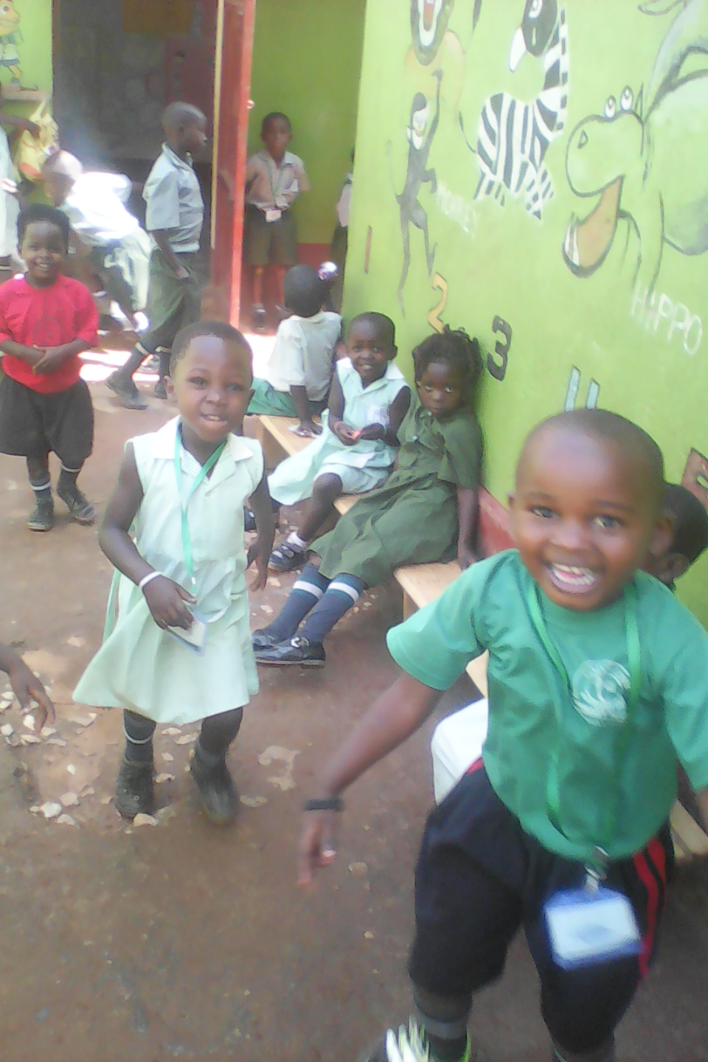
More has been given through direct debit via Global Giving. (They can claim Gift Aid for GLH though they take a %)

What are the highlights of the year?
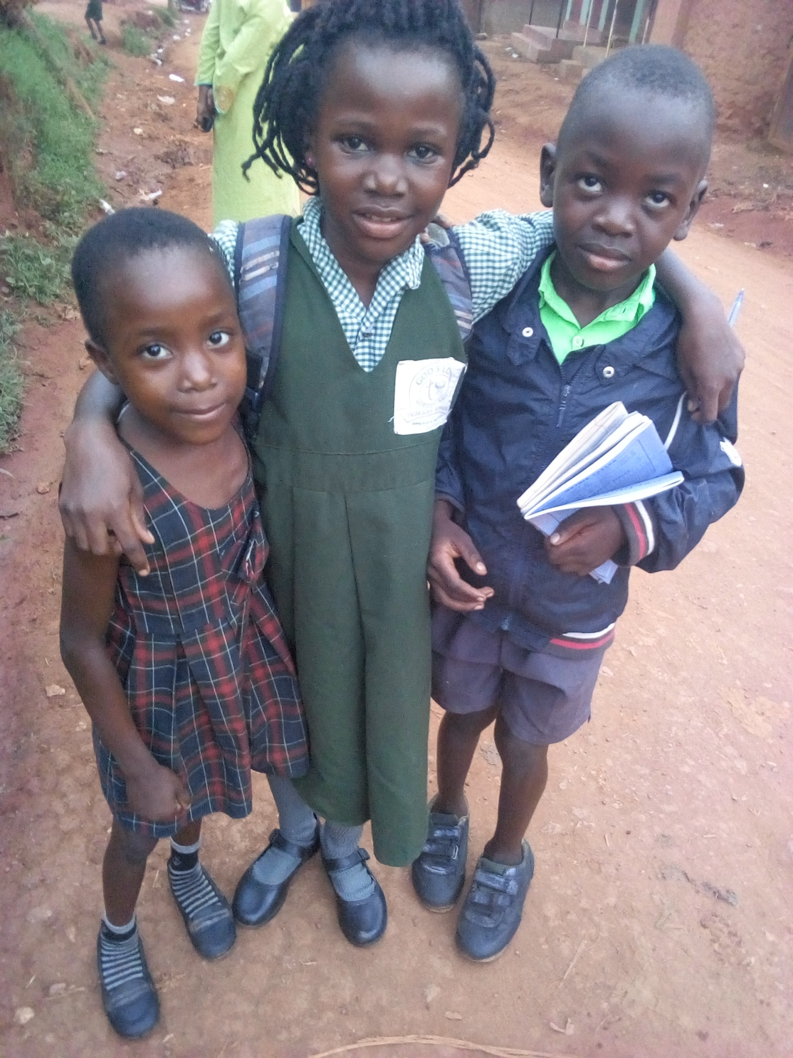
First is the obvious. 40+ children have been supported: housed, fed, loved and educated: a huge thing to celebrate. “Thank you”. James’s continuing problem is to get regular funding. We have several AIDS orphans and so far James has been unable to get regular support even for them

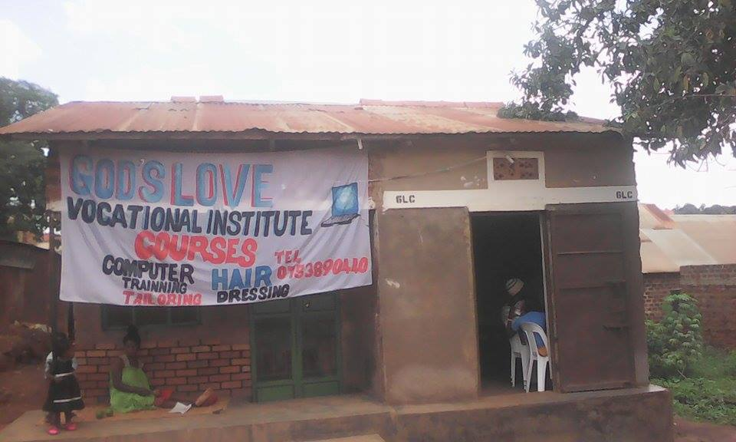
James started a small vocational unit (GLV) for the post primary girls learning dress making and hair dressing. The unit was affiliated to a local College and the girls all passed the end of year exam despite having limited equipment. “Tools with a Mission” (they collect used tools from UK and send them overseas) have donated sewing machines so this year even more progress should be possible.
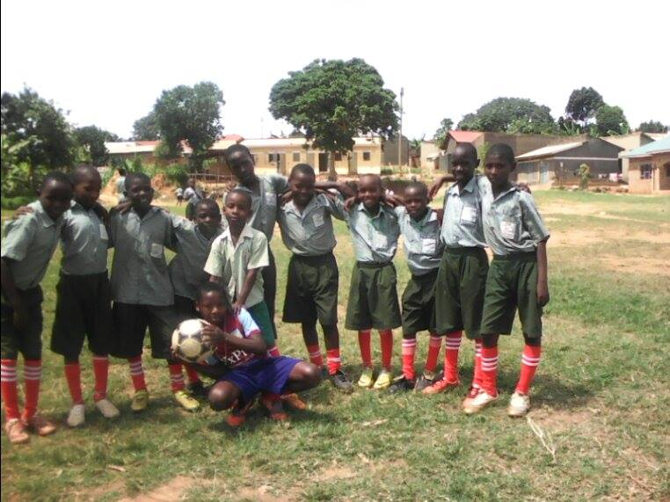
End of year celebrations
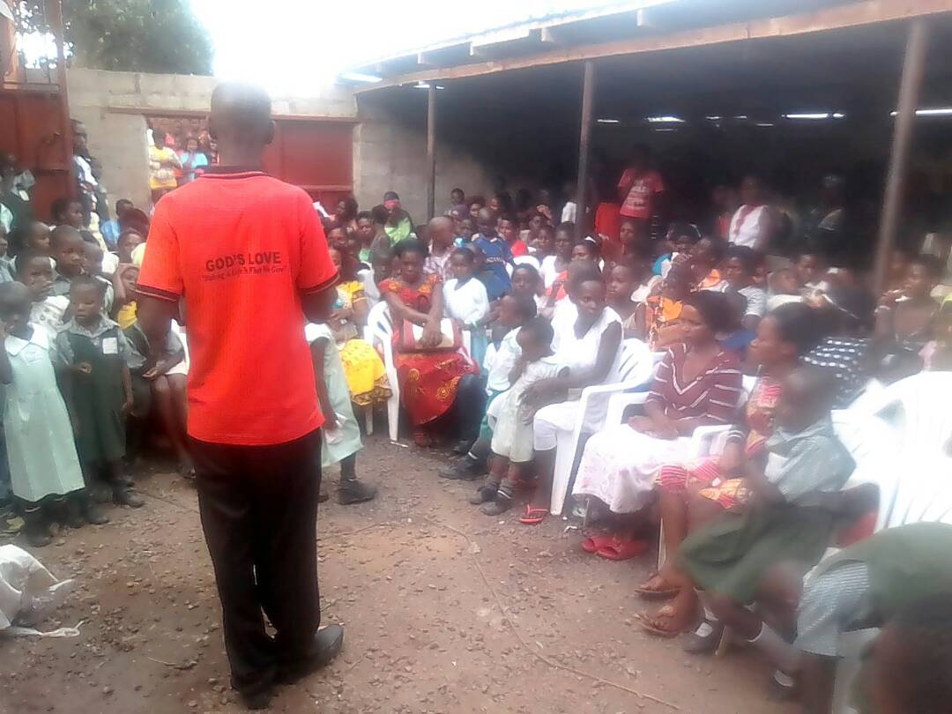
God’s Love School (GLS ) opens the final class this
month and they will sit the primary leaving exam next November. The school has two aims.. to provide a good Christ-centered education and, through selling surplus places help fund GLH. In the past the % of fees that have been paid has been low: in 2017 this was done more efficiently. The real limitation is in the size of the rooms limiting the class size. They are in the process of building a small classroom block so the final years will be a good size. An Australian friend of GLH has given enormous practical help here

A generous American friend has kindly bought a small farm about 20km from GLH; this should help feed GLH

There have also been lowlights (if there is such a word)
Recently one of our senior girls was kidnapped and held for ransom or she would be killed. Initial demands were for over £1000 but she was released for much less. I am so relieved but she has been through a real trauma. When people have little it is so easy to envy those with a little more. (Kidnapping can have a dreadful outcome; you might refer to “Susan Magara” on the internet). One of the older orphans has graduated with a first class diploma in Law; lacking the right contacts he is finding it hard to get a permanent job
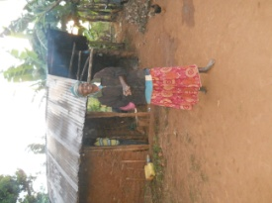
James mother has been very ill. James himself is getting over typhoid

So a very big thank you but can you turn these dry points into living prayer. As usual if I can answer any queries please raise them 01633 615339

Mark for James

