**WILLOW**

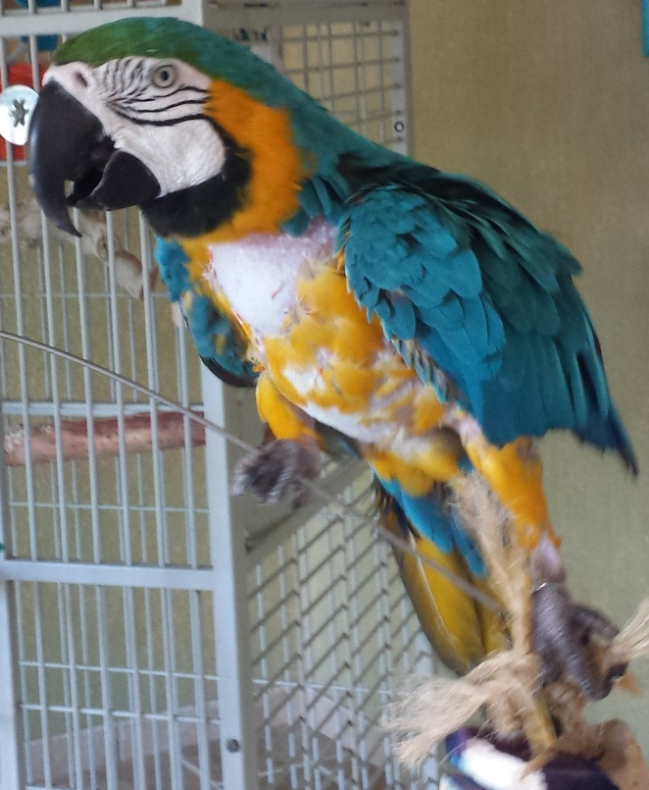

Willow is a 21-year-old blue-and-gold macaw who came to us in March of 2015 after she was found on someone’s roof in San Diego and turned over to the Department of Animal Services.  We know her age from her leg band.

She immediately converted over to a pelleted diet and is starting to show some interest in vegetables. She loves nuts and will eat both pistachios and Brazil nuts.

Willow has some feather loss on her chest, although she has shown no signs of feather destructive behavior and there are never any feathers on the bottom of her cage. She currently has a large number of pin feathers on her chest, legs, head, and back.

Willow loves to hang out on her playstand, and her antics are hilarious. She says “Hi lady,” “Willow,” and “Hola,” and she whispers a lot. She steps up very well.

She will make a wonderful companion for someone who has the time and space for a macaw.