TOOTSIE

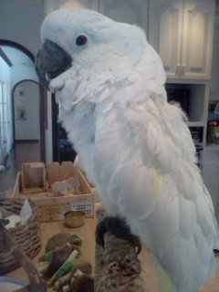

Tootsie came to PEAC in April of 2015. She is a 13-year-old female umbrella cockatoo. Prior to PEAC, Tootsie lived in her home for her entire 13 years. The couple that had Tootsie moved across country, and found themselves living in a RV trailer in San Diego. Tootsie was not able to adjust to her new environment, as the living quarters were very small and she was confined to a small carrier to sleep in at night and during the day when her owners were not home. Due to the stress she was under, she began to show feather destructive behavior, and pulled the majority of her feathers from her chest and legs.

Since coming to PEAC and getting an appropriate cage, Tootsie has grown back most of her feathers and currently is not plucking. She is gentle and loves to cuddle and be around her people. However, keep in mind that she becomes overly stimulated easily and becomes demanding of attention and will nip. She LOVES her toys! Tootsie knows a few words such as “hello” and “I love you.” She is a fast learner and just wants to be in a forever home that will love her and care for her the way she deserves. This potential new home should not have any dogs as she has a very bad habit of chasing small pets (cats and dogs) around. This should never be allowed as she could become seriously injured by a dog or cat. Currently at her foster home she has learned to stay on her play tree though she does try to get on the floor from time to time, again a behavior that should never be allowed. If you are interested in adopting her you should have prior experience with a cockatoo and either work from home or are retired as Tootsie will require lots of attention and time with her new owner.

