MERLIN

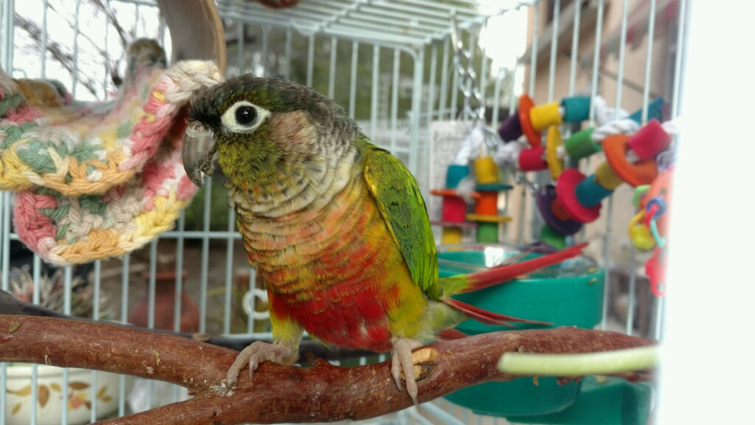

Merlin is a pineapple conure who came to PEAC via the Department of Animal Services at the Gaines St. animal shelter. We don’t know her age. She at first was a very frightened little girl who had had a fight while trying to survive out in the wild on her own. DAS took her to the vet and had her puncture wounds cleaned and dressed.
She was named Merlin. Merlin was a big racing yacht that sailed the Pineapple Express every year out of San Diego. We think maybe she was an aviary bird. Her foster mom keeps her cage in the kitchen and when they have left the cage door open so she can come out to explore, Merlin bolts to the sliding glass door. Merlin cannot be easily handled yet and the fosters are working on settling her down to finger train. When holding her, one must cuddle her against ones chest for head scritches. As we have only had her in the foster program a couple of months we are still seeing her true personality come forward. She is going to make someone a fun little bird to have.

