**JOEY**

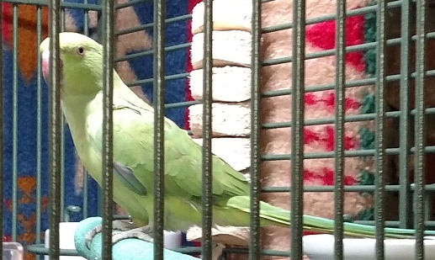

Joey is a DNA-sexed male Indian Ringneck Parakeet; he does not yet sport his neck ring so he’s likely less than 2 years old. He was found by a Good Samaritan in the San Diego area and turned in to Dept. of Animal Services; after no owner came forward a week later he was relinquished to PEAC on 9/27/15. We believe he is an escapee from a backyard aviary as he is wary of human approach but makes no attempt to bite.

Joey is a charming little guy in spite of not being hand tame at this time. He chirps and squeaks, holding entire conversations by himself! We are working with him to allow human approach and he is doing very well tolerating daily husbandry without any frantic behavior. He eats a wide variety of vegetables readily although has so far shown little interest in pellets. Please stay tuned for further updates as Joey progresses with taming and training.