IGGY
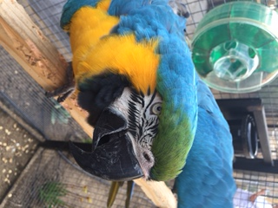

Iggy is a blue-and-gold macaw who is 11 years old and was purchased at a flea market in New Orleans, LA. She was originally named Ichabod as the owners were told that she was a he. After doing a DNA sex evaluation on her we finally know that Ichabod is not a boy but a girl, so has been renamed Iggy, to which she is responding very well. On arriving at ARC, a PEAC foster volunteer’s location and facility, she was very frightened of her new surroundings and for almost a week did not want to leave her cage. We slowly offered her sunflower seeds to entice her out but she would just take them and drop them, so she turned out not to be very food motivated. We started wrapping our hand and arm slightly with a towel and she very willingly now steps up on to the towel, comes out of her cage, and then transfers slowly over to the handler’s bare arm. Previously, she was kept fully flighted and was allowed to fly around her home. Having that much freedom has allowed her to develop strong flight skills and so most of her primary feathers have had to have been clipped to stop her ability to take flight but allow her to flutter down safely to the ground.

Iggy is still learning to trust and has a way to go, but with the right person and the use of consistent positive reinforcement training, she will become an amazing companion for someone looking for a large parrot.

