ABBI
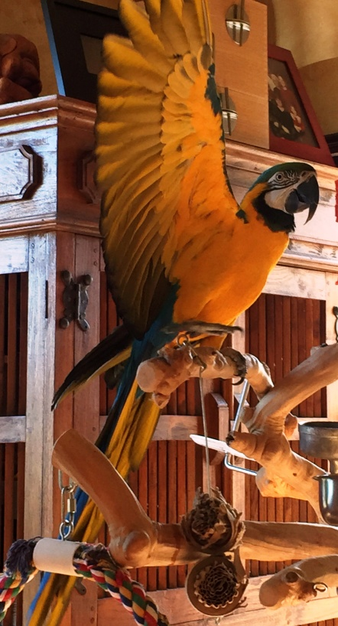

Abbi is a 30-year-old male Blue-and-Gold Macaw who came to us in January of 2015 after he lost his second home in 30 years. His first owner moved out of state, and he was placed for just a short time in another home, until they moved into an apartment. In Abbi's early life, he sustained a traumatic injury, which resulted in the loss of his left eye and the use of his left wing, which he is not able to open and extend.
Abbi can be a bit shy at first, as he is wary of his left side. Once he has adjusted, he enjoys the company of the household. He is great at playing with his toys, talking and laughing to himself, and chatting with other birds and animals in the house.

He gives wonderfully clear body language, so when he is ready for snuggles, he will let you know, and when he is not, it’s easy to avoid any hint of unpleasant behavior. Abbi is a wonderful companion for someone who is patient and has a huge heart, ready for all of his love.

