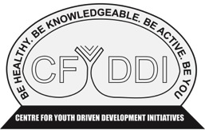


Note: This map is not to scale

Centre for Youth Driven Development Initiatives

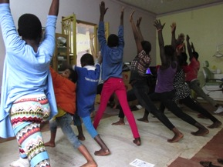
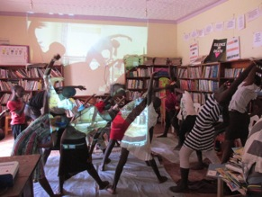
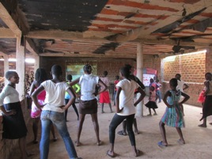

Zumba

Circuit

Yoga

Yoga is a Hindu spiritual and ascetic discipline, a part of which, including breath control, simple meditation, and the adoption of specific bodily postures, is widely practiced for health and relaxation.

Circuit is a strength building class that moves through different exercises aimed to increase strength and endurance. Some exercises include squats, lunges and bicep curls.

Benefits:
- Stress relieving
- Increased flexibility
- Increased strength
Benefits:
- Increased strength in upper and lower body
- Increased endurance

Zumba is an aerobic fitness program featuring movements inspired by various styles of Latin American dance and performed primarily to Latin American dance music.
Benefits:
- Increased endurance
- Better coordination
Zumba photo

