August 18, 2014
CFYDDI ATTAINS A RISE!
Dear CFYDDI Project supporter,
It is my pleasure to share our 3rd report via GlobalGiving on the progress of our project to build a community centre for 300 Ugandan youth project ID (15365)
An idea that was hatched in a small tinny two roomed building hosting CFYDDI community public library begins to yield physical fruits.
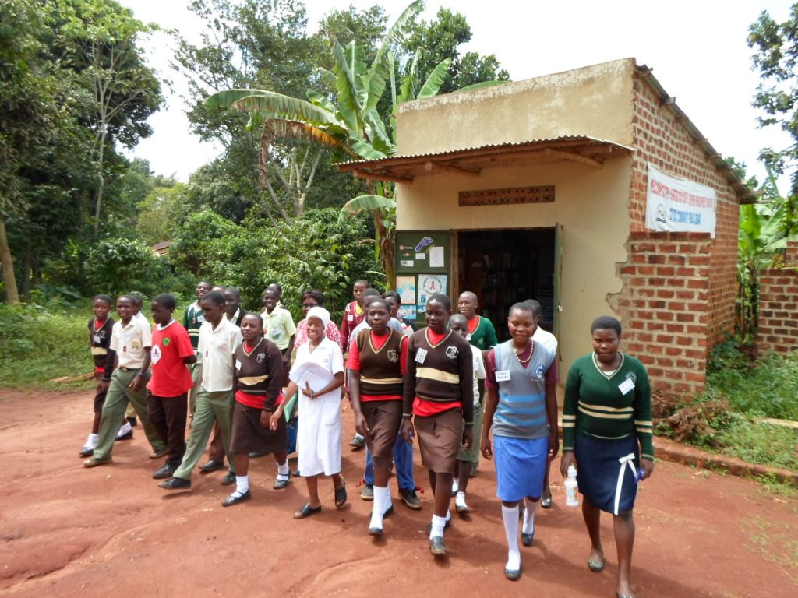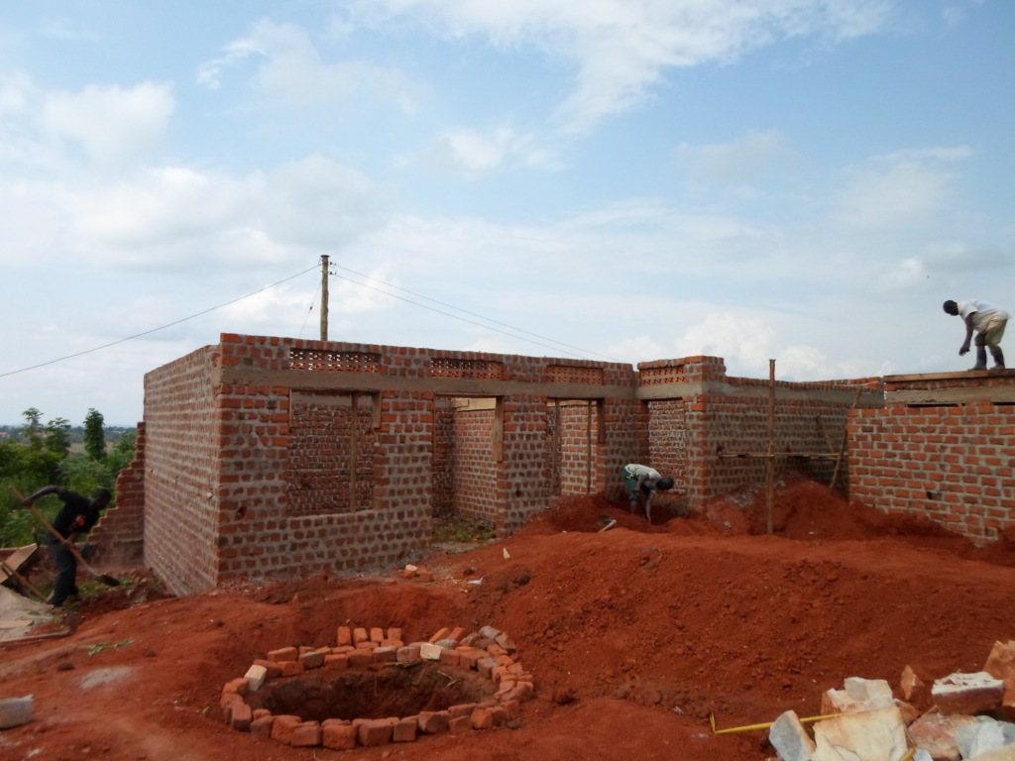
Camp participants during a visit to CFYDDI Library and on the right new proposed community youth centre.
Ever since we launched the fundraising campaign, we have had the opportunity to use the youth centre premises even though it still incomplete with walls standing without a roof, a cemented floor and without shutters
One very welcome development is the completion of the toilet that is functional and with it, the creation of Jobs to many unemployed youth. Holiday makers have joined to provide daily labor to raise their school fees. Paddy a senior Four (4) candidate student was not shy to work on site as some of his school mates joined the camp to work and raise school fees and other scholastics materials. The next step will be to continue fundraising for the remaining £10,653 to finish out the entire pending works.
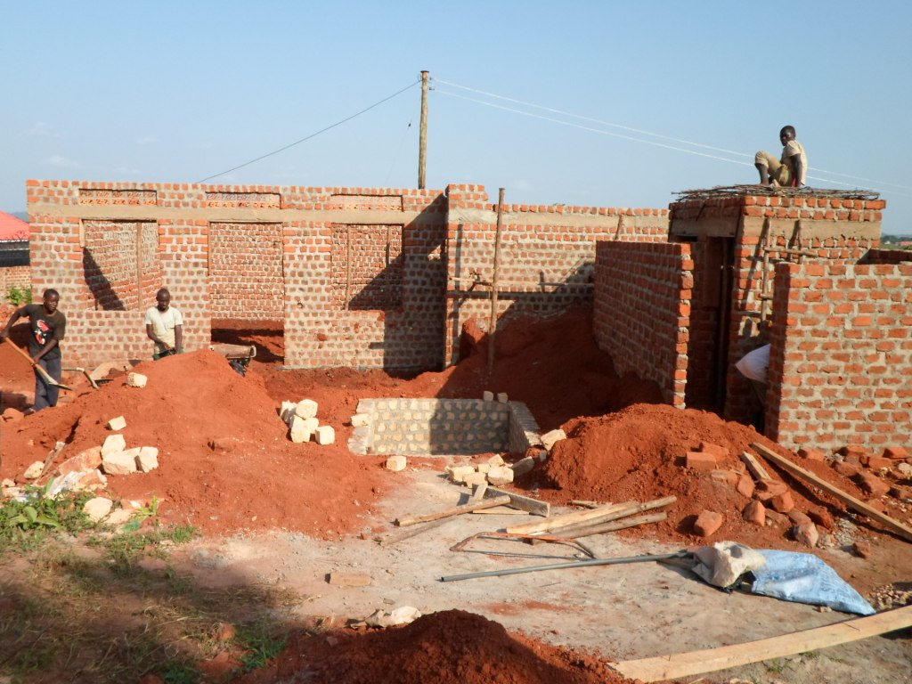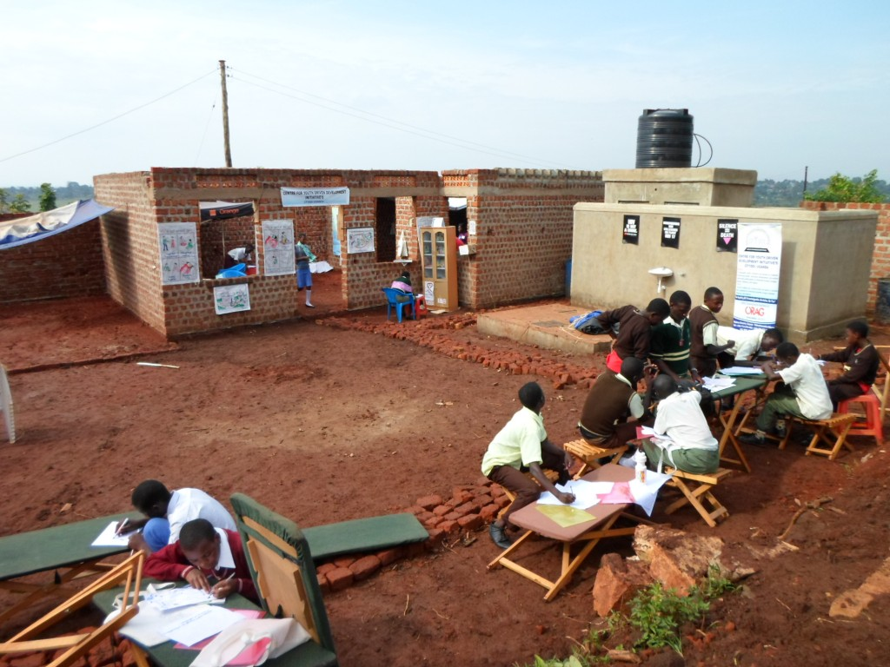
The youth team prepares the sight for the camp and on the right the site looking ready!
During the closing of the youth camp and the launch of CFYDDI_ Youth Leadership team, the guest of Honor Madam Norah Madaya in her speech summed up her feelings about this milestone. She said that the results are sustainable and that if the centre is completed it will provide an excellent environment, conducive to learning, researchers and young people to have fun and innovate in a rural place. The local chairman of Ndanzabazadde was amazed by the speed of progress exhibited in such a short period of time. Counselor Bugoba in his speech noticed that it’s just a year that he was invited to be part of the launch for the small library space and here he comes to see a vision grow big. He applauded the dedication of the youthful team that was spear-heading the fundraising campaign and extended extensive gratitude to the people behind the scenes for supporting and believing in community development.
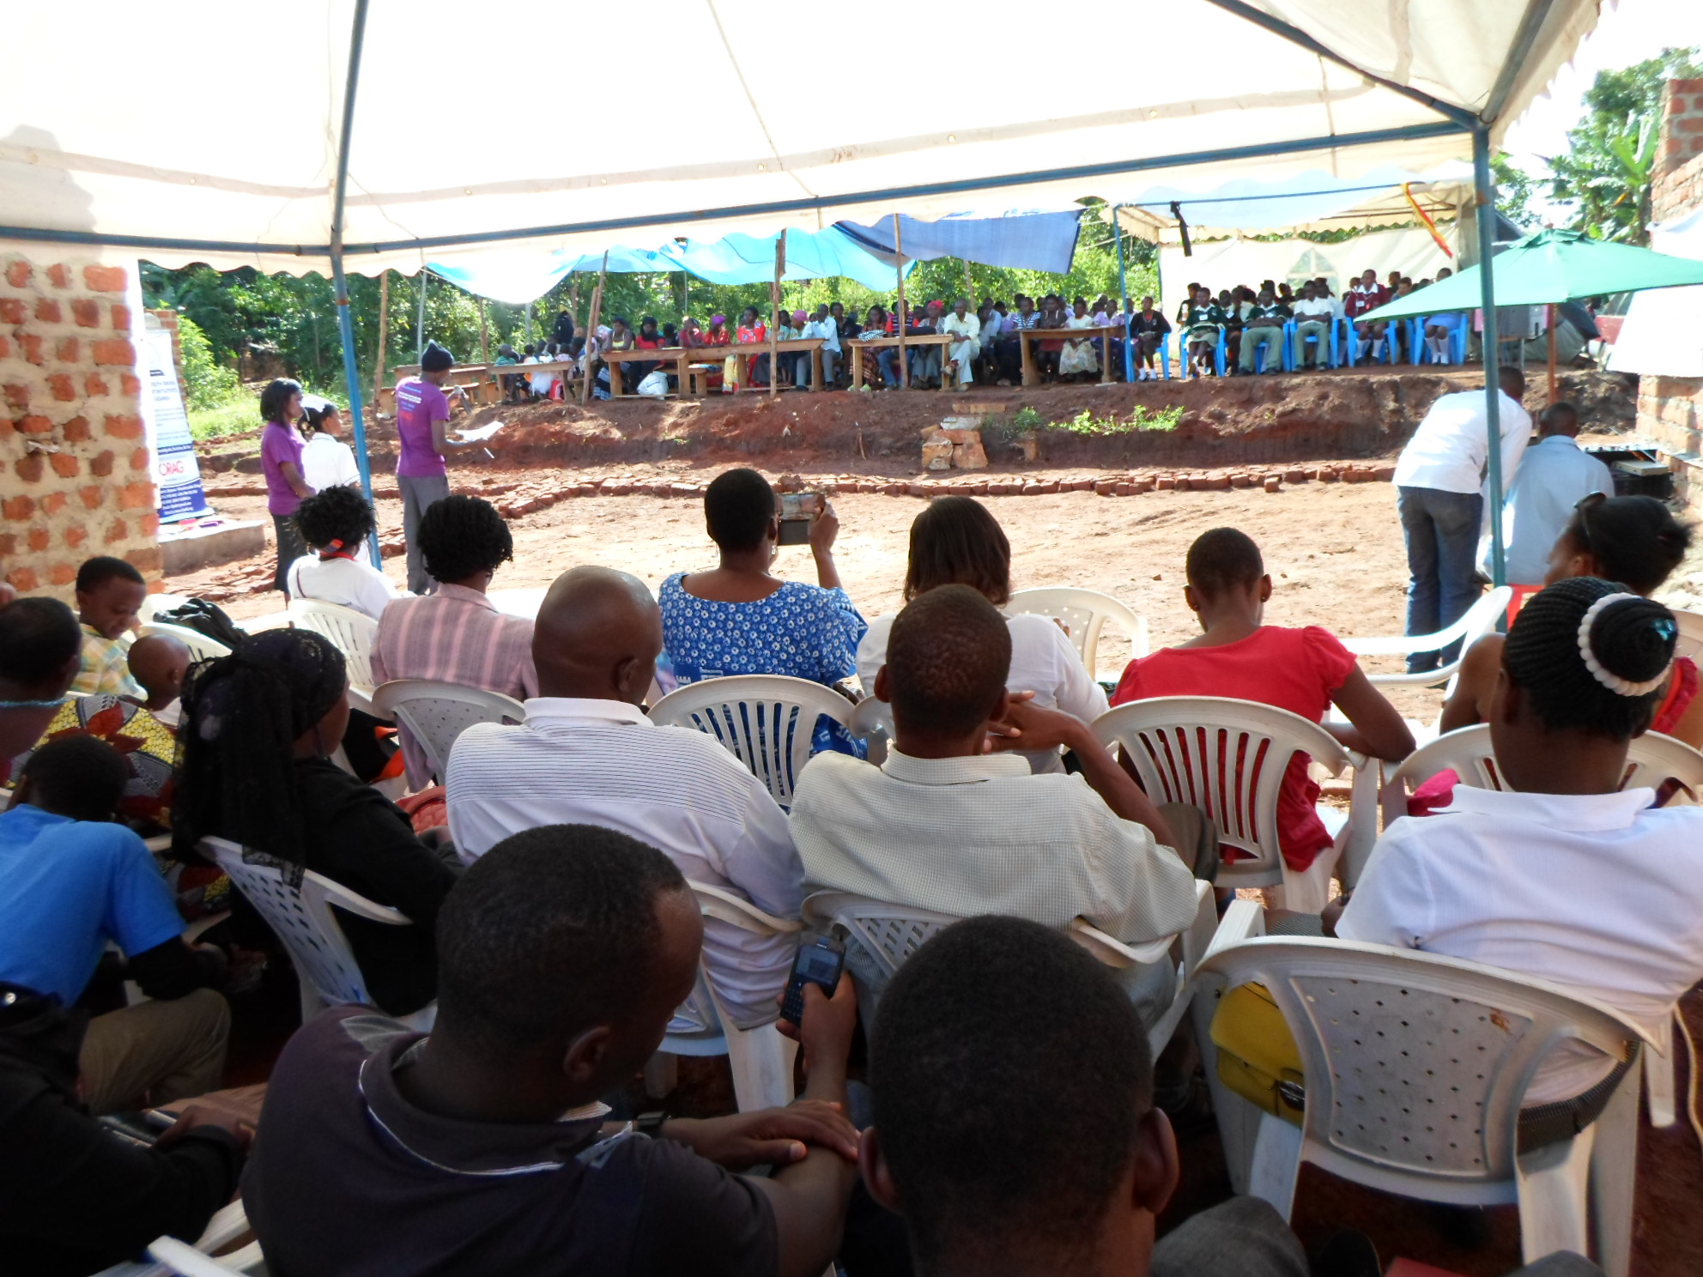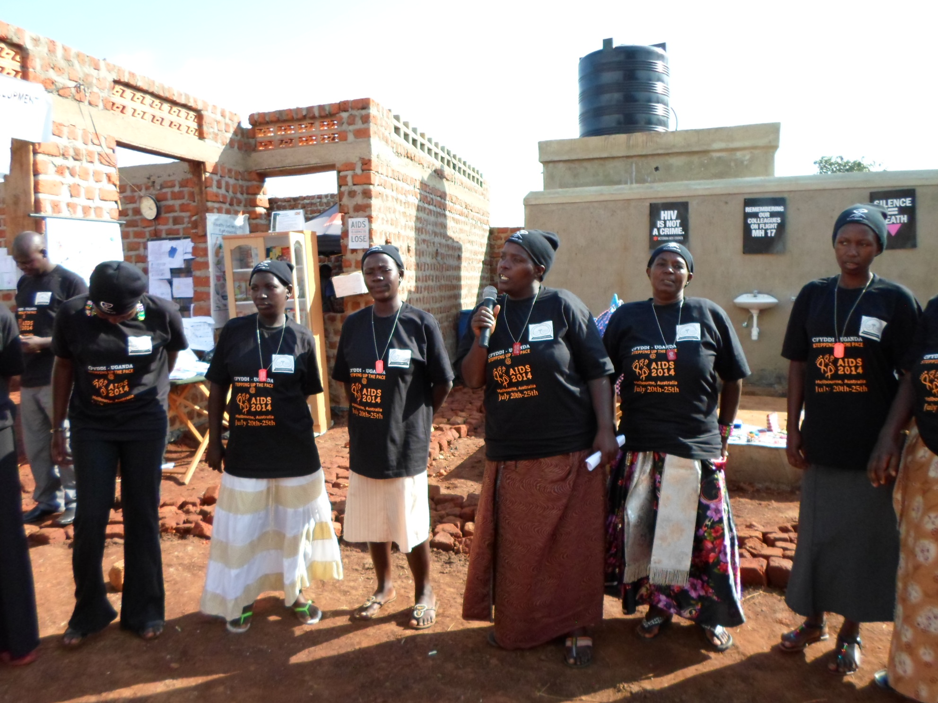
Guests take their sits at the youth centre on the closure while a women’s group on the right entertains the guests.
The administrator of Sir Apollo Kagwa Vocation secondary school, Madam Mariam Nansubuga, spoke on behalf of all teachers present. She said that this community centre is a road map to a modern community that can reduce rural urban migration and moving long distances in search for services.
The participants were astounded and amazed at the excellent flushing toilet in such a rural area.
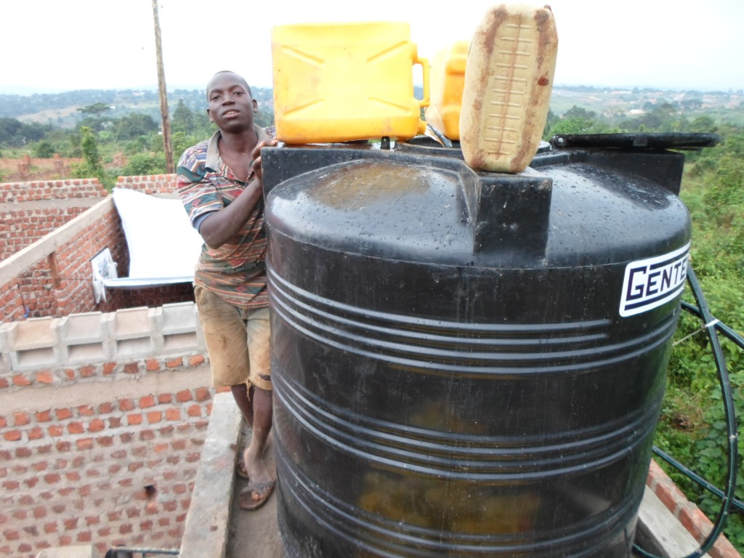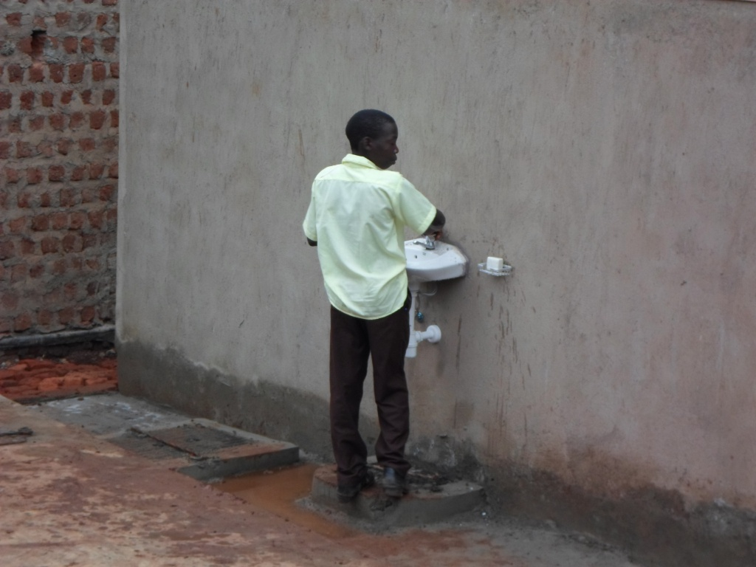
Paddy fills up the water tank while a participant washes hands after using the flashing toilets;
The other exciting development was that of hosting the youth camp at the new site. On the 11th of August 2014, a total of 20 young people from 4 different schools Sir Apollo Kagwa Vocation secondary school, Spire high School, Trust High school and Kakwero Church of Uganda Secondary School joined the camp with a lot of excitements under the theme ‘Health Reading and Computer training camp. The aim was to provide health and nutrition education to adolescents, and the site was able to comfortably host the 10 boys and 10 girls, with some added space for games and sports. Although we were interrupted by rain on occasion, it proved to be a great success. When the weather proved to be a problem, the initiative taken by the facilitators meant that no time was wasted and the experience was as thorough as possible. We managed to split up into two groups and returned to our small confines at the old library space for a few activities, and the nearby neighborhood provided space for another group. The neighbours graciously provided electricity to help power the laptops and the music system on the final day.

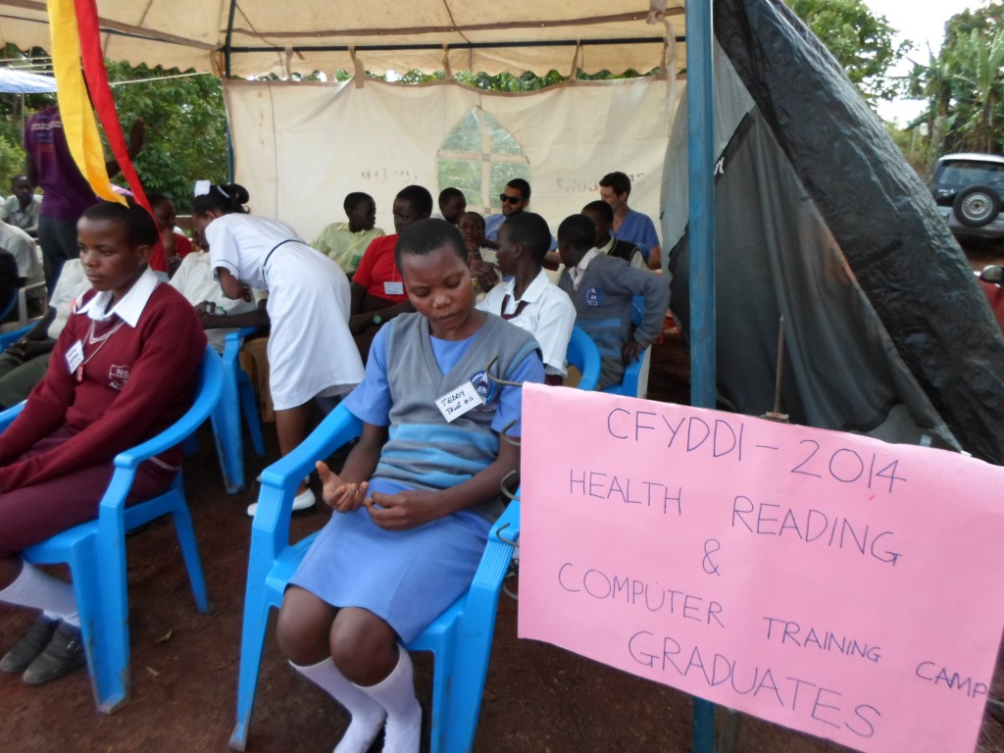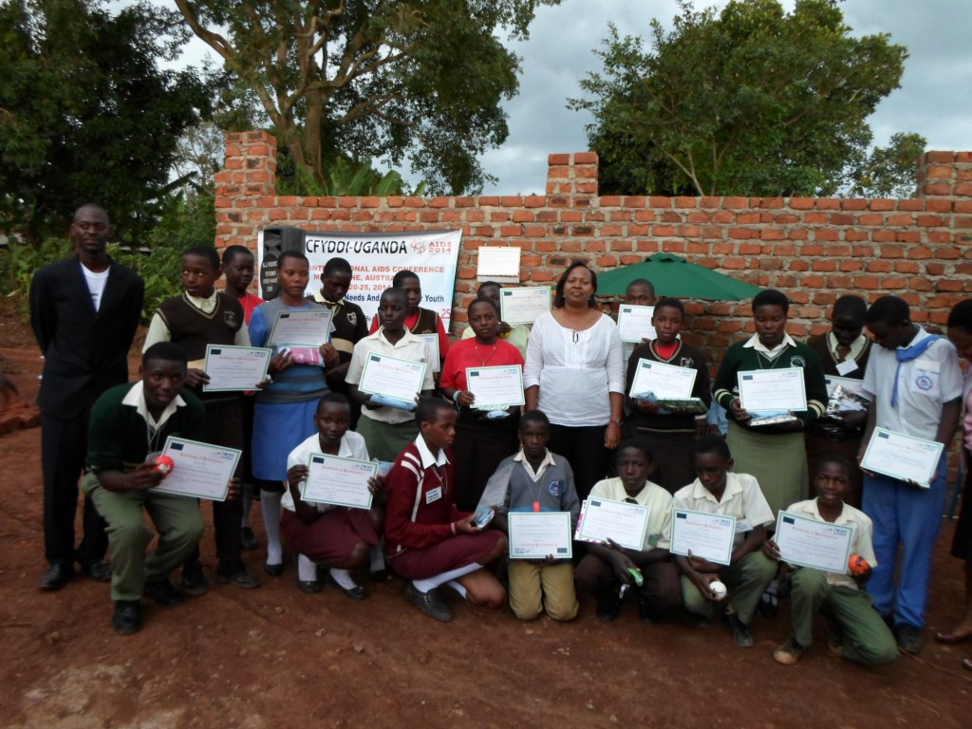
Camp graduates sit in there special tent and on the right they pose with the Guest of Honor after receiving there certificates;
The camp ended in style with guests from the government, civil society organization, various community youth groups, activist, teachers and pupils from neighboring schools and other individuals working in the field of HIV. We emphasized the importance of information established at the camp, yearning for zero new infections, good nutrition and improved internet searching for all, regardless of location or family background. The atmosphere was incredible and the reception was unimaginable; all of the children, all of the guests, indeed all of the facilitators could not have imagined an event quite like it. It was highly successful and most accommodating.

Young people where excited for the first time to use internet, touch and learn computer skills as well as the importance for being able to search important sites which have SRHR information.

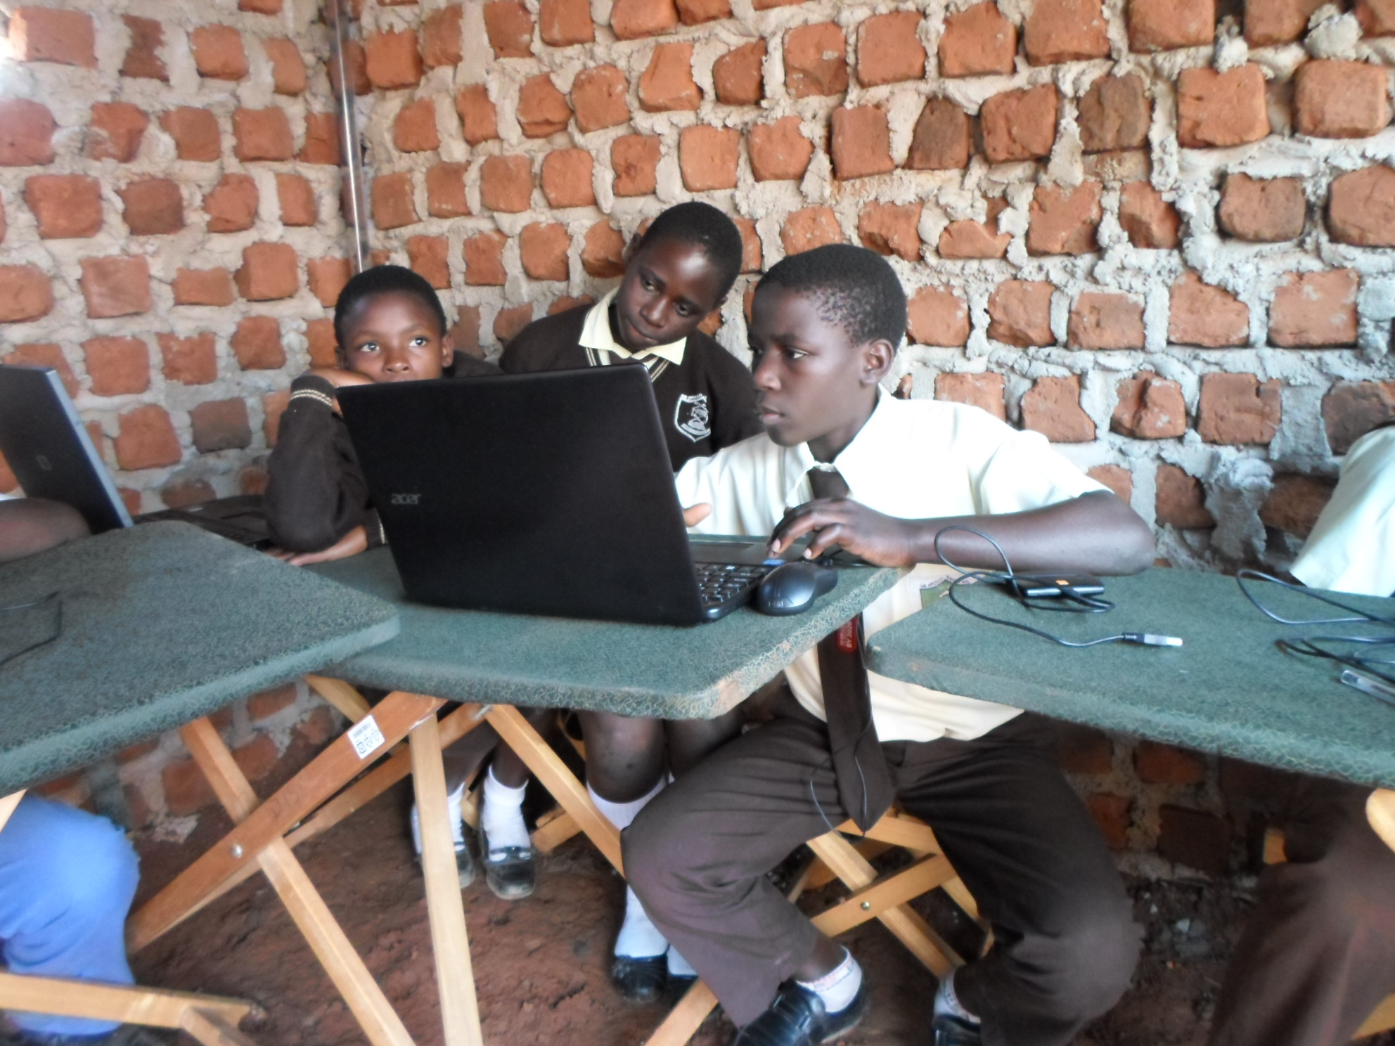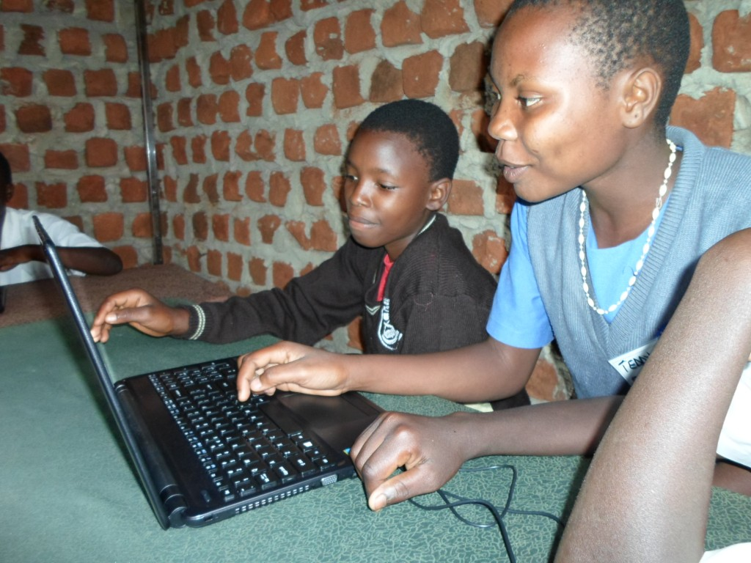
Students enjoy the computers during the Youth Health and Computer training Camp

As this was the first health reading camp at our unfinished youth centre, we decided to coincide this with the launch of the first CFYDDI_ Youth Leaderships Team. This team, comprised of the children who participated in the camp, will continue working to promote honest, open communication about sexuality and to safeguard their access to sexual health information and services on the ongoing impact of HIV in our communities, both here and around the world.
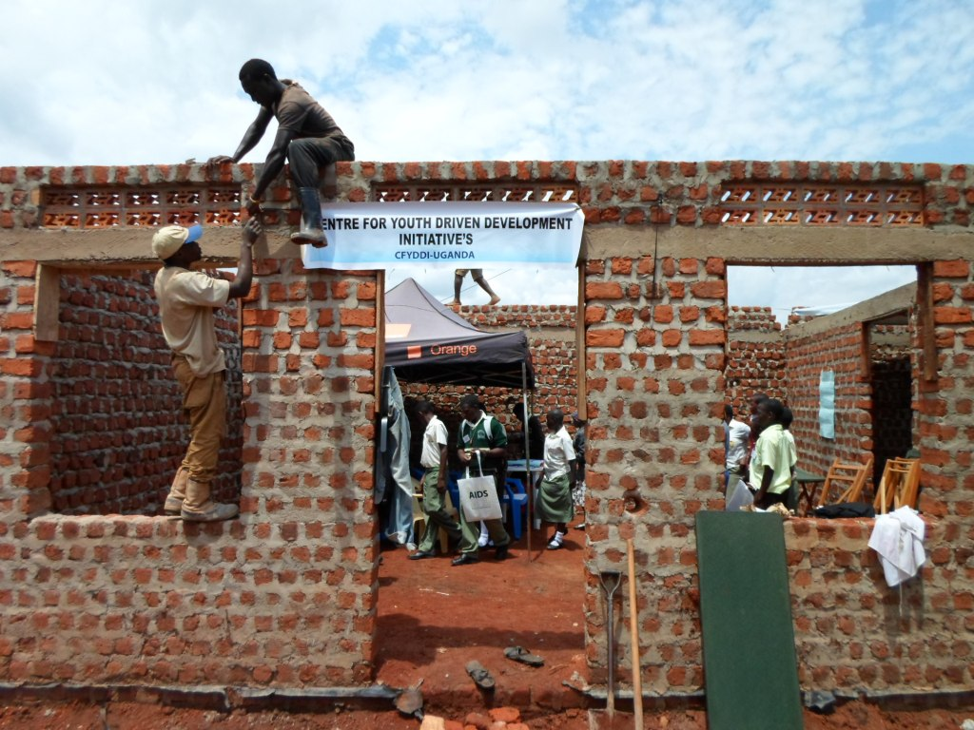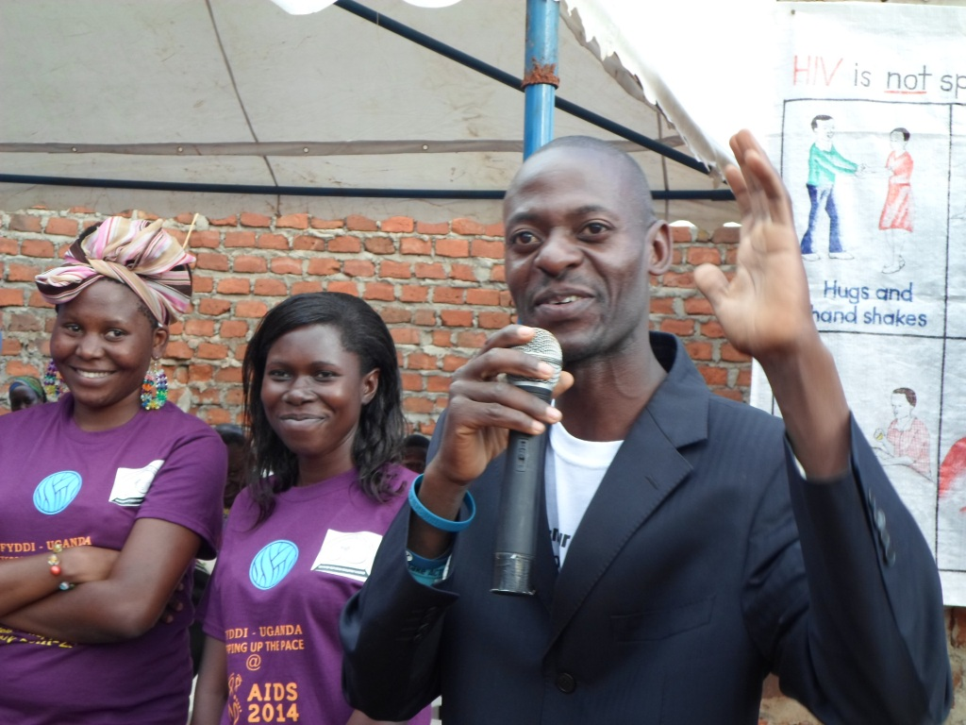
Volunteers pin up the sign post and Enoch and team address the guests:

The final note is that CFYDDI is incredibly inspired by the fact that we have been able to host the Health reading and Computer training Camp at such a larger and promising secure site. We have very realistic aims that by the end of this year we will fully and effectively occupy the completed youth centre in order to host many successful events in the future.

If you have thought about or have supported us before now is a great time to help us double the impact and One great day to do this will be from 1st September 2014 (2 pm BST) GlobalGiving UK will be matching all donations up to £600 by 50% until funds last. they are offering £5,000 worth of matching funds plus there are additional cash bonuses of £800, £400 and £400 that will be unlocked as soon as the campaign ends, on Monday 8th September 2014 (1.59 pm BST).
Thank you very much for your interest in investing in institutions in ways that empower young people and provide a plat form for meaningful engagements. Please feel free to contact us with any questions, comments or ideas at cfyddi@gmail.com
yours sincerely,
Enoch Magala CFYDDI Program Director and project Leader.

